# 

**Multimedia University**

**CCP6124 Object Oriented Programming and Data Structures 2410**

**Lecture section: TC3L**

**Tutorial section: T11L**

**Group number: G27**

**Group leader student name: Fadzlul Baqi Faez bin Fadzil**

| **Num** | **Student ID** | **Student Name by**  **alphabetical order** | **Task Descriptions** | **Percentage (%)** |
| --- | --- | --- | --- | --- |
| 1 | 1211112320 | Fadzlul Baqi Faez bin Fadzil | Simulation and battlefield initialization + Report Writer | 25% |
| 2 | 1211112293 | Haziq Izzuddin bin Ahmad Tarmidzi | Classes base code + Report Writer | 25% |
| 3 | 1211112295 | Umar Haziq bin Faizin | Logical computation + Report Writer | 25% |
| 4 | 1211112289 | Wan Amirul Amir bin Wan Romzi | Additional robot classes + Report Writer | 25% |
|  |  |  | Total | 100% |

# 

# 

# 

Assignment Evaluation Criteria (40%)

Student 1

| Student ID | 1211112320 | Total Score 40% |
| --- | --- | --- |
| Student name | Fadzlul Baqi Faez bin Fadzil |  |
| Task descriptions | Simulation and battlefield initialization + Report Writer |

Student 2

| Student ID | 1211112293 | Total Score 40% |
| --- | --- | --- |
| Student name | Haziq Izzuddin bin Ahmad Tarmidzi |  |
| Task descriptions | Classes base code + Report Writer |

Student 3

| Student ID | 1211112295 | Total Score 40% |
| --- | --- | --- |
| Student name | Umar Haziq bin Faizin |  |
| Task descriptions | Logical computation + Report Writer |

Student 4

| Student ID | 1211112289 | Total Score 40% |
| --- | --- | --- |
| Student name | Wan Amirul Amir bin Wan Romzi |  |
| Task descriptions | Additional robot classes + Report Writer |

# Assignment implementation (30%)

| **Criteria** | **Max** | **A1** | **A2** | **Mark** |
| --- | --- | --- | --- | --- |
| Q1. Design documentation, UML class diagram, two sample inputs and outputs or -30  - has UML class diagram + screenshots (inputs, outputs) + figures,  - has code segments + pseudocodes,  - accept & has explanations, good, great | 5 | * | * | ? |
| Q2. Initialization of a simulation, read input file and output initial of all robots, fixed seed integer for random functions | 1 | * | * | ? |
| Q3. Display and logging of the status of the battlefield of robots at each turn  - accept & has file output, good, great | 3 | * | * | ? |
| Q4. Display and logging of the robot actions and the status of each robot at each turn  - accept & has file output, good, great | 3 | * | * | ? |
| Q5. Implementation of the required 7 robot classes with OOP concepts +1 or I&P&OO -3 | 8 | * | * | ? |
| Q6. The algorithms used to optimize the actions of robots, optimize the two actions or -2  - has screenshots (inputs, outputs) + figures,  - has code segments + pseudocodes,  - accept & has explanations, good, great | 5 |  | * | ? |
| Q7. Design and implementation of data structures, linked list and queues or -2  - has linked list with screenshots (inputs, outputs) + figures + code segments + explanations + linked list to keep track robot actions during the simulation,  - has queues with screenshots (inputs, outputs) + figures + code segments + explanations + two queues to keep track of the destroyed and waiting robots,  - accept & has explanations, good, great | 5 |  | * | ? |
|  |  |  |  |  |
| Q8. Extra |  |  |  |  |
| Implementation of additional three robot classes | 3 |  |  |  |
|  |  |  |  |  |
| Total | 33 => 30 |  |  | ? |
|  |  |  |  |  |

Examined with the additional term test

| **Item**  9. Questions added as part of the assignment (individual marks) |  | **Maximum marks** | **Actual**  **Marks** |
| --- | --- | --- | --- |
| - Student Name 1: Fadzlul Baqi Faez bin Fadzil  - Student Name 2: Hazid Izzuddin bin Ahmad Tarmidzi  - Student Name 3: Umar Haziq bin Faizin  - Student Name 4: Wan Amirul Amir bin Wan Romzi |  | 10 | ?1  ?2  ?3  ?4 |
| Total |  | 40 | ?1  ?2  ?3  ?4 |

Additional Comments

|  |
| --- |

# Table of contents with page numbers and links

Title page 1

Assignment implementation (30%) 2

Table of contents with page numbers and links 3

Questions Section 6

Q1. [5] Design documentation, UML class diagram, two sample inputs and outputs 6

Q2. [1] Initialization of a simulation, read input file and output initial of all robots, fixed seed integer for random functions 56

Q3. [3] Display and logging of the status of the battlefield of robots at each turn 60

Q4. [3] Display and logging of the robot actions and the status of each robot at each turn 60

Q5. [8] Implementation of the required 7 robot classes with OOP concepts +1 or I&P&OO -80

Q6. [5] The algorithms used to optimize the actions of robots, optimize the two actions or -92

Q7. [5] Design and implementation of data structures, linked list and queues or -2 95

Question: How to compile, how to run the program 98

# 

# Questions Section

# Q1. [5] Design documentation, UML class diagram, two sample inputs and outputs

UML class diagram

[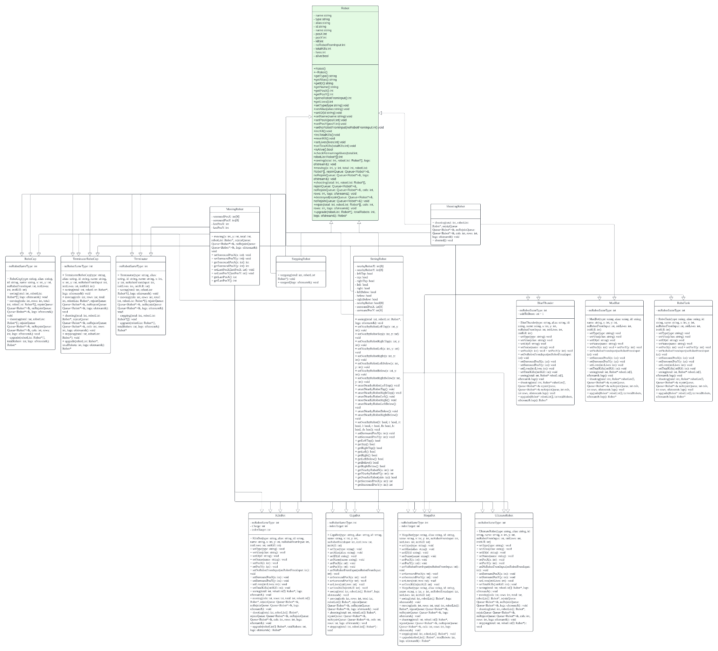](https://lucid.app/lucidchart/148a5bc7-4de9-4321-b6ab-188b3c1b8209/edit?view_items=96xHYdaRjUrY&invitationId=inv_b3e186bb-14e2-4104-ad10-de52544d5d37)

<https://lucid.app/lucidchart/148a5bc7-4de9-4321-b6ab-188b3c1b8209/edit?view_items=96xHYdaRjUrY&invitationId=inv_b3e186bb-14e2-4104-ad10-de52544d5d37>

**class Robot;**

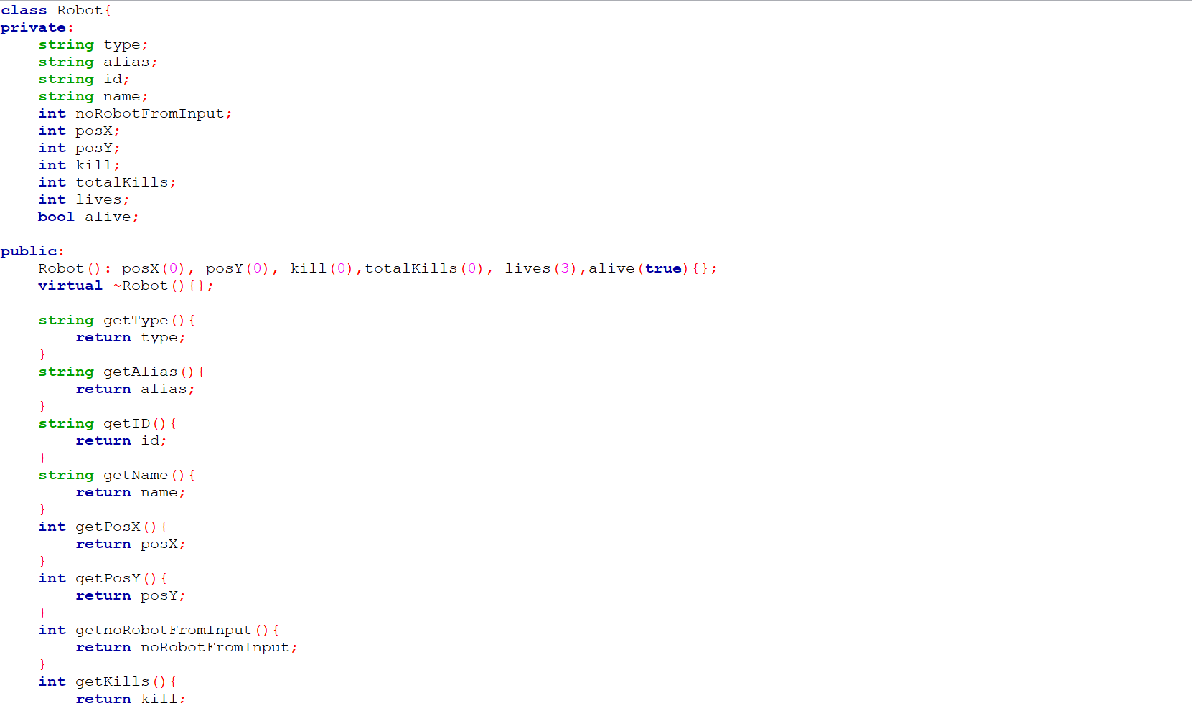

-The Robot class includes essential attributes such as type, alias, id, name, noRobotFromInput, posX, posY, kill, totalKills, lives, and alive.



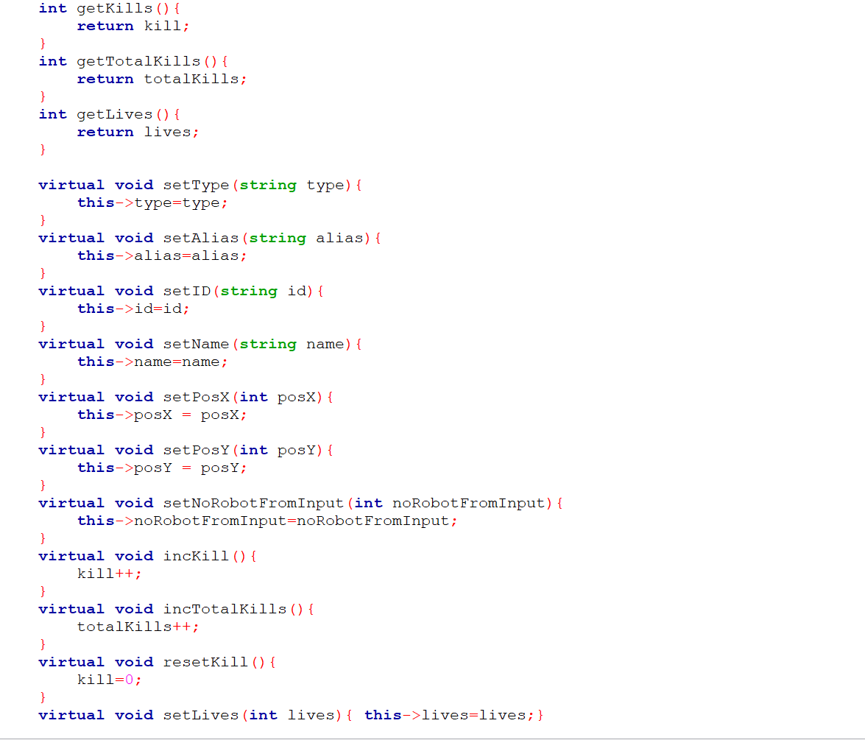

-These public methods provide access to various attributes of the Robot class, allowing external code to retrieve information such as type, alias, ID, name, position, kills, total kills, lives, and input-related counts.



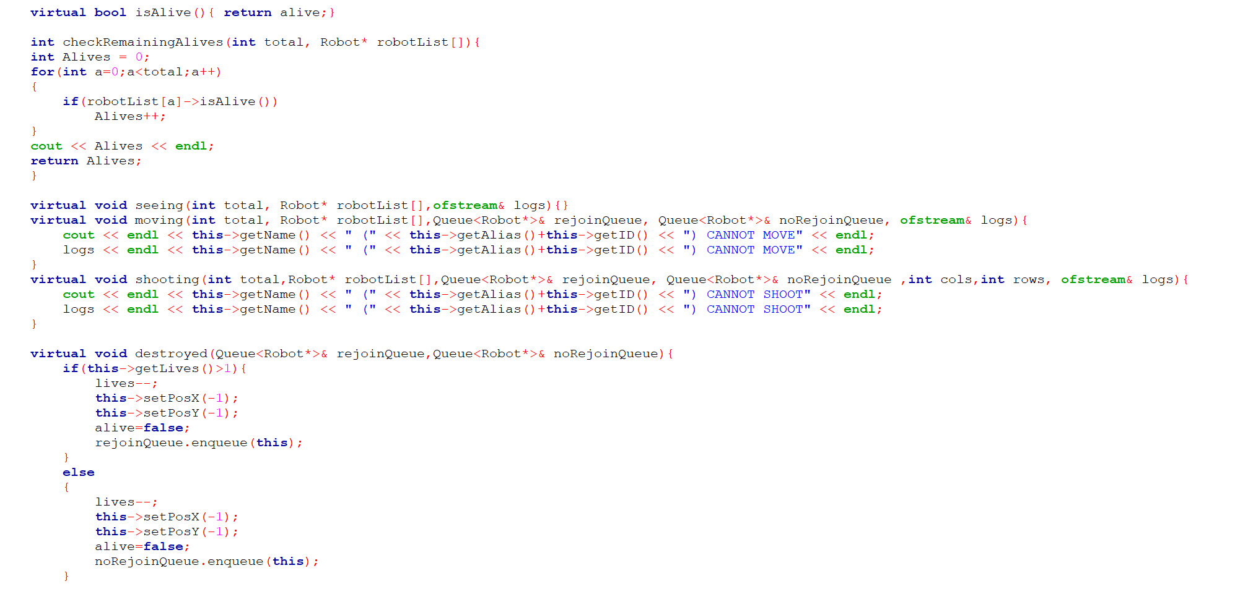

-These setter and additional methods let you modify and control different characteristics of the Robot class, like its type, alias, ID, name, position, kill count, total kills, lives, and life status.



-The checkRemainingAlives iterates through an array of Robot pointers and counts how many of them are currently alive based on the isAlive() method of the Robot class.

-The for loop iterates through each element of the robotList array from index 0 to total - 1.

-if the Robot object pointed to by robotList[a] is alive, increment the Alives counter.

-After iterating through all elements of robotList, the function returns the total count of alive robots.

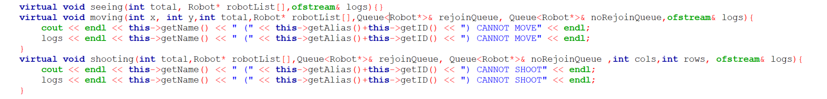

-This method takes parameters x and y for movement coordinates, total as a count, robotList[] for a list of robots, rejoinQueue and noRejoinQueue as queues of Robot pointers, and logs for logging.

-Print a message to the console and logs indicating that the robot cannot move.



-This method takes parameters total, robotList[], rejoinQueue, noRejoinQueue, cols, rows as dimensions, and logs.

-Print a message to the console and logs indicating that the robot cannot shoot.



-This method handle the destruction or disabling of a Robot instance based on its current lives count.

-If the robot has more than one life left, it decrements the lives count, sets the position to -2, sets alive to false and adds the robot back to the rejoinQueue.

-If not, it decrements the lives count, sets the position to -2, sets alive to false and adds the robot back to the norejoinQueue.

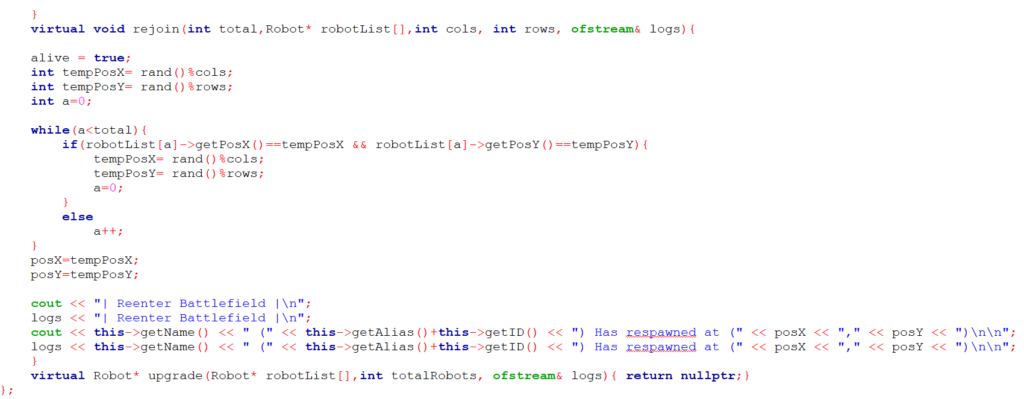

Rejoin method:

-Resets the robot's alive status to true and finds a new random position within the battlefield where the robot can respawn without overlapping with existing robots .

-Prints a message to the console and logs indicating the respawn location.

Upgrade method:

- perform actions to upgrade or modify a robot.

**class SeeingRobot;**

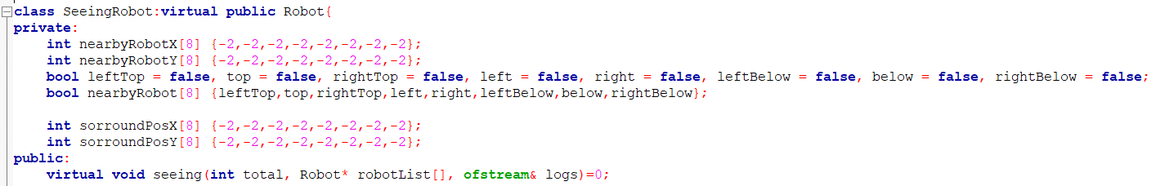

Class definition :

-‘SeeingRobot’ is derived from ‘Robot’

- ‘virtual’ inheritance is used to avoid multiple instances of the ‘Robot’ base class when dealing with multiple inheritance.

Private members :

-Arrays ‘nearbyRobotX’ and ‘nearbyRobotY’ store the coordinates of nearby robots.

-Boolean variables like ‘leftTop’, ‘top’, etc., indicate the presence of nearby robots in the respective positions.

-The ‘nearbyRobot’ array is a collection of these boolean values for easy access.

- Array ‘sorroundPosX’ and ‘sorroundPosY’ store the surrounding positions relative to the robot’s position.

Public methods :

- Pure virtual function ‘seeing’ : This function must be implemented by derived classes to define the specific behavior when a robot sees other robots.

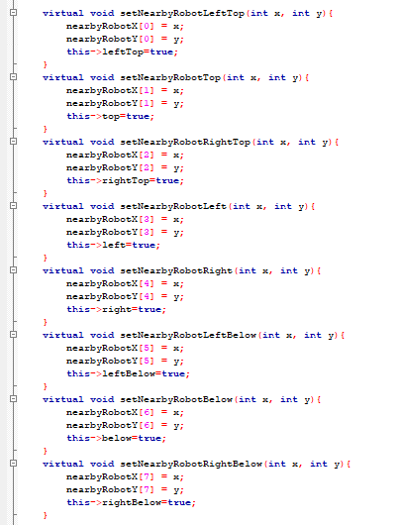

-These methods set the coordinates of nearby robots in specific positions and mark the respective boolean flags as ‘true’.

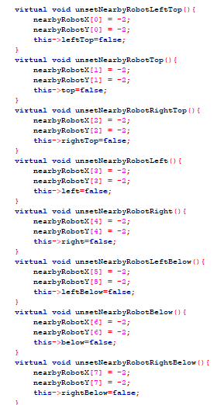

-These methods reset the coordinates of nearby robots to ‘-2’ (indicating no robot present) and mark the respective boolean flags as ‘false’.

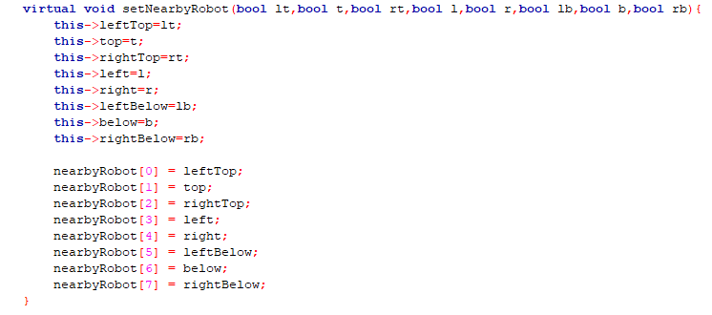

-This method sets the boolean flags for the presence of nearby robots in specific positions and updates the ‘nearbyRobot’ array accordingly.

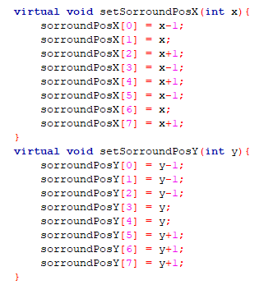

-These methods set the coordinates for the surrounding positions relative to the robot’s position.

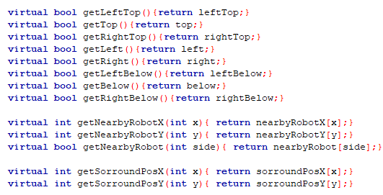

-These methods return the boolean flags for the presence of nearby robots and the coordinates of nearby robots and surrounding positions.

**class MovingRobot;**

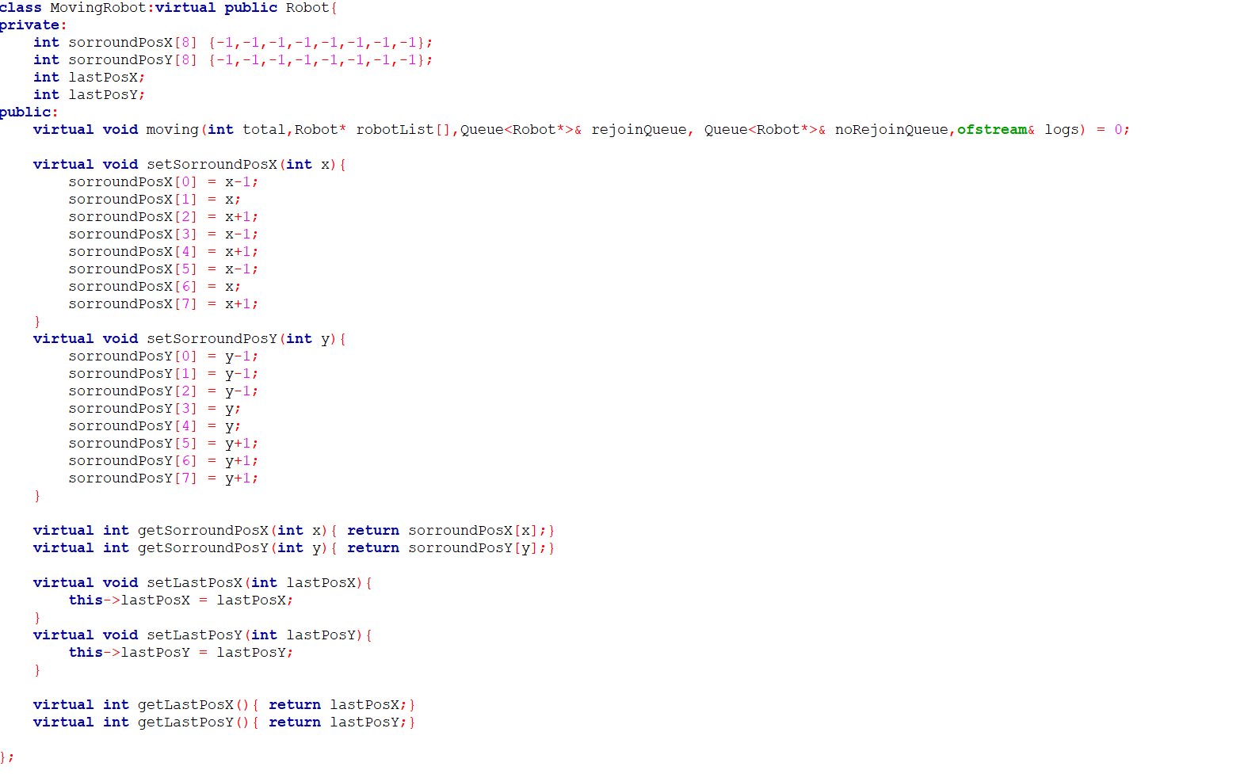

Class Definition

-MovingRobot is a class that inherits from the Robot class.

-virtual is used with inheritance to ensure that if multiple classes inherit from Robot, there will be only one instance of Robot shared among them

Private Members

-Arrays sorroundPosX and sorroundPosY store the surrounding positions' X and Y coordinates relative to the robot’s position. The initial values of -2 might be used as a placeholder to indicate that these positions have not been set yet.

-lastPosX and lastPosY store the last known position of the robot in terms of X and Y coordinates, respectively.



Public Methods

-Pure virtual function moving must be implemented by any derived class. It is intended to define the specific behavior when a robot moves.

Setter Methods

-setSorroundPosX method sets the X coordinates of the surrounding positions relative to the robot's current X coordinate x

-setSorroundPosY method sets the Y coordinates of the surrounding positions relative to the robot's current Y coordinate y.



-These methods enable the program to keep track of the robot's movement history and its surrounding positions, which can be useful for pathfinding, collision avoidance, and other movement-related logic.

**class ShootingRobot;**

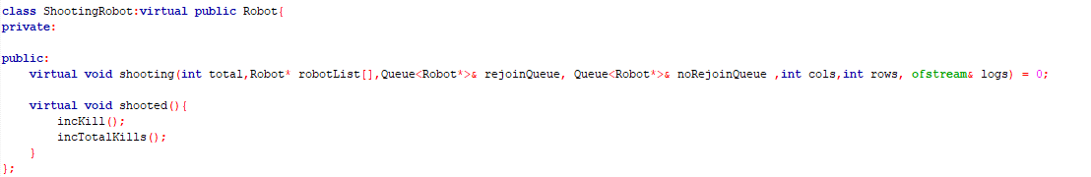

Pseudocode:

* Inherit member from class Robot (total, robotList, rejoinQueue, noRejoinQueue, cols, rows, logs)
* ‘virtual’ inheritance is used to avoid multiple instances of the ‘Robot’ base class when dealing with multiple inheritance.
* No private members
* Public:
  + Pure virtual function ‘shooting’ : This function must be implemented by derived classes to define the specific behavior when a robot shoots other robots.
  + These methods will be called by the robot to shoot at a certain coordinate based on the variable inherited by Robot class
  + Pure virtual function ‘shooted’: This function must be implemented when a robot successfully shoots at another robot
  + The kill counts and total kill counts will be incremented by incKill and incTotalKills for the respective robot.

**class SteppingRobot;**

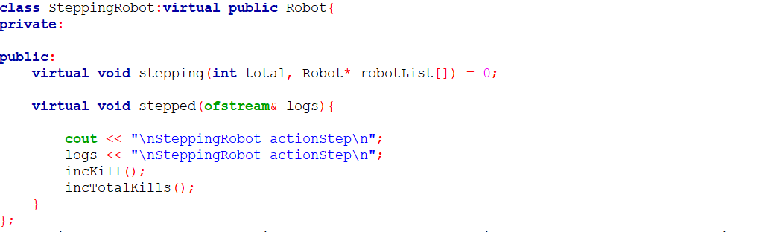

*class SteppingRobot Pseudocode*

Class Definition

-SteppingRobot is a class that inherits from the Robot class using virtual inheritance.

Private Members

-No private members declared in this class

Public Methods

-Pure virtual function stepping must be implemented by any derived class. It is intended to define the specific behavior when the robot performs a "stepping" action

-stepped(ofstream& logs) method is a concrete implementation provided by SteppingRobot.

-Prints "SteppingRobot actionStep" to the console.

-Writes "SteppingRobot actionStep" to the log file.

-Calls incKill(): Presumably increments some internal counter related to kills.

-Calls incTotalKills(): Presumably increments a global counter of total kills

across all robots.

**class UltimateRobot;**

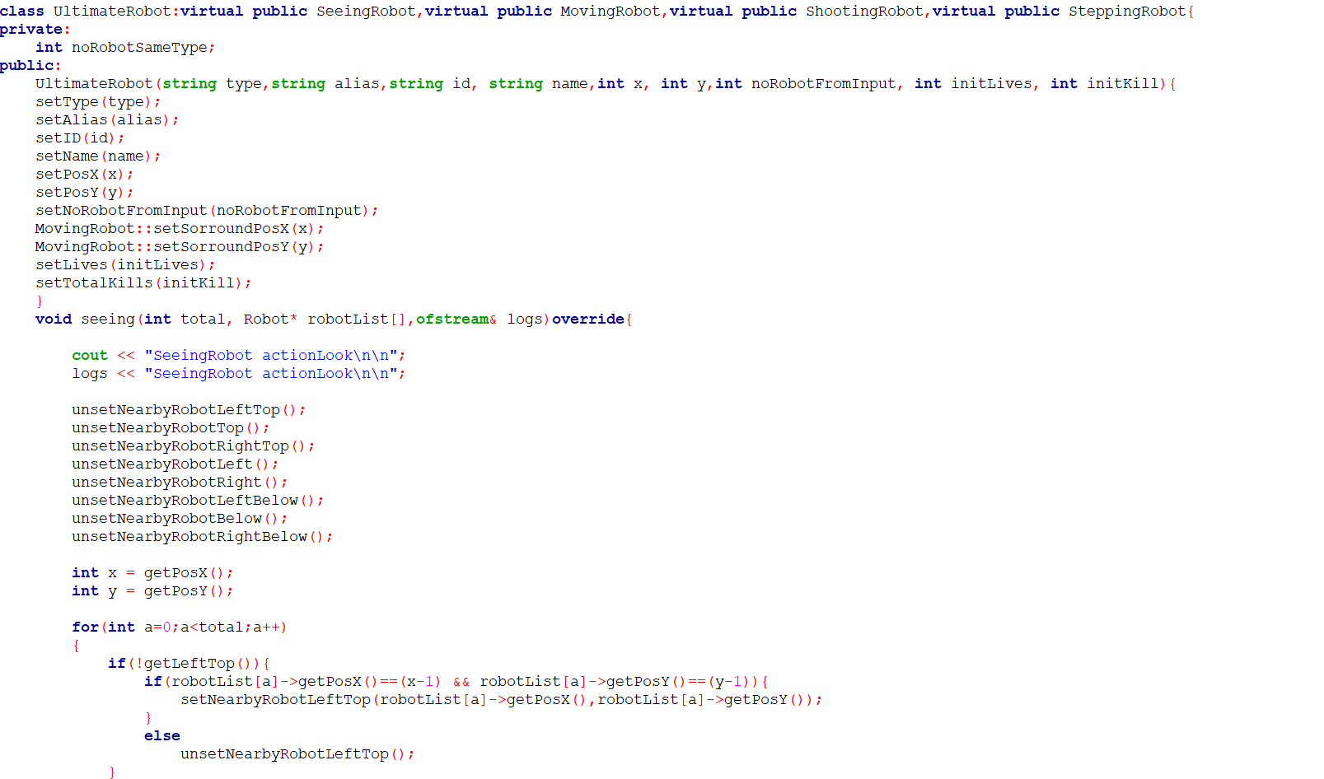

-The UltimateRobot class combines functionalities from multiple base classes which is SeeingRobot, MovingRobot, ShootingRobot and SteppingRobot.

Private method:

-Stores the number of robots of the same type.

Public method:

-Sets the type, alias, ID, name, position (x, y), number of robots from input, initial lives, and initial total kills

-Calls specific setter methods from MovingRobot to initialize surrounding positions relative to the robot's starting position.



-Print "SeeingRobot actionLook" to the console and log it into the logs stream.

-resetting these flags, the robot starts with a clean slate, ensuring accurate detection and assessment of its surroundings based on current sensory inputs or data.

-Retrieves the current X and Y coordinates of the robot using getPosX() and getPosY().

-Checks if the left-top direction flag is not already set for the current robotChecks.

-If the position of the current robot matches the position (x-1, y-1), call setNearbyRobotLeftTop() to set the left-top flag and store the position of the nearby robot.

-If statement is not met calls unsetNearbyRobotLeftTop() to reset or unset the left-top flag.

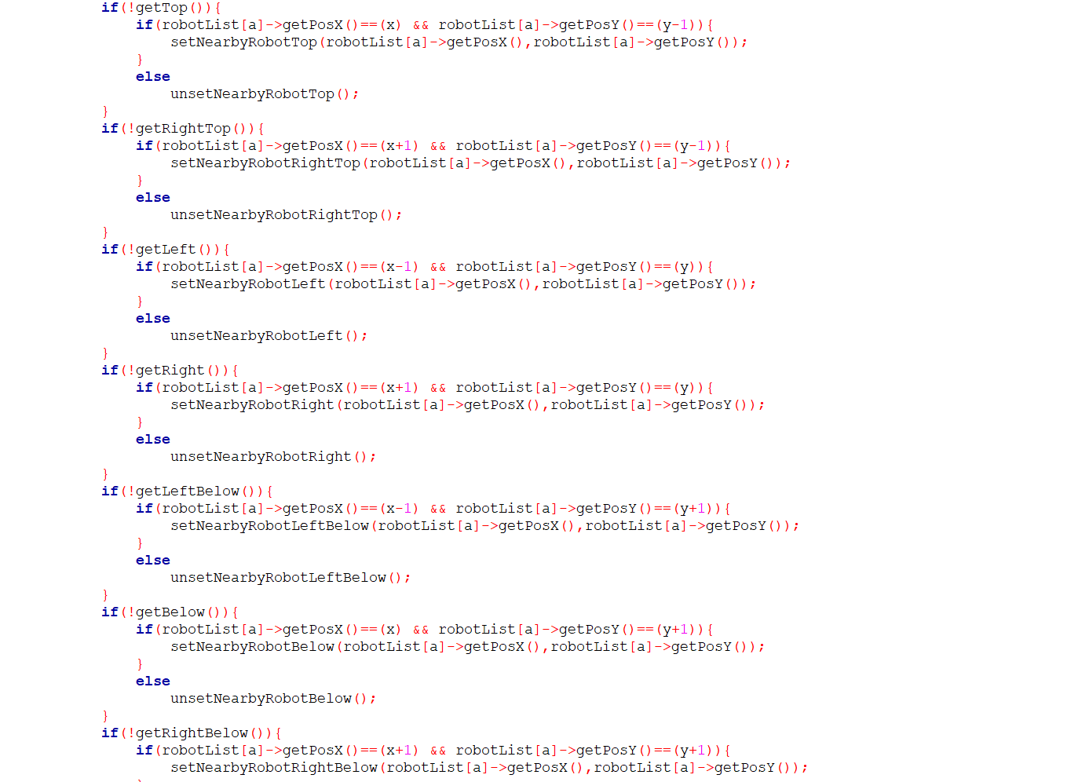

-Checks if the top direction flag is not already set for the current robot.

-If the position of the current robot matches the position, calls setNearbyRobotTop() to set the top flag and store the position of the nearby robot.

-If statement is not met , calls unsetNearbyRobotTop() to reset or unset the top flag.



-Checks if the rightTop direction flag is not already set for the current robot.

-If the position of the current robot matches the position, calls setNearbyRobotRightTop() to set the rightTop flag and store the position of the nearby robot.

-If statement is not met, calls unsetNearbyRobotRightTop() to reset or unset the rightTop flag.



-Checks if the left direction flag is not already set for the current robot

-If the position of the current robot matches the position, calls setNearbyRobotLeft() to set the left flag and store the position of the nearby robot.

-If statement is not met, calls unsetNearbyRobotLeft() to reset or unset the left flag.



-Checks if the right direction flag is not already set for the current robot.

-If the position of the current robot matches the position, indicating a robot is located in the right direction relative to the current robot's position, calls setNearbyRobotRight() to set the right flag and store the position of the nearby robot.

-If statement is not met, calls unsetNearbyRobotRight() to reset or unset the right flag.



-Checks if the left-below direction flag is not already set for the current robot.

-If the position of the current robot matches the position, call setNearbyRobotLeftBelow() to set the left-below flag and store the position of the nearby robot.

-If statement is not met, calls unsetNearbyRobotLeftBelow() to reset or unset the left-below flag.



-Checks if the below direction flag is not already set for the current robot.

-If the position of the current robot matches the position, calls setNearbyRobotBelow() to set the below flag and store the position of the nearby robot.

-If statement is not met, calls unsetNearbyRobotBelow() to reset or unset the below flag.

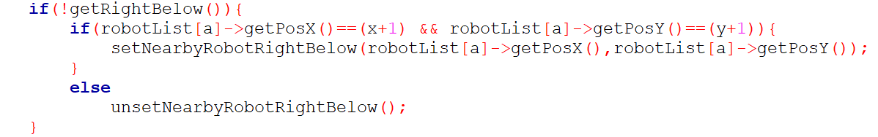

-Checks if the rightBelow direction flag is not already set for the current robot.

-If the position of the current robot matches the position, calls setNearbyRobotRightBelow() to set the rightBelow flag and store the position of the nearby.

-If statement is not met, calls unsetNearbyRobotRightBelow() to reset or unset the rightBelow flag.

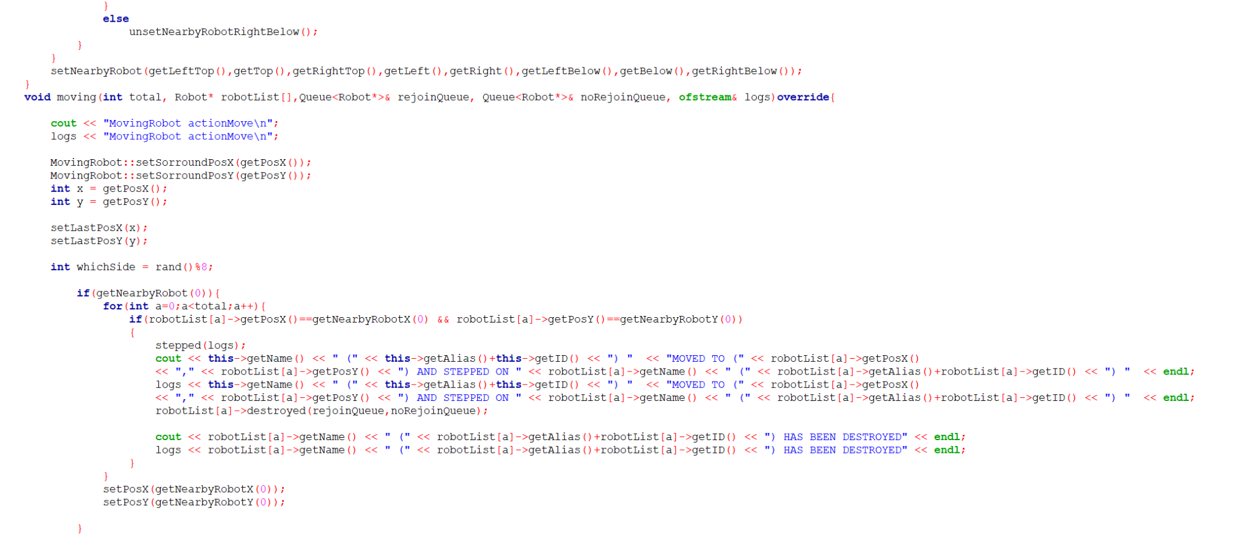

-The setNearbyRobot method updates the robot's internal state about the presence of other robots in its surroundings.

-The moving method handles the robot's movement logic, considering the(cols, rows), the total number of robots, the list of robots, and the rejoin/no-rejoin queues, while logging actions to a file.

-Prints and logs the message "MovingRobot actionMove" to the console and the log file.

-Sets the surrounding position coordinates to the robot's current X and Y coordinates using the MovingRobot::setSorroundPosX and MovingRobot::setSorroundPosY methods.

-Retrieves the robot's current X and Y coordinates and stores them in x and y variables.

-Sets the robot's last X and Y positions using the setLastPosX and setLastPosY methods.

-Generates a random integer between 0 and 7 and stores it in the whichSide variable.



-If there is a nearby robot at the position specified by getNearbyRobotX(0) and getNearbyRobotY(0). Executes the stepped(logs) method to indicate the robot has moved onto another robot.

-Prints and logs a message detailing the movement and the robot stepped upon.

-Calls the destroyed method on the robot that was stepped upon, managing its life status and queues.

-Prints and logs a message indicating the destruction of the stepped-upon robot.

-Updates the current robot's position to the position of the stepped-upon robot using setPosX and setPosY.

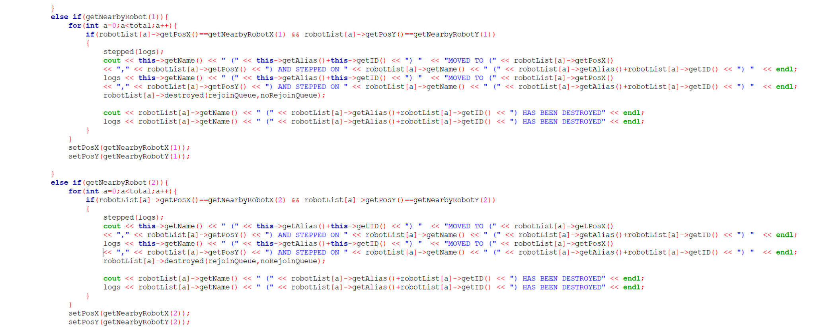

-Checks if there is a nearby robot at the position specified by getNearbyRobotX(1) and getNearbyRobotY(1).

-If a robot is found at that position:

-Calls stepped(logs) to indicate the robot has moved onto another robot.

-Prints and logs a message detailing the movement and the robot stepped upon.

-Calls destroyed(rejoinQueue, noRejoinQueue) on the robot that was stepped upon, managing its life status and queues.

-Prints and logs a message indicating the destruction of the stepped-upon robot.

-Updates the current robot's position to the position of the stepped-upon robot using setPosX and setPosY.



-Checks if there is a nearby robot at the position specified by getNearbyRobotX(2) and getNearbyRobotY(2).

If a robot is found at that position:

-Calls stepped(logs) to indicate the robot has moved onto another robot.

-Prints and logs a message detailing the movement and the robot stepped upon.

-Calls destroyed(rejoinQueue, noRejoinQueue) on the robot that was stepped upon, managing its life status and queues.

-Prints and logs a message indicating the destruction of the stepped-upon robot.

-Updates the current robot's position to the position of the stepped-upon robot using setPosX and setPosY.

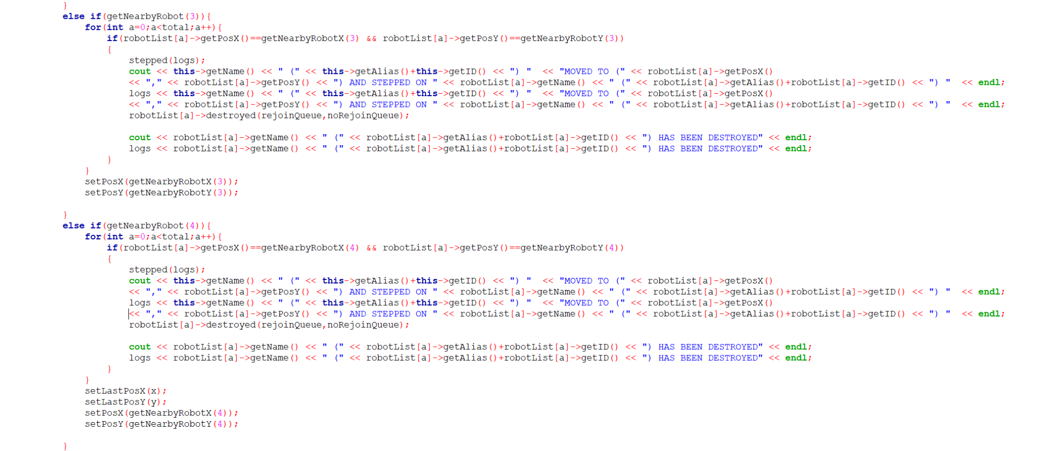

-Checks if there is a nearby robot at the position specified by getNearbyRobotX(3) and getNearbyRobotY(3).

-If a robot is found at that position:

-Calls stepped(logs) to indicate the robot has moved onto another robot.

-Prints and logs a message detailing the movement and the robot stepped upon.

-Calls destroyed(rejoinQueue, noRejoinQueue) on the robot that was stepped upon, managing its life status and queues.

-Prints and logs a message indicating the destruction of the stepped-upon robot.

-Updates the current robot's position to the position of the stepped-upon robot using setPosX and setPosY.



-Check Condition: Checks if there is a nearby robot at the position specified by getNearbyRobotX(4) and getNearbyRobotY(4).

-If a robot is found at that position:

-Calls stepped(logs) to indicate the robot has moved onto another robot.

-Prints and logs a message detailing the movement and the robot stepped upon.

-Calls destroyed(rejoinQueue, noRejoinQueue) on the robot that was stepped upon, managing its life status and queues.

-Prints and logs a message indicating the destruction of the stepped-upon robot.

-Updates the current robot's last position to its previous coordinates.

-New Position: Updates the current robot's position to the position of the stepped-upon robot (getNearbyRobotX(4) and getNearbyRobotY(4)).

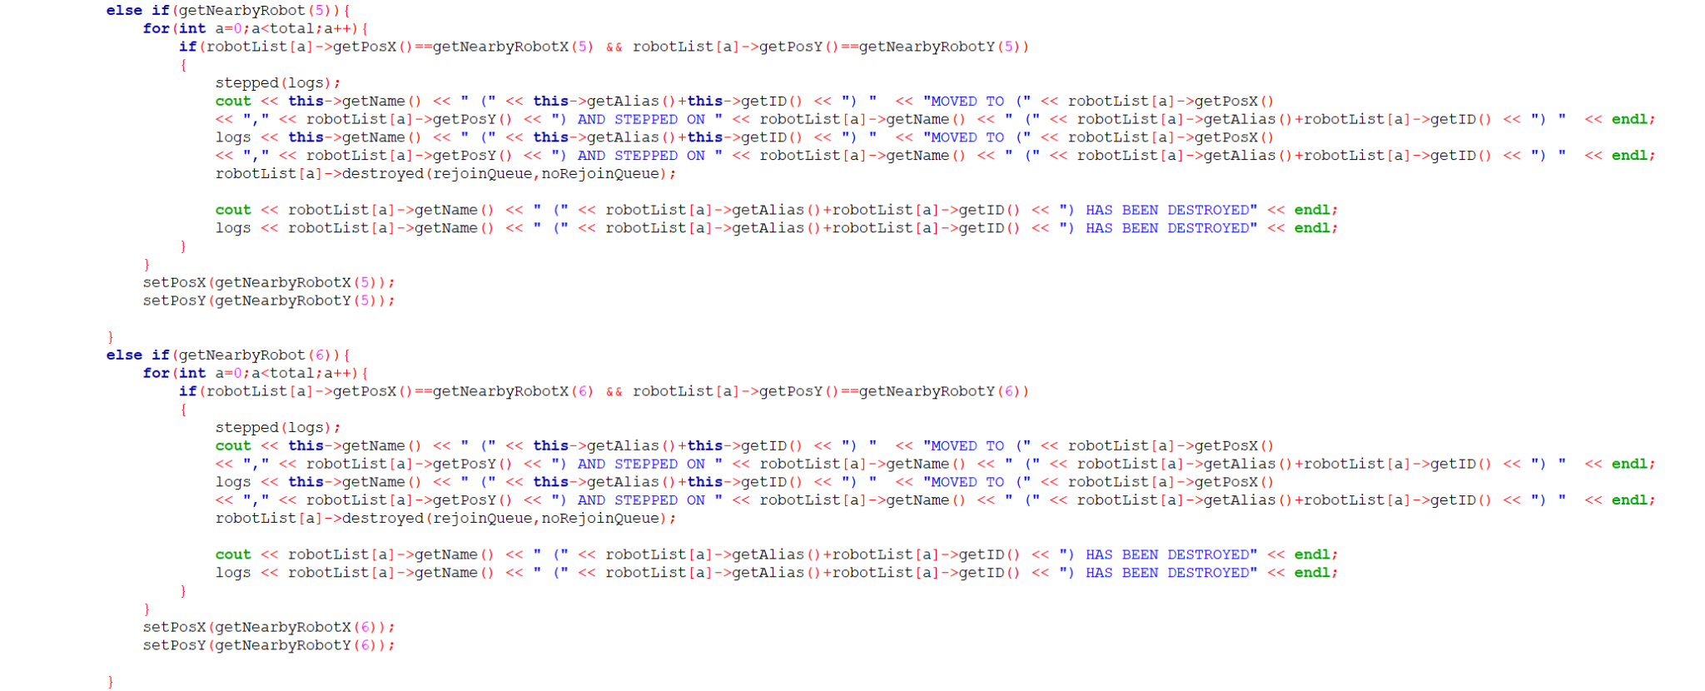

-Checks if there is a nearby robot at the position specified by getNearbyRobotX(5) and getNearbyRobotY(5).

-If a robot is found at that position:

-Calls stepped(logs) to indicate the robot has moved onto another robot.

-Prints and logs a message detailing the movement and the robot stepped upon.

-Calls destroyed(rejoinQueue, noRejoinQueue) on the robot that was stepped upon, managing its life status and queues.

-Prints and logs a message indicating the destruction of the stepped-upon robot.

-Updates the current robot's position (setPosX and setPosY) to the position of the stepped-upon robot (getNearbyRobotX(5) and getNearbyRobotY(5)).



-Checks if there is a nearby robot at the position specified by getNearbyRobotX(6) and getNearbyRobotY(6).

Interaction Handling:

If a robot is found at that position

-Calls stepped(logs) to indicate that the current robot has moved onto another robot.

-Prints and logs a message detailing the movement and the robot that was stepped upon.

-Calls destroyed(rejoinQueue, noRejoinQueue) on the robot that was stepped upon, managing its destruction and queueing.

-Prints and logs a message indicating the destruction of the robot that was stepped upon.

Updates the current robot's position to the position of the robot that was stepped upon (getNearbyRobotX(6) and getNearbyRobotY(6)).

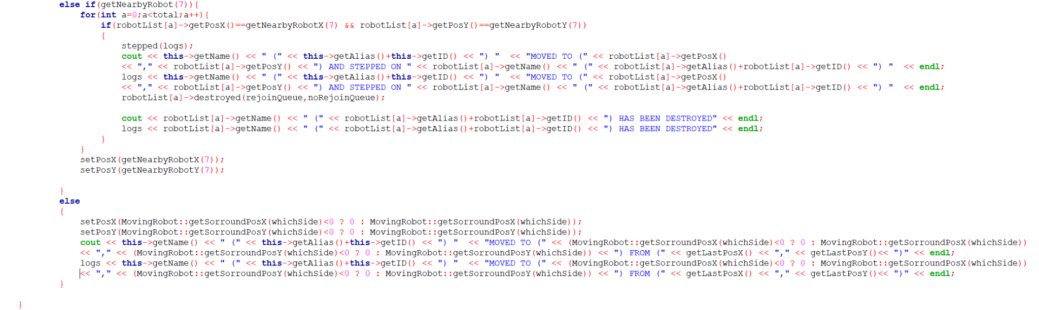

-Checks if there is a nearby robot at the position specified by getNearbyRobotX(7) and getNearbyRobotY(7).

Interaction Handling:

-If a robot is found at that position

-Calls stepped(logs) to indicate that the current robot has moved onto another robot.

-Prints and logs a message detailing the movement and the robot that was stepped upon.

-Calls destroyed(rejoinQueue, noRejoinQueue) on the robot that was stepped upon, managing its destruction and queueing.

-Prints and logs a message indicating the destruction of the robot that was stepped upon.

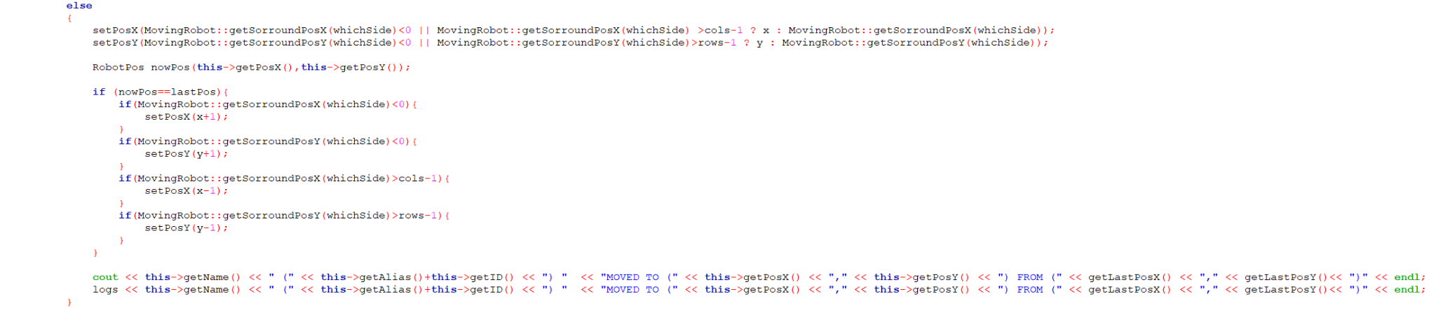

-Updates the robot's position based on a random direction determined by whichSide. If the calculated position is out of bounds , it retains the current position.

-Checks if after moving, the robot's current position is the same as its last position

-Adjusts the robot's position further if it is stuck at the boundary.

- indicating the robot's movement from its last position to its current position.

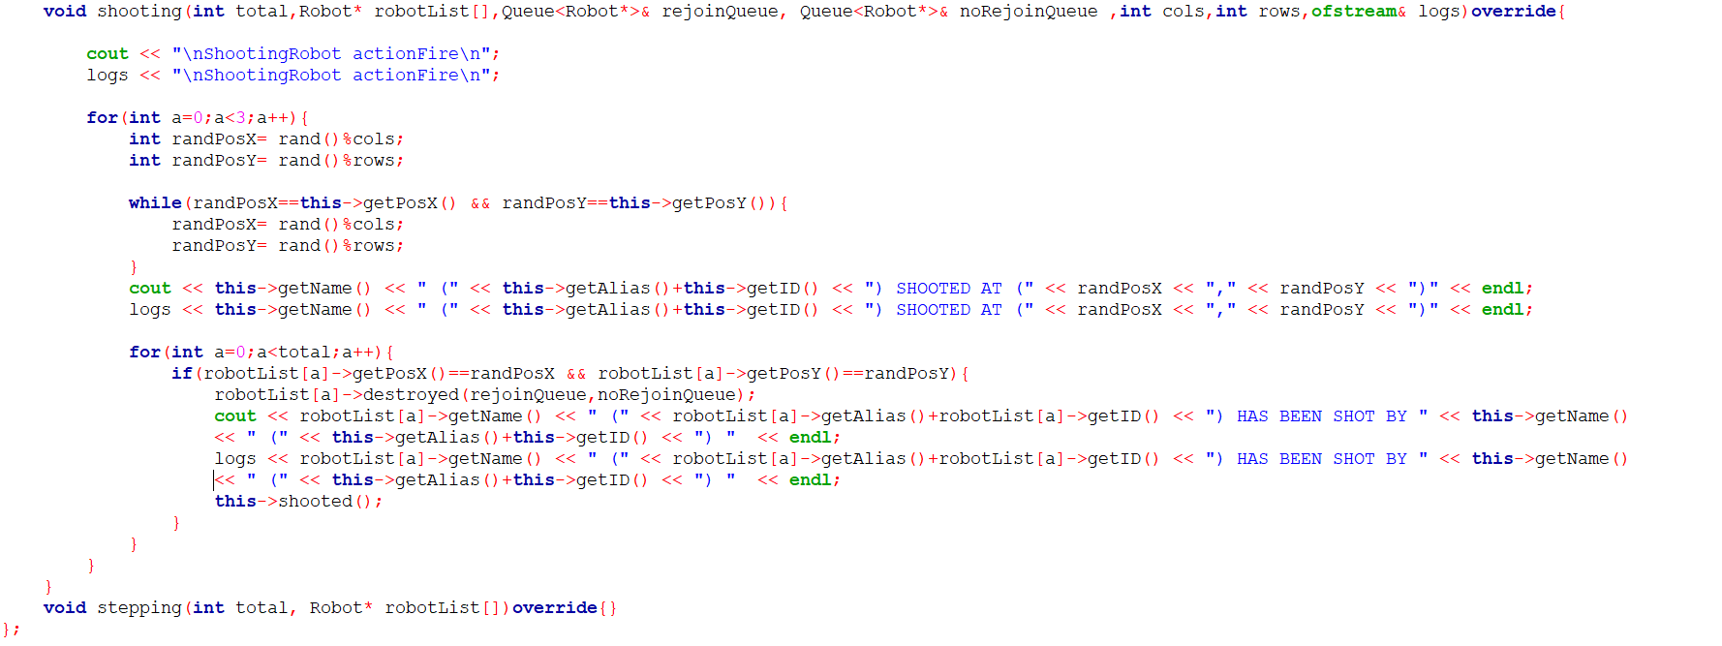

Shooting method:

-Implements the behavior of shooting at random positions within the specified grid (cols x rows).

-Prints and logs that the robot is performing the shooting action.

-It iterates three times to simulate shooting three times. Generates random positions within the grid boundaries.

-Ensures the robot does not shoot at its own position by checking randPosX and randPosY against its current position.

-Checks if any robot in the robotList has the same position as the generated random position.

-If a robot is found at that position

-Calls destroyed on the targeted robot to remove it from the battlefield .

-Prints and logs that the robot has been shot by the current robot.

-Calls shooted() on the current robot to possibly update its internal state or perform other actions related to shooting.

Logging:

Logs each shooting action and its outcome to the provided logs output stream.

Empty stepping Method:

-The stepping method is declared but not implemented. This suggests that the UltimateRobot class does not define any specific behavior for stepping.

**class RoboTank;**

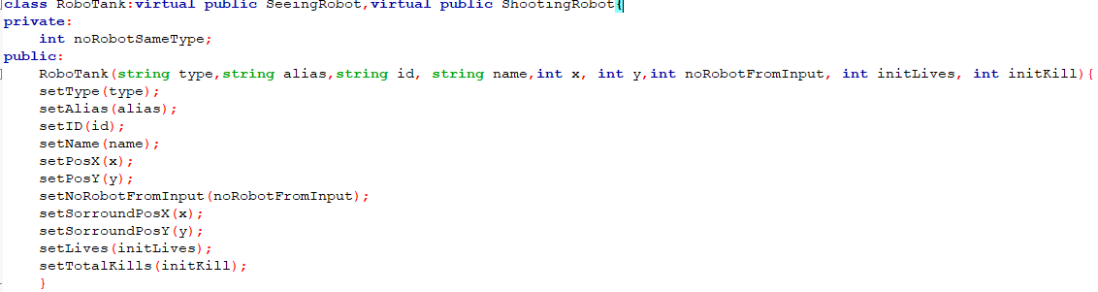

**-** ‘RoboTank’ inherits from both ‘SeeingRobot’ and ‘ShootingRobot using virtual inheritance to avoid multiple instances of the ‘Robot’ base class.

Private members :

- ‘noRobotSameType’ : A private member variable to store the number of robots of the same type.

Public methods :

- Constructor: Initializes a ‘RoboTank’ object with the given parameters. It sets the type, alias, ID, name, position (x,y), number of robots from input, initial lives, and initial total kills using the respective setter methods.

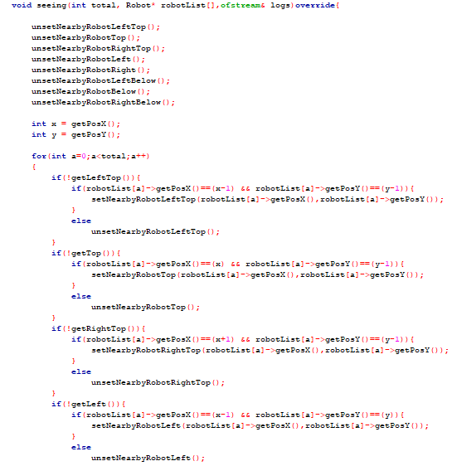

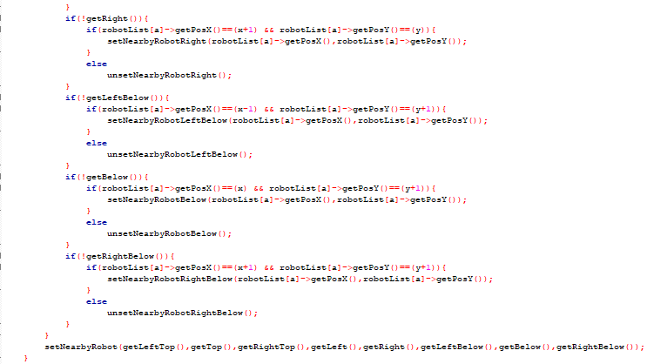

void seeing : Implements the pure virtual method from ‘SeeingRobot’. It checks the positions of all robots in the list and updates the nearby robots’ positions and flags accordingly. It resets all nearby robots’ flags and positions at the start, then sets them based on the robots’ positions relative to the current robot.

Assume the RoboTank is at position (5, 5) and there are three other robots in the vicinity at positions (4, 4), (5, 4), and (6, 4). In this example, the RoboTank at (5, 5) will detect robots at (4, 4) (LeftTop), (5, 4) (Top), and (6, 4) (RightTop). It sets the respective flags and positions.

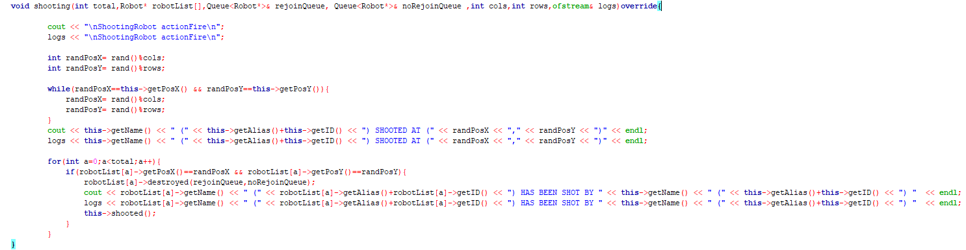

void shooting : -

Random Position Selection:

* The method first generates random ‘x’ and ‘y’ coordinates within the bounds of the field (cols and rows).
* It ensures that the generated random position is not the same as the current position of the RoboTank.

Logging the Shooting Action:

* The method logs the shooting action to the console and to a log file.

Checking for Target Hit:

* It iterates through the list of robots (‘robotsList’) to check if any robot is present at the randomly chosen position (‘randPosX’, ‘randPosY’).
* If a robot is found at that position, it calls the ‘destroyed’ method on the target robot and logs the hit.
* It then calls the ‘shooted’ method to update the kill counts.

Assume the field is 10x10, and the RoboTank is at position (5,5). The shooting might randomly select a position such as (1,2) to shoot at. If a robot is present at (1,2), it will be destroyed.

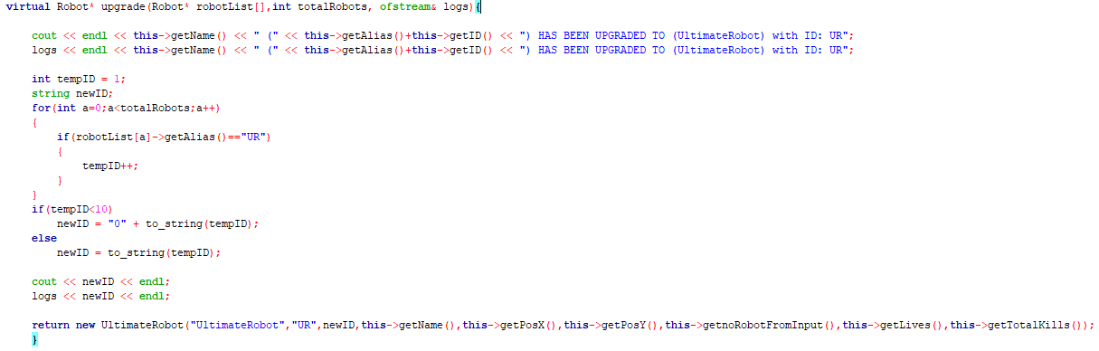

upgrade method : This method upgrades the RoboTank to an UltimateRobot. It logs the upgrade action, generates a new ID for the UltimateRobot, and returns a new UltimateRobot object with the updated attributes.

Assume the RoboTank is being upgraded, and the UltimateRobot robots already have IDs UR01, UR02, etc. In this example, the RoboTank is upgraded to an UltimateRobot with a new ID, such as UR03. The new UltimateRobot object is created and returned.

**class MadBot;**

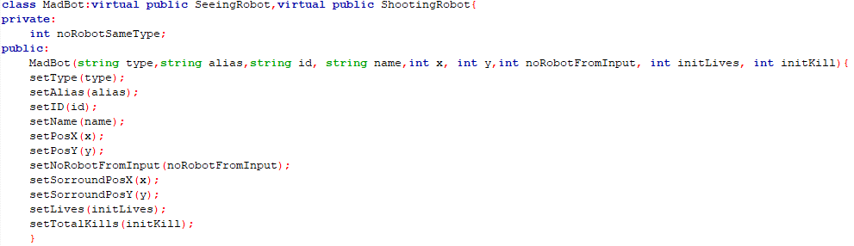

- ‘MadBot’ inherits from both ‘SeeingRobot’ and ‘ShootingRobot’ using virtual inheritance to avoid multiple instances of the ‘Robot’ base class.

Private members :

- ‘noRobotSameType’ : A private member variable to store the number of robots of the same type.

Public methods :

- Constructor : Initializes a ‘MadBot’ object with the given parameters. It sets the type, alias, ID, name, position (‘x’, ‘y’), number of robots from input, initial lives, and initial total kills using the respective setter methods.





void seeing : Implements the pure virtual method from ‘SeeingRobot’. It checks the positions of all robots in the list and updates the nearby robots’ positions and flags accordingly. It resets all nearby robots’ flags and positions at the start, then sets them based on the robots’ positions relative to the current robot.

Let’s assume the ‘MadBot’ is at position ‘(5,5)’ and there are three other robots in the vicinity at positions (4,4), (5,4), and (6,4). The MadBot at (5,5) will detect robots at (4,4) (LeftTop), (5,4) (Top) and (6,4) (RightTop). It sets the respective flags and positions.

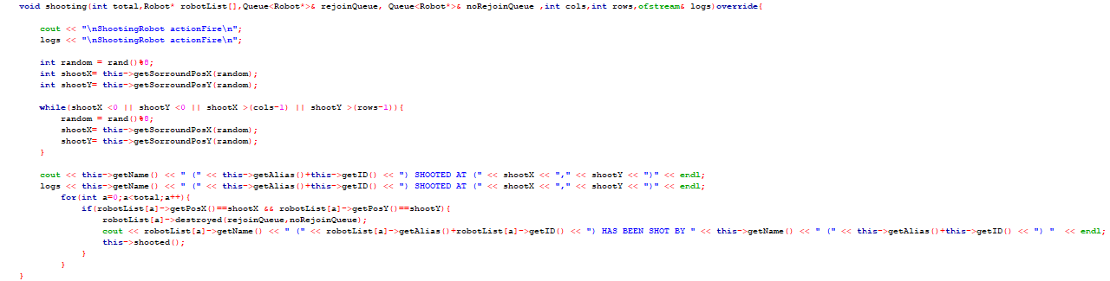

void shooting : Randomly selects a position to shoot at from the surrounding positions. It ensures the selected position is within the bounds of the field. It logs the shooting action and checks if any robot is at the target position. If a robot is hit, it marks it as destroyed and updates the kill counts.  
  
Assume the field is 10x10 and the MadBot is at position (5,5). The surround positions might include (4,4), (5,4),(6,4), etc. The MAdBot might shoot at position (4,4). If a robot is present at that position, it is marked as destroyed.

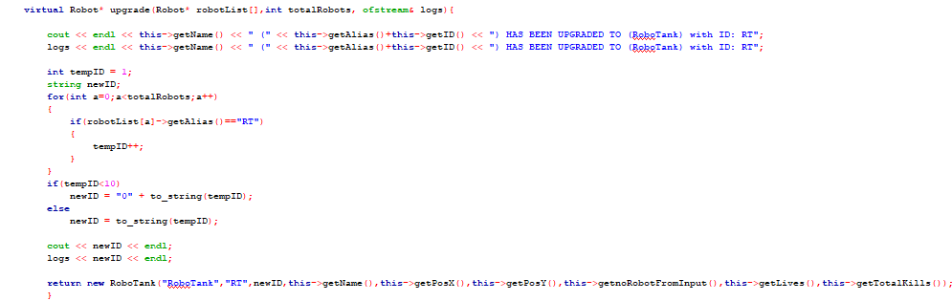

upgrade method : This method upgrades the MadBot to a RoboTank. It logs the upgrade action, generates a new ID for the RoboTank, and returns a new RoboTank object with the updated attributes.  
  
Assume the MadBot is being upgraded, and the RoboTank robots already have IDs RT01, RT02. In this example, the MadBot is upgraded to a RoboTank with a new ID, such as RT03. The new RoboTank object is created and returned.

**class BlueThunder;**

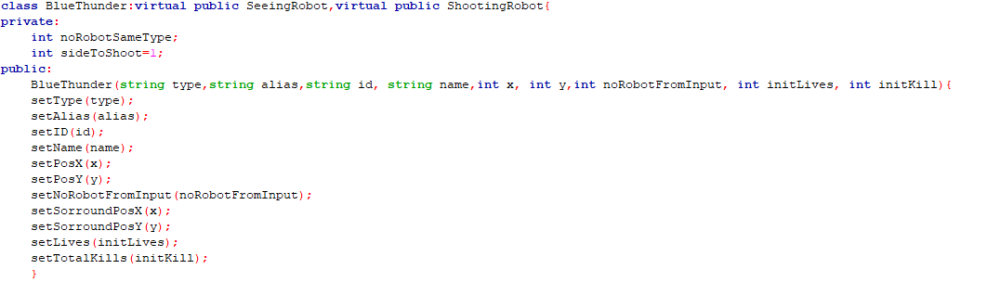

* ‘BlueThunder’ inherits from both ‘SeeingRobot’ and ‘ShootingRobot’ using virtual inheritance to avoid multiple instances of the ‘Robot’ base class.
* private members:

noRobotSameType: A private member variable to store the number of robots of the same type.

sideToShoot: used to track which side to shoot

* public members:

initializes the BlueThunder object with provided values for type, alias, id, name, initial position (x, y), number of robots from input, initial lives, and initial kills and uses inherited setter methods to set these values.

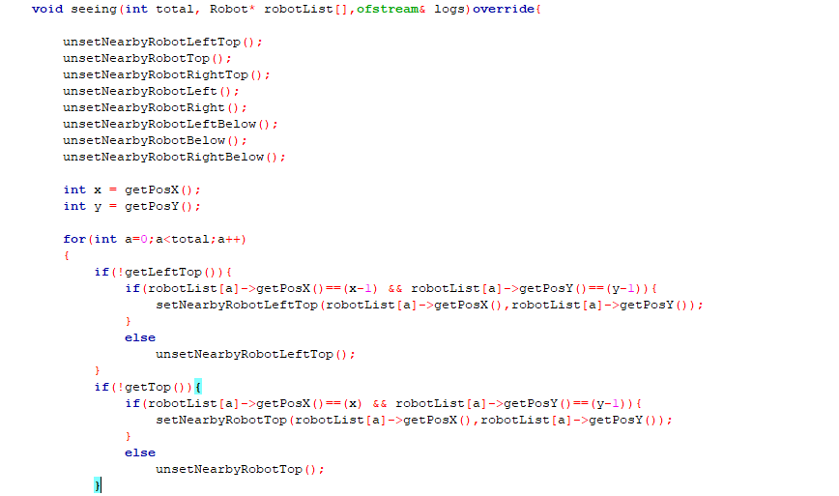

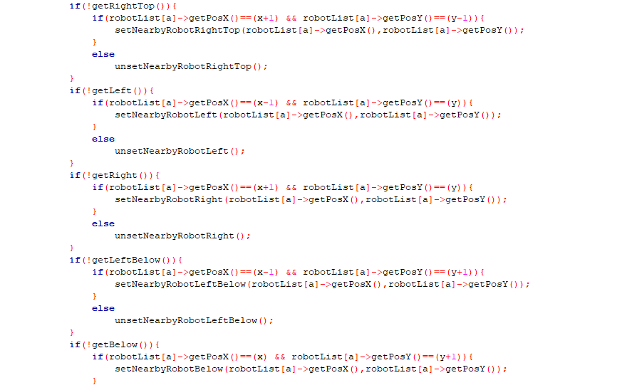

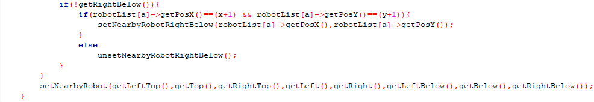

* void seeing: Implements the pure virtual function from SeeingRobot. It checks the positions of all robots in the list and updates the nearby robots’ positions and flags accordingly. It resets all nearby robots’ flags and positions at the start, then sets them based on the robots’ positions relative to the current robot.

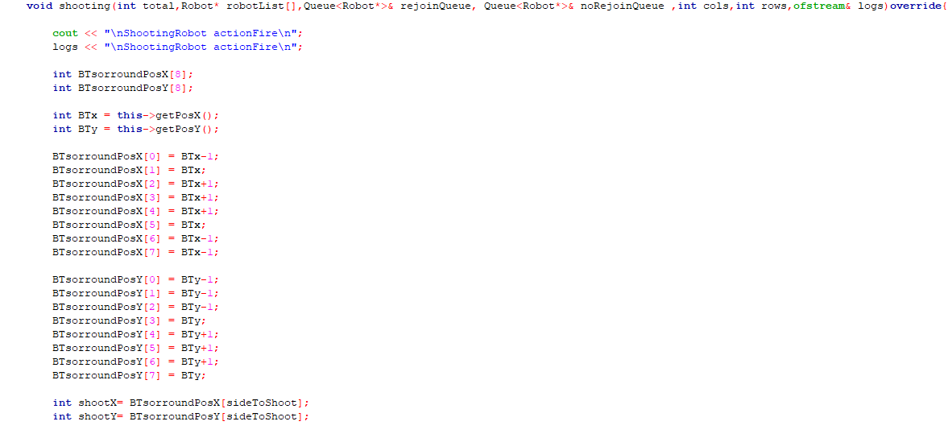

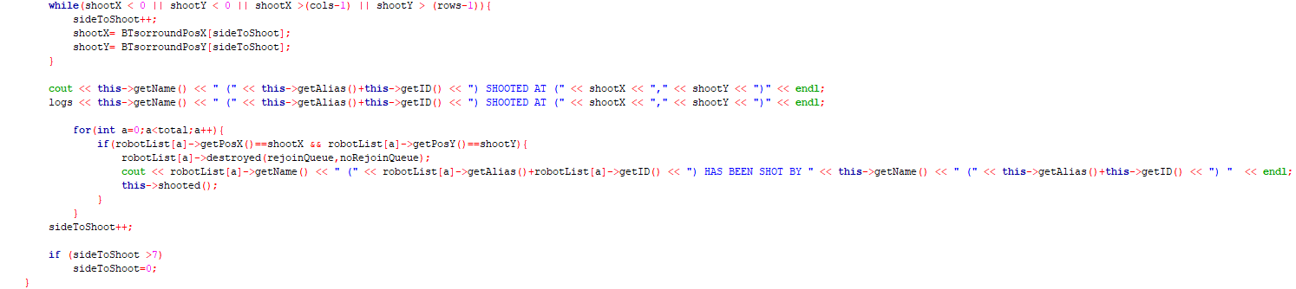

* void shooting: Arrays store the surrounding coordinates of BlueThunder. A while loop was used to make sure the selected position is within boundaries. When a position has been selected, the code will checks within robotList to see if there is any robot in those positions. If a robot is found at the position, it will be destroyed and the kill counts will be incremented by its functions. sideToShoot also will be incremented to prepare for next target and will be reset if it exceeds 7 to ensure it cycled through 8 surrounding positions

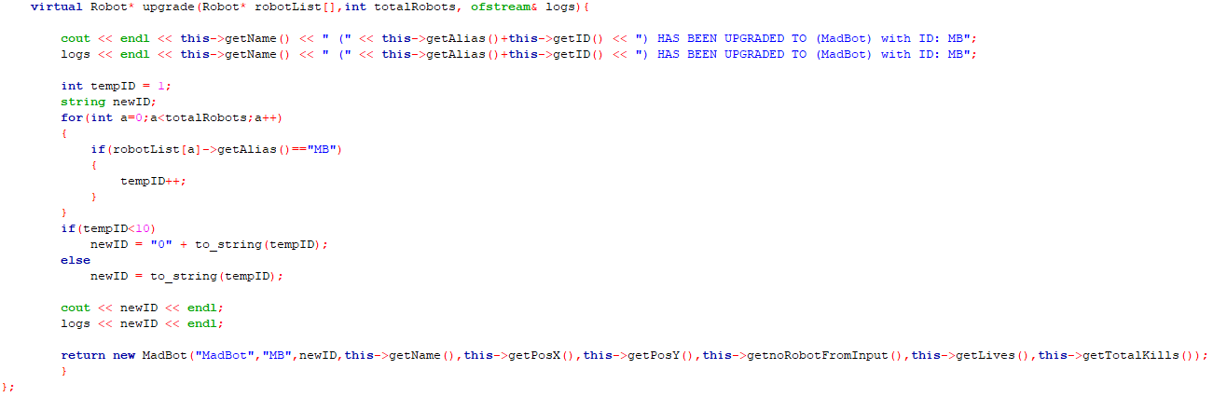

* upgrade method : This method upgrades the BlueThunder to a MadBot. It logs the upgrade action, generates a new ID for the MadBot, and returns a new MadBot object with the updated attributes.

**class Terminator;**

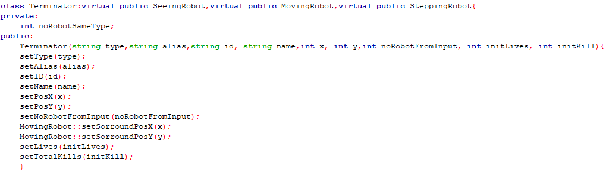

* Terminator inherits from SeeingRobot, MovingRobot and SteppingRobot using virtual inheritance to avoid multiple instances of the ‘Robot’ base class.
* private members:

noRobotSameType: A private member variable to store the number of robots of the same type.

* public members :

initializes the Terminator object with provided values for type, alias, id, name, initial position (x, y), number of robots from input, initial lives, and initial kills and uses inherited setter methods to set these values.

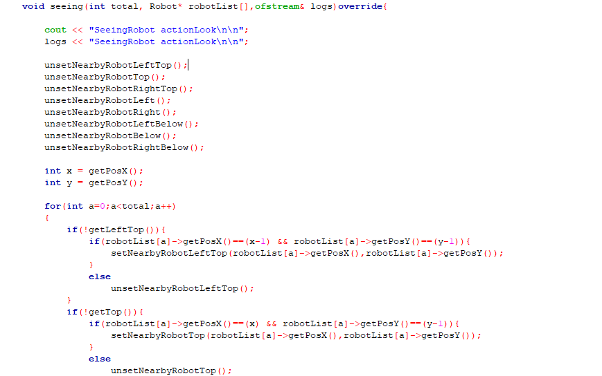

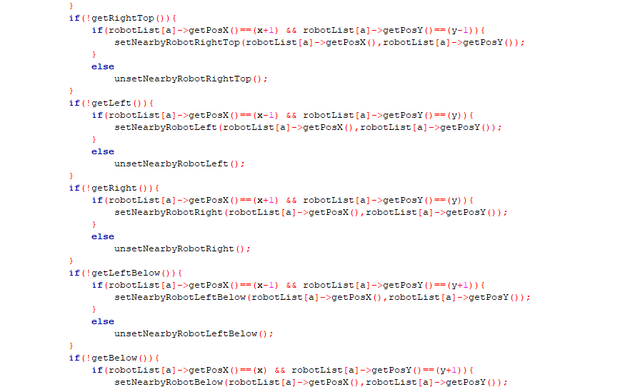

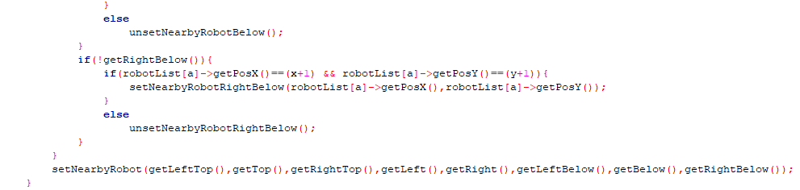

* void seeing: Implements the pure virtual function from SeeingRobot. It checks the positions of all robots in the list and updates the nearby robots’ positions and flags accordingly. It resets all nearby robots’ flags and positions at the start, then sets them based on the robots’ positions relative to the current robot

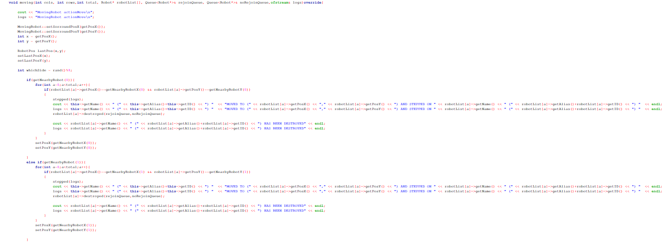

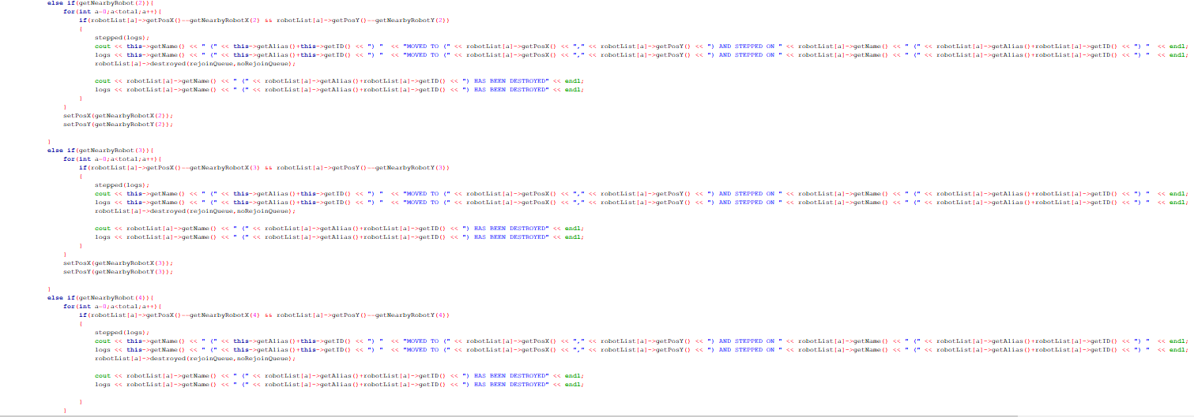

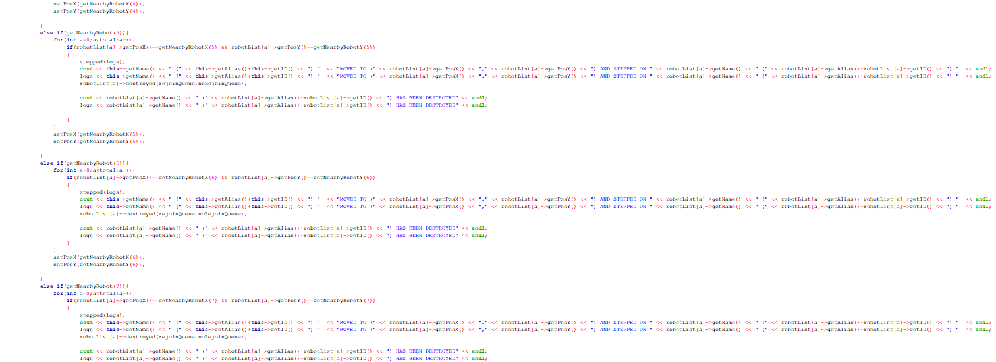

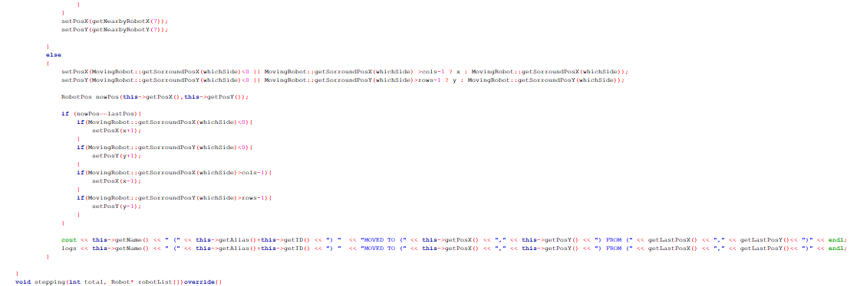

* The moving method enables the Terminator robot to navigate a grid, interact with nearby robots by moving and potentially destroying them by stepping, and handle logging of these actions. It checks each of the 8 possible directions for nearby robots, performs actions if a robot is found, or moves in a random direction while ensuring it remains within the grid boundaries.

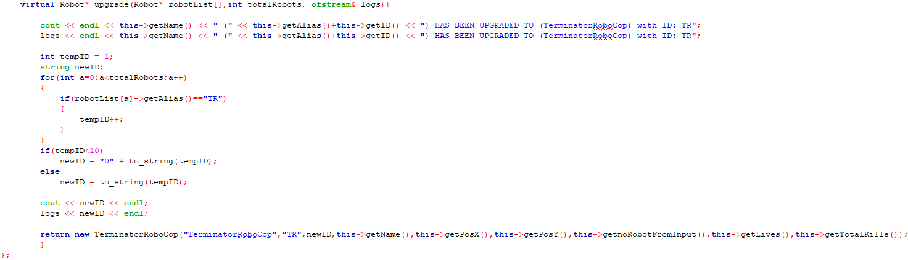

* upgrade method : This method upgrades the Terminator to a TerminatorRobocop. It logs the upgrade action, generates a new ID for the TerminatorRobocop, and returns a new TerminatorRobocop object with the updated attributes.

**class TerminatorRoboCop;**

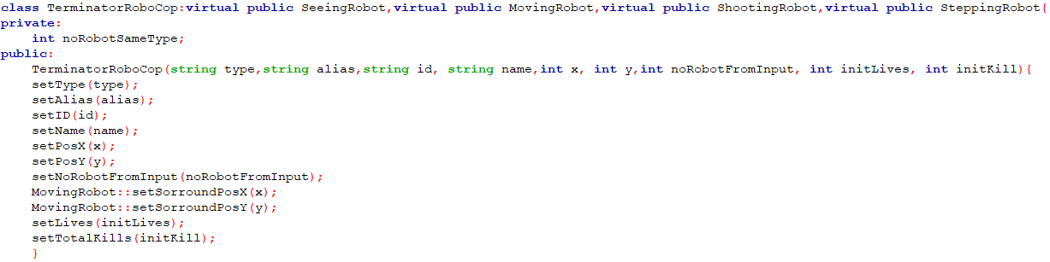

* TerminatorRoboCop inherits from SeeingRobot, MovingRobot, ShootingRobot and SteppingRobot using virtual inheritance to avoid multiple instances of the ‘Robot’ base class.
* private member:

noRobotSameType: A private member variable to store the number of robots of the same type.

* public members:

initializes the TerminatorRobocop object with provided values for type, alias, id, name, initial position (x, y), number of robots from input, initial lives, and initial kills and uses inherited setter methods to set these values.

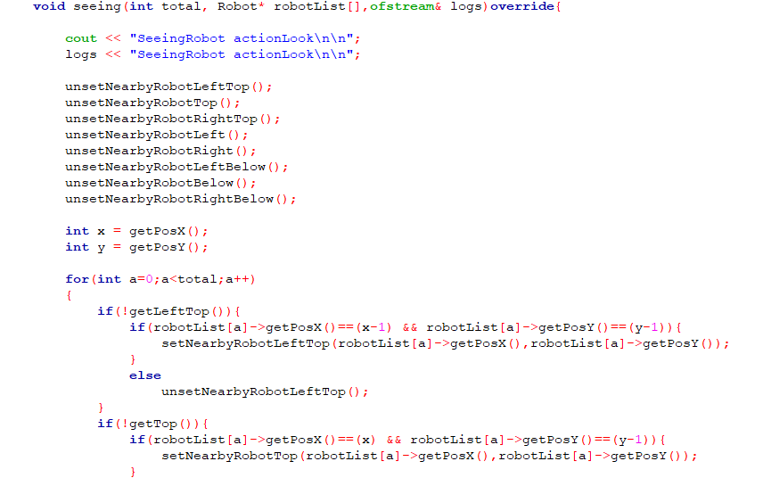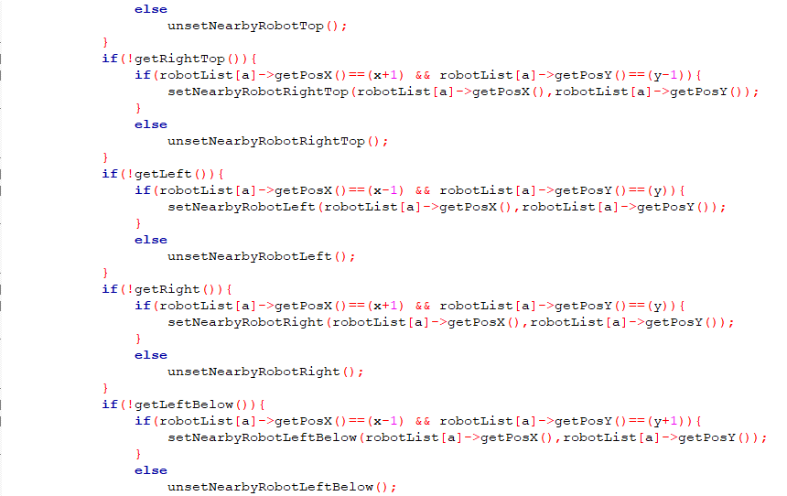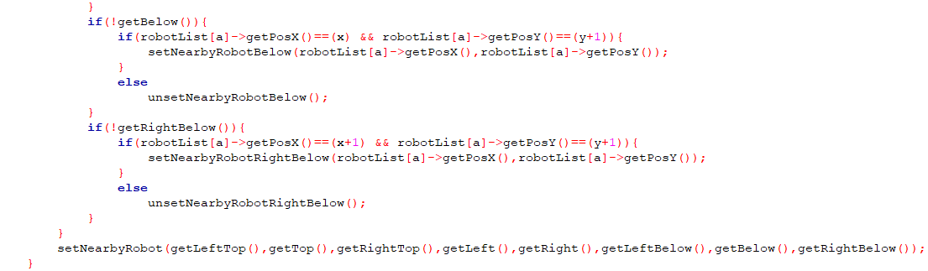

* void seeing: Implements the pure virtual function from SeeingRobot. It checks the positions of all robots in the list and updates the nearby robots’ positions and flags accordingly. It resets all nearby robots’ flags and positions at the start, then sets them based on the robots’ positions relative to the current robot

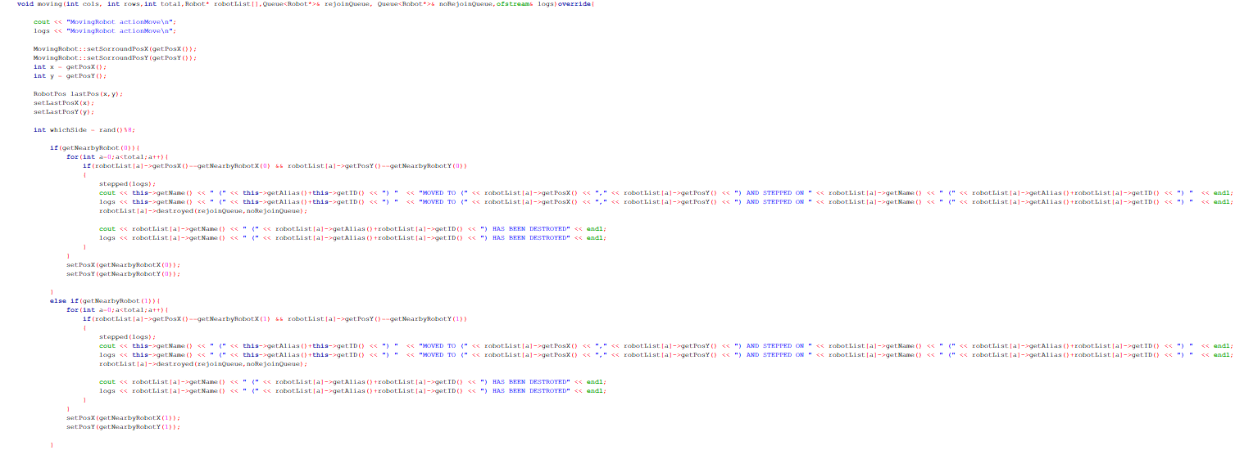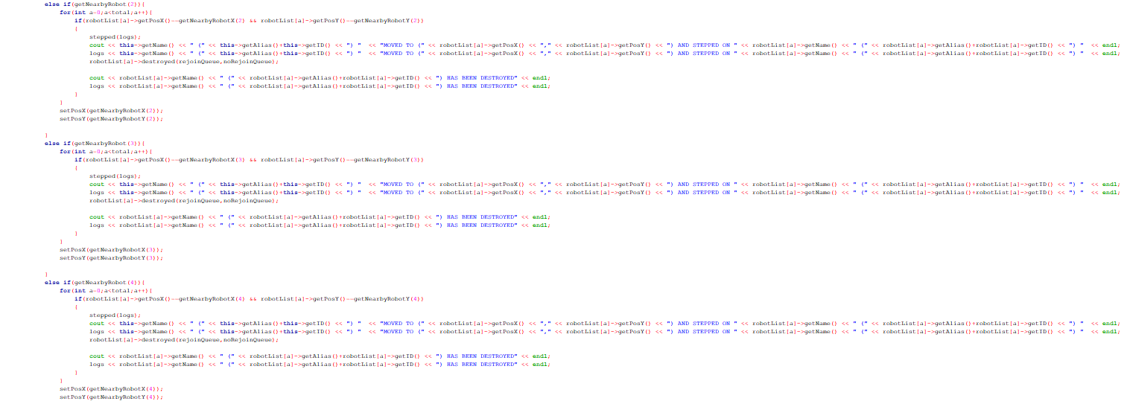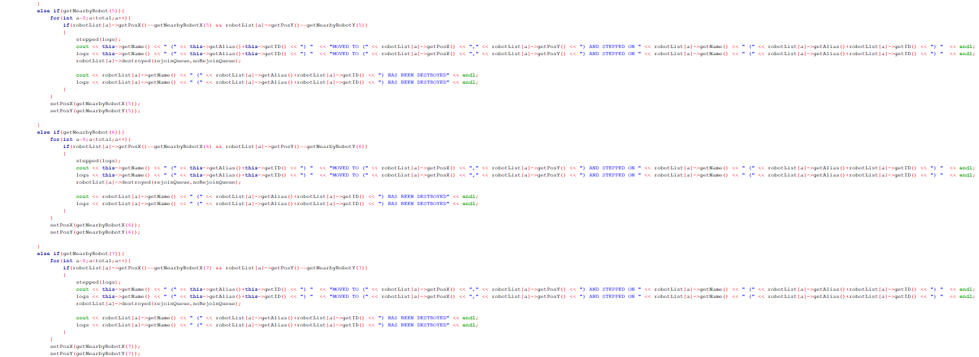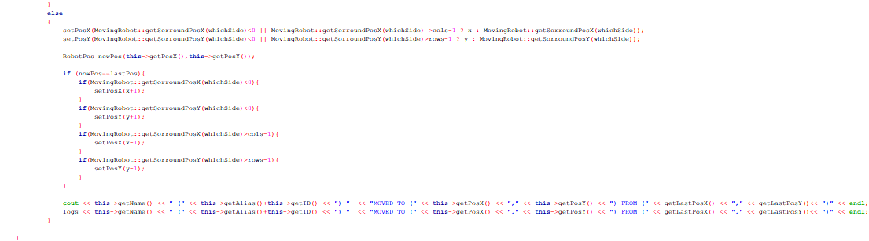

* The moving method enables the Terminator robot to navigate a grid, interact with nearby robots by moving and potentially destroying them by stepping, and handle logging of these actions. It checks each of the 8 possible directions for nearby robots, performs actions if a robot is found, or moves in a random direction while ensuring it remains within the grid boundaries.

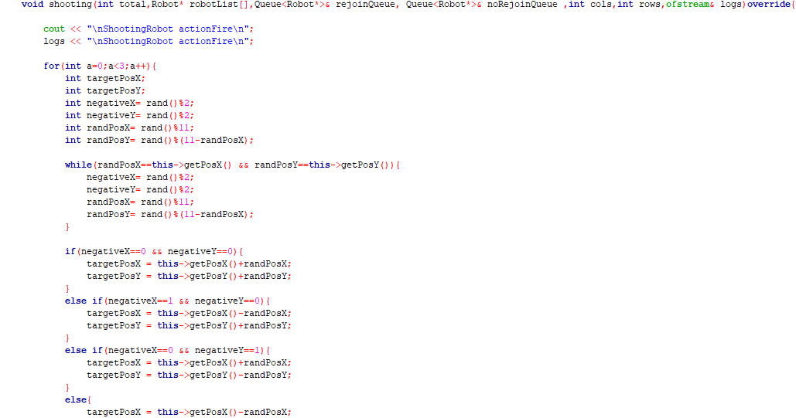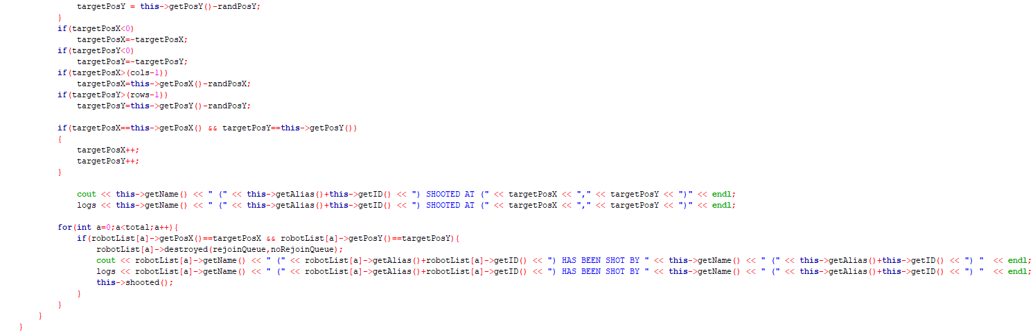

* void shooting: TerminatorRobocop will execute 3 shooting attempts. It will generate a random target position for each shot, ensuring it is not the current position of the robot and ensure that it is not out of boundaries. This program will output a message if TerminatorRobocop successfully shoots and destroys another robot.

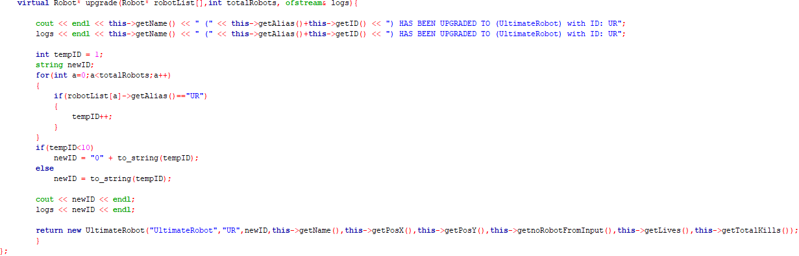

* upgrade method : This method upgrades the TerminatorRobocop to a UltimateRobot. It logs the upgrade action, generates a new ID for the UltimateRobot, and returns a new UltimateRobot object with the updated attributes.

**class RoboCop;**

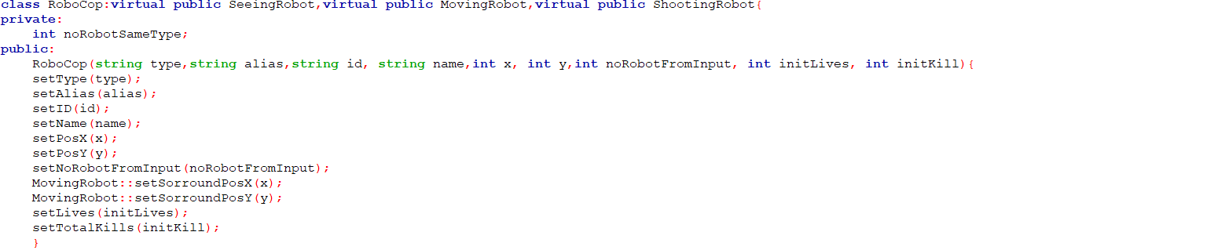

-RoboCop class inherits the SeeingRobot, MovingRobot, and ShootingRobot classes

Private members:

-declare noRobotSameType

Public members:

-These functions initialize various attributes of the RoboCop object, such as type, alias, ID, name, position, number of robots of the same type, surrounding position, lives, and total kills.

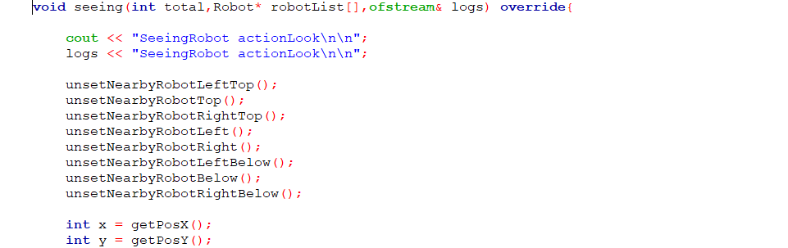

-The seeing method in the RoboCop class, which overrides a virtual function from the SeeingRobot class

-Print and log the message "SeeingRobot actionLook" to both the console and a log file.

-These method calls reset the status of nearby robots in all eight directions around the current robot. This ensures the robot has a fresh view of its surroundings before performing further actions.

-These lines retrieve the current x and y positions of the robot.

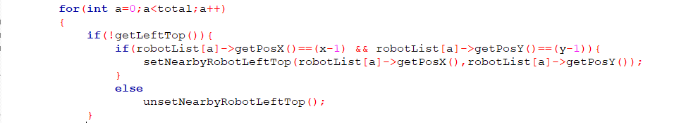

-Checks the conditions for each robot relative to the current robot's position (x, y).

-If the robot at index a matches the position directly to the top-left of the current robot, it sets this robot as nearby in the top-left direction.

-If no robot matches this position, it clears the nearby robot status.

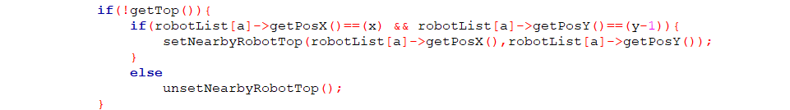

-Checks if there is no robot detected in the top direction relative to the current robot.

-If true, it then checks if there exists a robot positioned directly above, it sets it as nearby in the top direction.

-If no matching robot is found, it clears the nearby robot status.

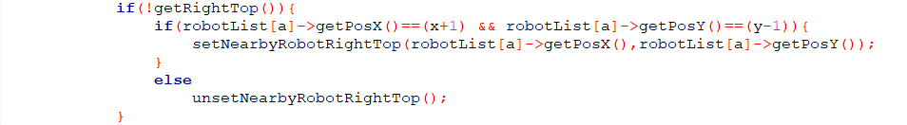

-Checks if there is no robot detected in the top-right direction relative to the current robot.

-If true, it then verifies if there exists a robot positioned diagonally to the top-right, it sets it as nearby in the top-right direction.

-If no matching robot is found, it clears the nearby robot status.

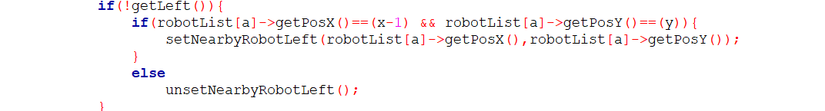

-Checks if there is no robot detected on the left side of the current robot.

-If true, it then checks if there exists a robot positioned directly to the left, it sets it as nearby to the left.

-If no matching robot is found, it clears the nearby robot status.

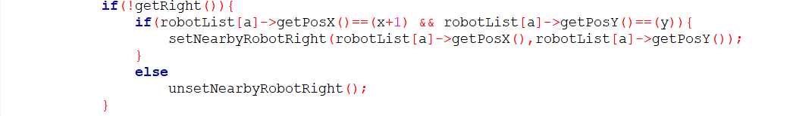

-Checks if there is no robot detected on the right side of the current robot.

If true, it then verifies if there exists a robot positioned directly to the right, it sets it as nearby to the right.

If no matching robot is found, it clears the nearby robot status.

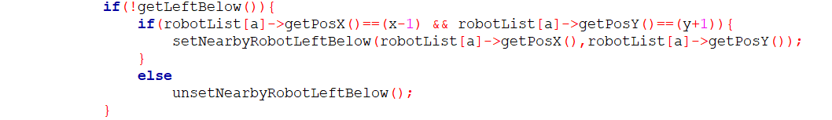

-Checks if there is no robot detected on the left below the current robot.

-If true, it then verifies if there exists a robot positioned directly to the left below, it sets it as nearby to the left below.

-If no matching robot is found, it clears the nearby robot status.

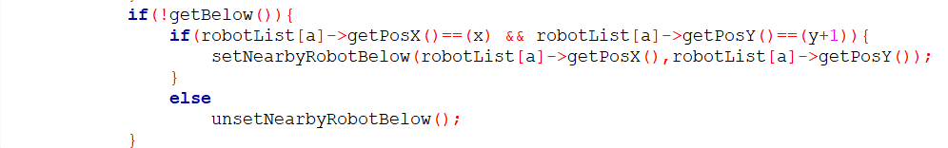

-Checks if there is no robot detected directly below the current robot.

-If true, it then checks if there exists a robot positioned directly below, it sets it as nearby below.

-If no matching robot is found, it clears the nearby robot status.

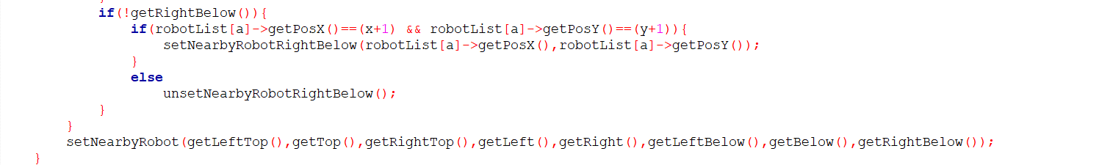

-Checks if there is no robot detected directly below the current robot.

-If there exists a robot positioned directly below, it sets it as a nearby robot below using setNearbyRobotBelow.

-If no matching robot is found, it clears the nearby robot below status using unsetNearbyRobotBelow().

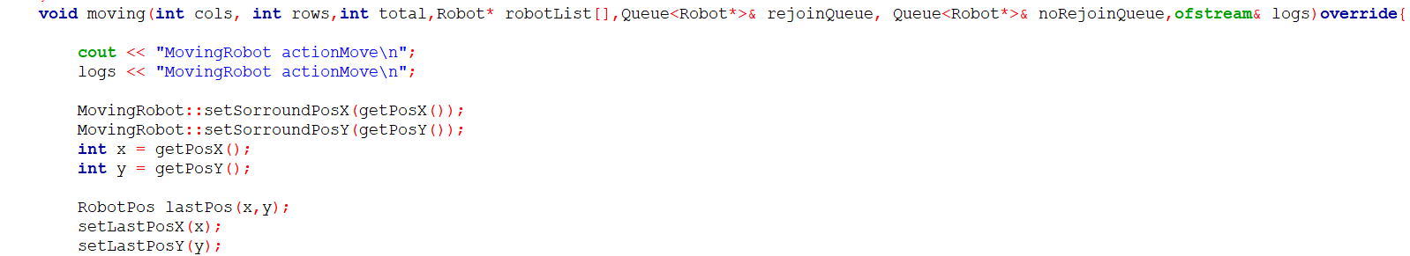

-This method moving in the RoboCop class handles the movement action for a RoboCop robot

-Prints a message indicating that the robot is performing a movement action both to the console and to the log file.

-Updates the surrounding position for movement using MovingRobot::setSorroundPosX and MovingRobot::setSorroundPosY.

-Retrieves the current position of the robot and stores it as the last known position.

-Sets the last known X and Y positions using setLastPosX and setLastPosY.

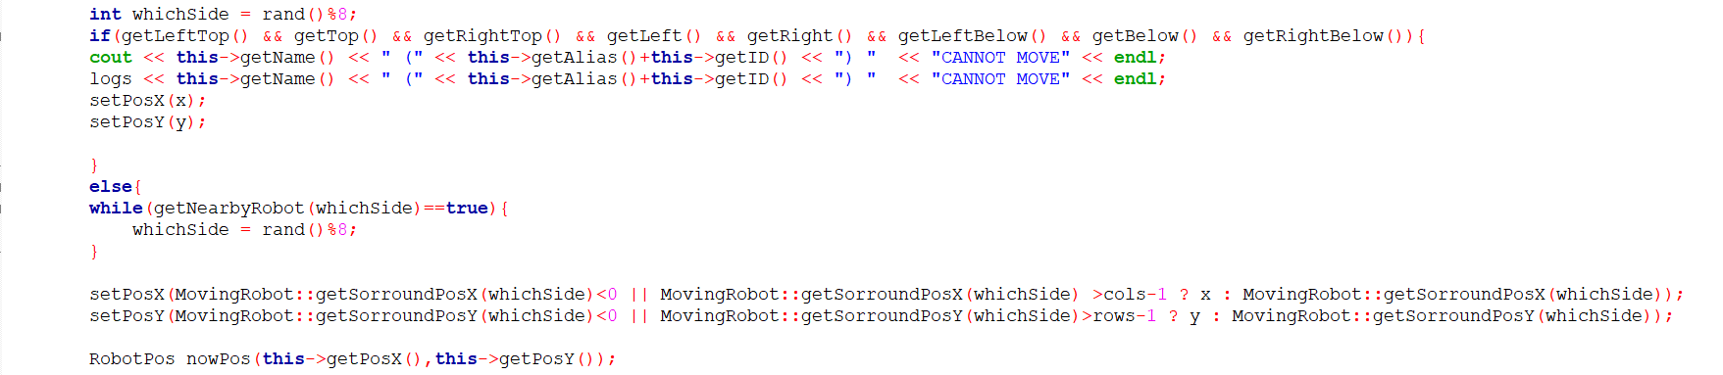

-This segment of code within the moving method determines the movement behavior for the RoboCop robot:

-Generates a random number whichSide between 0 and 7 to decide the direction of movement.

-If all surrounding positions are occupied by other robots, it prints a message indicating that the robot cannot move, resets its position to the current position, and logs this action.

-Else, it continues to generate a random direction until it finds an unoccupied direction.

-Then updates the robot's position based on the surroundings. If the new position would be out of bounds, it maintains the current position.

-Lastly, it records the current position in nowPos using RobotPos.

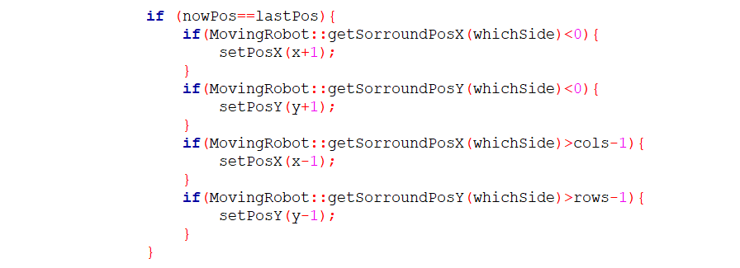

-If MovingRobot::getSorroundPosX(whichSide) < 0, it increments the X position to attempt movement to the right.

-If MovingRobot::getSorroundPosY(whichSide) < 0, it increments the Y position to attempt movement downwards.

-If MovingRobot::getSorroundPosX(whichSide) > cols-1, it decrements the X position to attempt movement to the left.

-If MovingRobot::getSorroundPosY(whichSide) > rows-1, it decrements the Y position to attempt movement upwards.



-This line prints to the standard output the name, alias with ID, current position and the last position.

-This line writes the same movement information to an output log file.

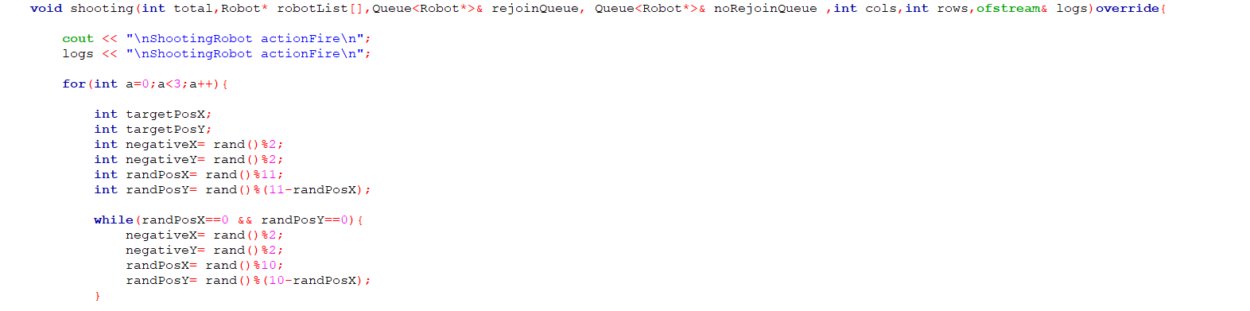

-robot is executing its shooting action.

-prints a message indicating that the robot is performing its shooting action to the console.

-writes the same message to an output log file (logs).

-set up variables to store target coordinates and determine random directions for shooting. -Random offsets within specified ranges are also generated for target.

-The loop ensures that the random position coordinates are not both zero, which would mean shooting at the same position.

-This code snippet provides the initial setup for the shooting action, including random target position generation and ensuring that the action is logged for tracking purposes.

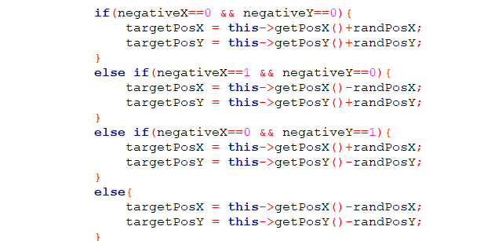

-if both negativeX and negativeY are zero, indicating positive offsets in both x and y directions from the current robot position .

-If negativeX is one and negativeY is zero .

-If negativeX is zero and negativeY is one.

-If both negativeX and negativeY are one, indicating negative offsets in both x and y directions from the current robot position

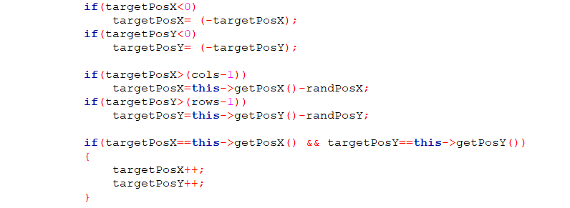

-if targetPosX is negative, adjust it to its absolute value.

-if targetPosY is negative, adjust it to its absolute value.

-if targetPosX exceeds the maximum column index (cols - 1) and adjusts it based on the current robot position and randPosX.

-if targetPosY exceeds the maximum row index (rows - 1) and adjusts it based on the current robot position and randPosY.

-if targetPosX and targetPosY are equal to the current robot's position, increments both targetPosX and targetPosY by one.

.

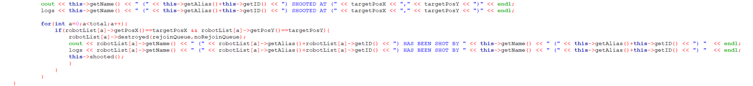

-Print and log a message indicating that the current robot has shot at coordinates.

-for loop: Iterates through the robotList to find any robot located at.

-if a robot is found at (targetPosX, targetPosY), calls the destroyed method on the found robot, passing rejoinQueue and noRejoinQueue.

-Prints and logs a message indicating that the found robot has been shot by the current robot.

-Calls the shooted method on the current robot.

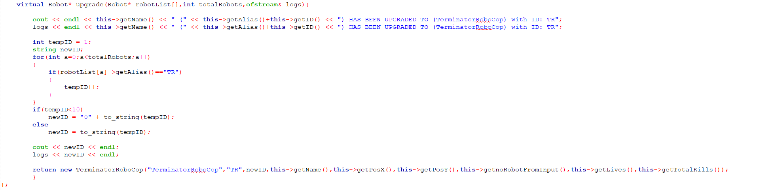

-This upgrade method in the RoboCop class handles the process of upgrading a robot to a TerminatorRoboCop:

-Print and logs a message indicating that the current robot has been upgraded to a TerminatorRoboCop with a new ID.

-Calculates a new ID for the TerminatorRoboCop based on the number of existing robots with the alias "TR".

-If true (tempID < 10), it creates a new ID string newID by concatenating "0" with the string representation of tempID.

-If false (tempID >= 10), it simply converts tempID to a string.

-Prints and logs the generated newID.

-Returns a new instance of TerminatorRoboCop, initializing it with the upgraded attributes including type, alias, new ID, name, position, initial robot count, lives, and total kills.

Sample 1 input file

filename: fileInput2a.txt

/////

M by N: 10 15

turns: 120

robots: 30

RoboCop RC01_Askar1 0 0

RoboCop RC02_Askar2 1 12

RoboCop RC03_Askar3 2 4

Terminator T01_Kuda1 3 8

Terminator T02_Kuda2 4 5

Terminator T03_Kuda3 5 10

TerminatorRoboCop TR01_Serigala1 6 1

TerminatorRoboCop TR02_Serigala2 7 14

TerminatorRoboCop TR03_Serigala3 8 7

BlueThunder BT01_Doktor1 9 11

BlueThunder BT02_Doktor2 0 9

BlueThunder BT03_Doktor3 1 2

MadBot MB01_Bangsawan1 2 13

MadBot MB02_Bangsawan2 3 3

MadBot MB03_Bangsawan3 4 12

RoboTank RT01_Harimau1 5 0

RoboTank RT02_Harimau2 6 6

RoboTank RT03_Harimau3 7 5

UltimateRobot UR01_Gorila1 8 9

UltimateRobot UR02_Gorila2 9 3

UltimateRobot UR03_Gorila3 0 14

KiloBot KB01_Dubuk1 1 1

KiloBot KB02_Dubuk2 2 10

KiloBot KB03_Dubuk3 3 6

MegaBot MT01_Helang1 4 0

MegaBot MT02_Helang2 5 13

MegaBot MT03_Helang3 6 2

GigaBot GB01_Singa1 7 8

GigaBot GB02_Singa2 8 4

GigaBot GB03_Singa3 9 7

/////

Sample 1 output file  
filename:fileOutput2a.txt

/////

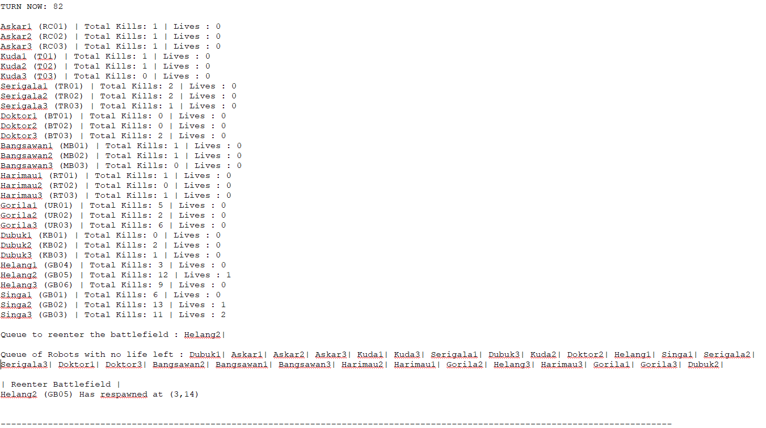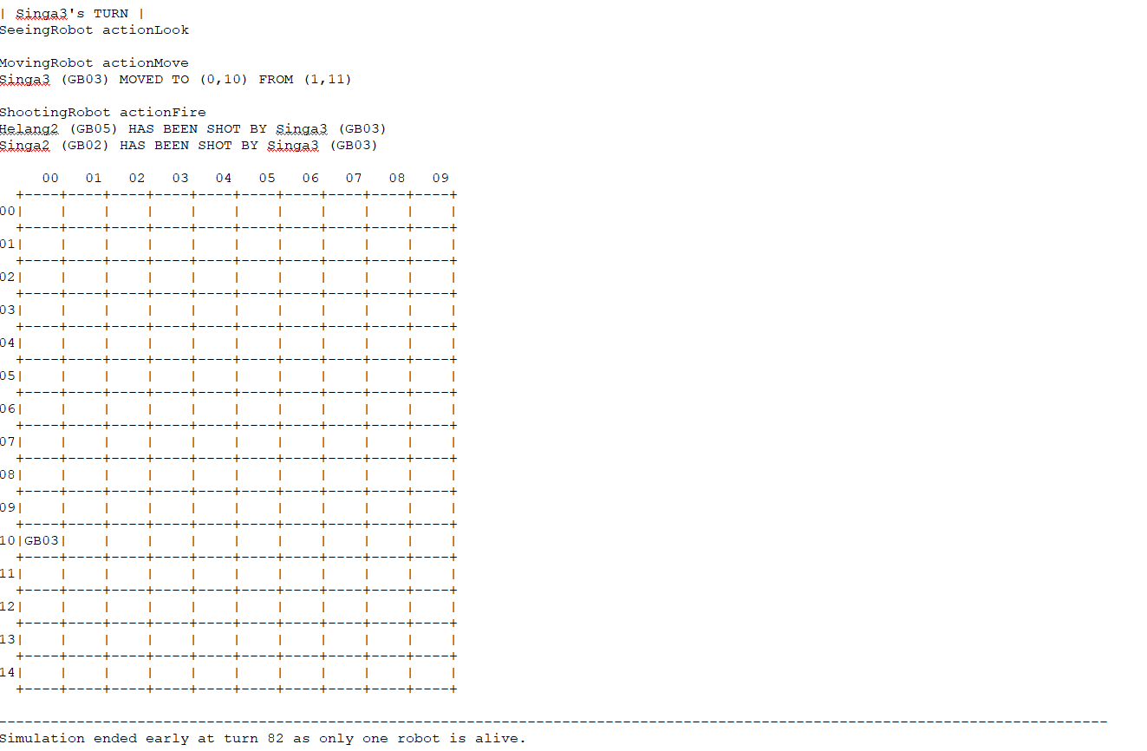

/////

Sample 2 input file

filename: fileInput2b.txt

/////

M by N: 10 15

turns: 80

robots: 30

RoboCop RC01_Askar1 0 0

RoboCop RC02_Askar2 1 12

RoboCop RC03_Askar3 2 4

Terminator T01_Kuda1 3 8

Terminator T02_Kuda2 4 5

Terminator T03_Kuda3 5 10

TerminatorRoboCop TR01_Serigala1 6 1

TerminatorRoboCop TR02_Serigala2 7 14

TerminatorRoboCop TR03_Serigala3 8 7

BlueThunder BT01_Doktor1 9 11

BlueThunder BT02_Doktor2 0 9

BlueThunder BT03_Doktor3 1 2

MadBot MB01_Bangsawan1 2 13

MadBot MB02_Bangsawan2 3 3

MadBot MB03_Bangsawan3 4 12

RoboTank RT01_Harimau1 5 0

RoboTank RT02_Harimau2 6 6

RoboTank RT03_Harimau3 7 5

UltimateRobot UR01_Gorila1 8 9

UltimateRobot UR02_Gorila2 9 3

UltimateRobot UR03_Gorila3 0 14

KiloBot KB01_Dubuk1 1 1

KiloBot KB02_Dubuk2 2 10

KiloBot KB03_Dubuk3 3 6

MegaBot MT01_Helang1 4 0

MegaBot MT02_Helang2 5 13

MegaBot MT03_Helang3 6 2

GigaBot GB01_Singa1 7 8

GigaBot GB02_Singa2 8 4

GigaBot GB03_Singa3 9 7

/////

Sample 2 output file  
filename: fileOutput2b.txt

/////

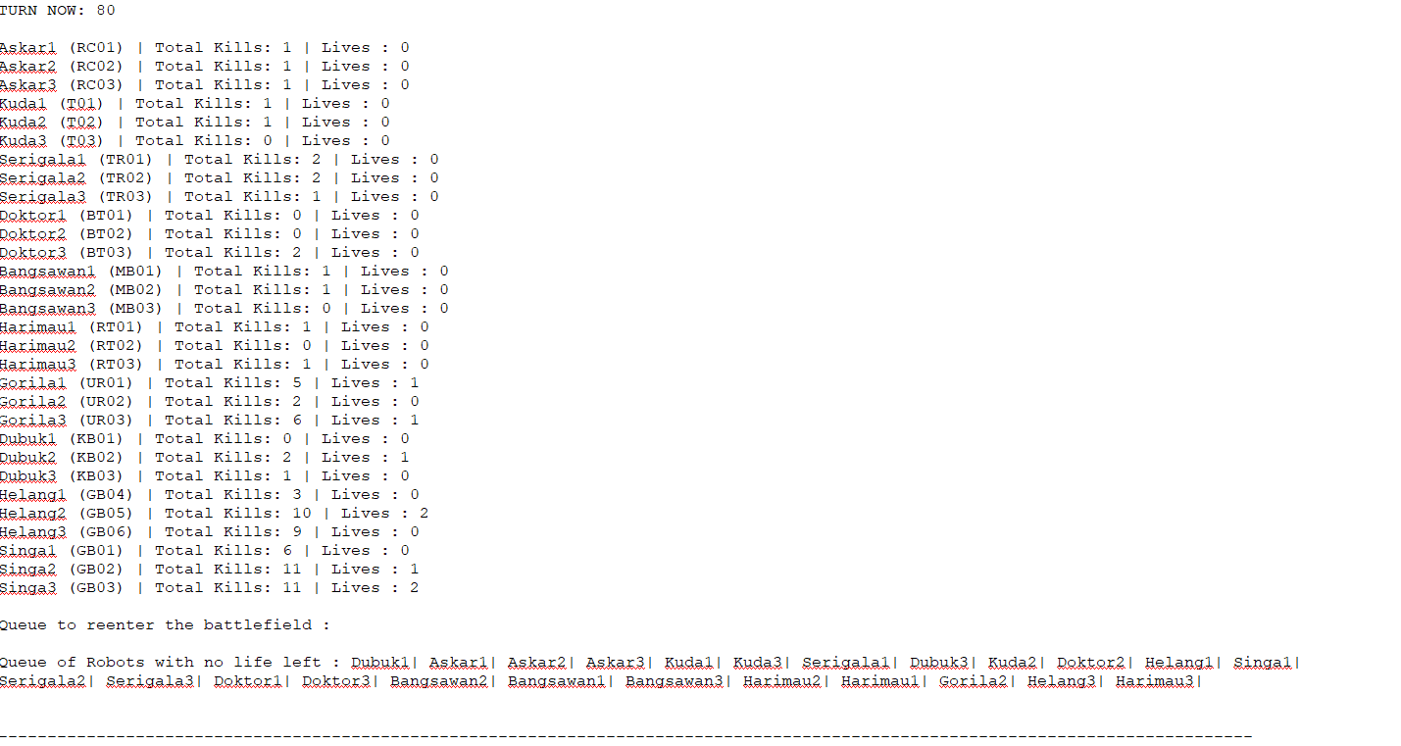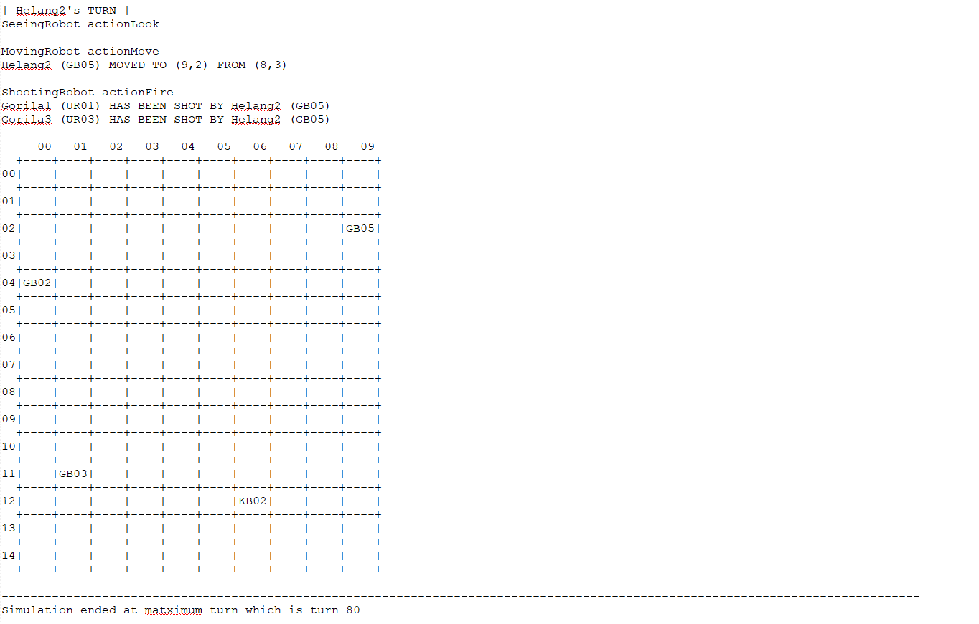

/////

## 

# Q2. [1] Initialization of a simulation, read input file and output initial of all robots, fixed seed integer for random functions





* **Firstly, the program will open and read the fileInput2a.txt file to get the command. The program also operates on fileOutput2a.txt to print out and store the simulation output.**

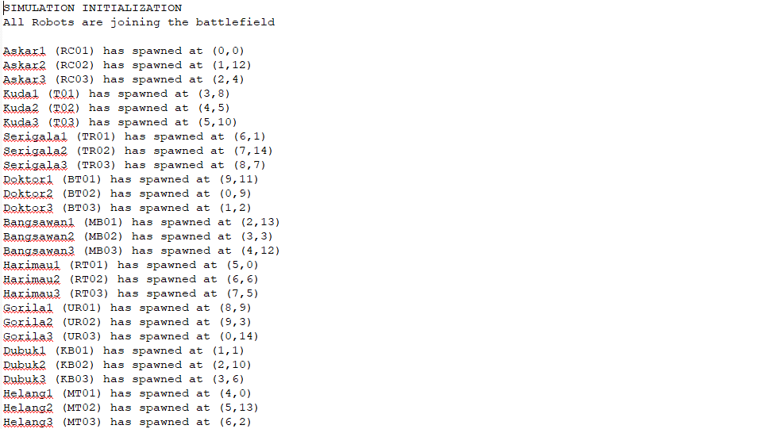



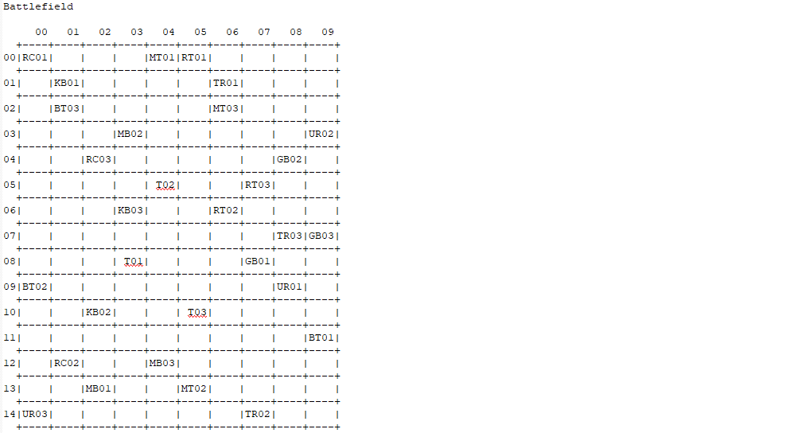

* **Before the first turn, all robots will be spawned based on the position in the input file.**

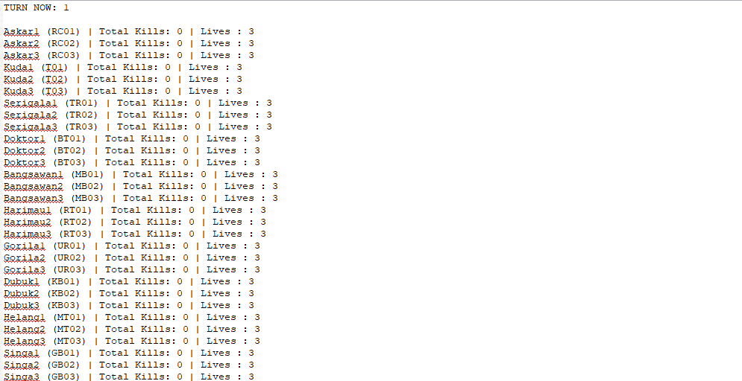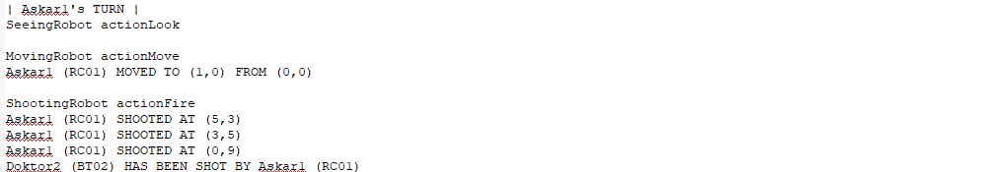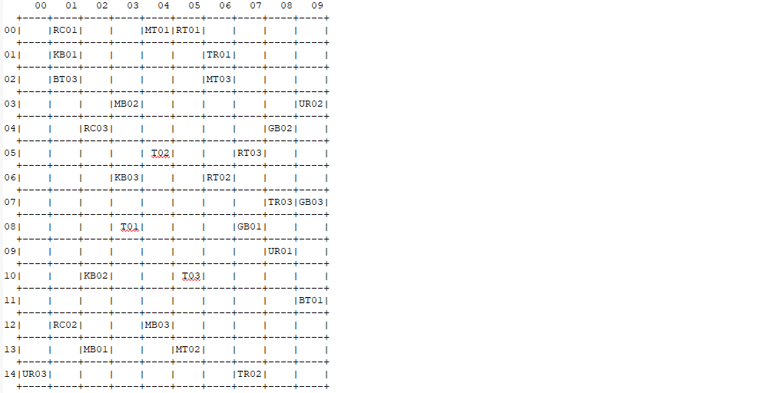

* **RoboCop Askar1 will take the first action based on the input file command and the program will print the current status of the battlefield**

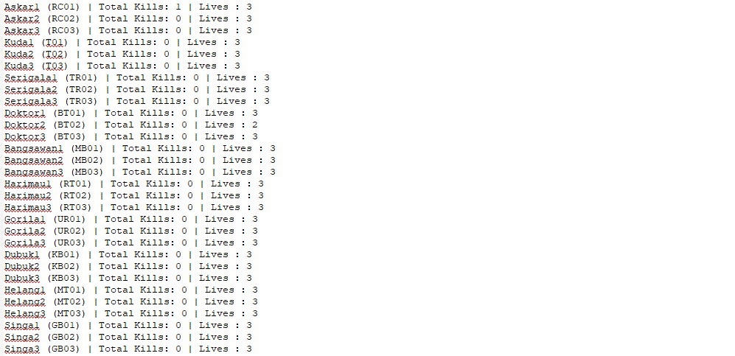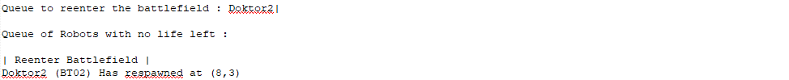

* **This is the current status of all robots after Turn 1. Since Doktor2 is the only robot in queue to re-enter the battlefield, it will be respawned immediately.**

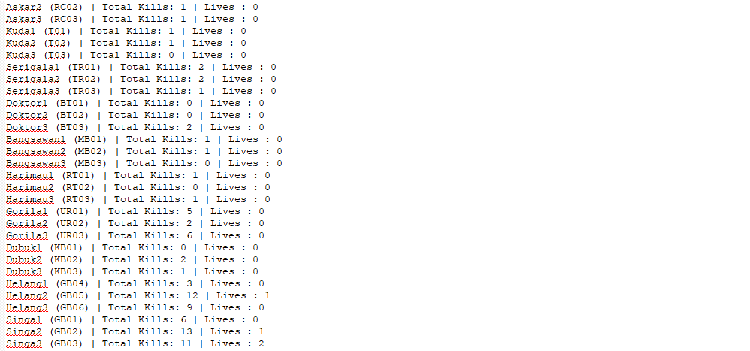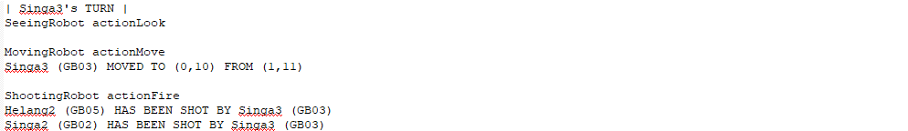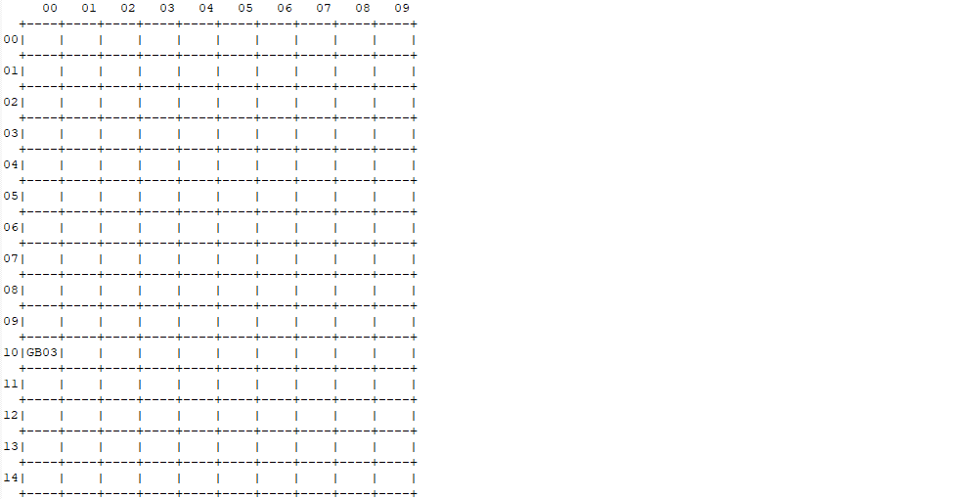

* **This is the state of the battlefield after Turn 82. The simulation ended since there is only one robot alive. The simulation output will be stored in the fileOutput2a.txt file.**

# Q3. [3] Display and logging of the status of the battlefield of robots at each turn

# Q4. [3] Display and logging of the robot actions and the status of each robot at each turn

**a. RoboCop**: In each turn, this robot looks at its current position and decides on a move to one of its 8 neighboring locations. RoboCop cannot move to a location that contains another robot. It moves to one random location.

In the same turn, this robot fires (three times) at random positions in the battlefield.

This sequence is repeated for each turn. The maximum city block distance of firing should be set to 10 (i.e. for any fire (robotPositionX + x, robotPositionY + y), (x + y) is at most 10 at least 1).

If RoboCop fires a total of 3 robots, then it will be upgraded to be allowed to move to a location that contains another robot, thus stepping and killing that robot. This type of robot is called TerminatorRoboCop (see below).

MOVING

**BEFORE**

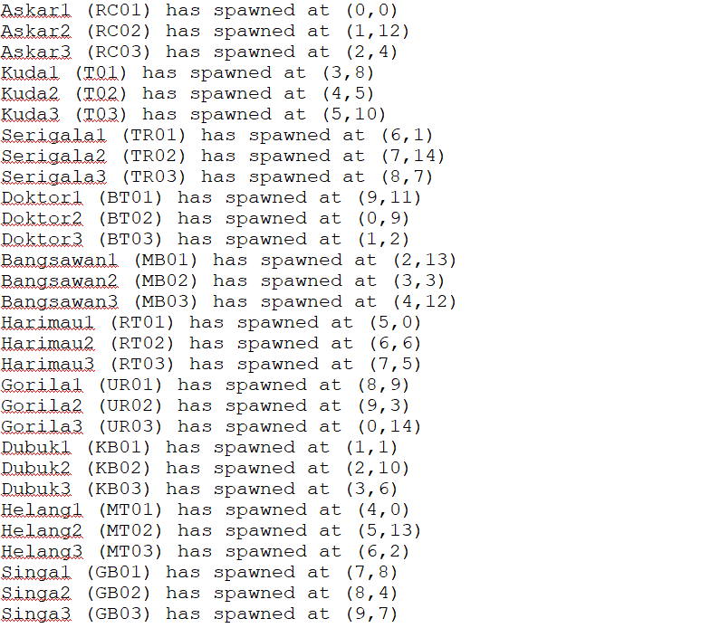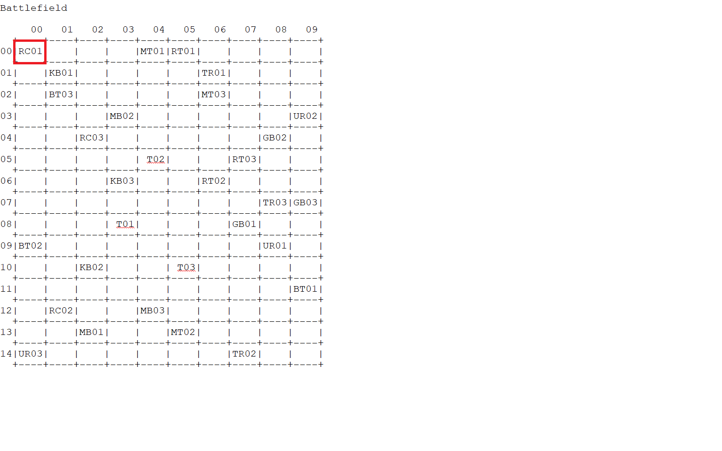

**AFTER**

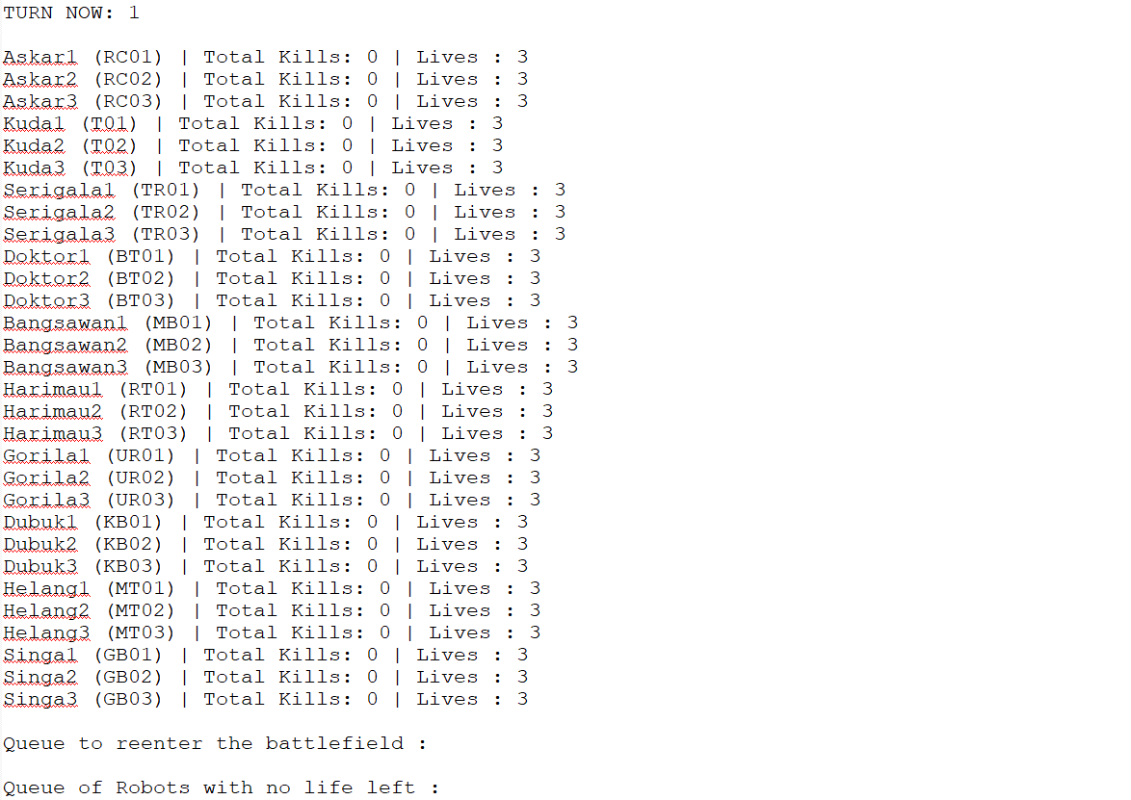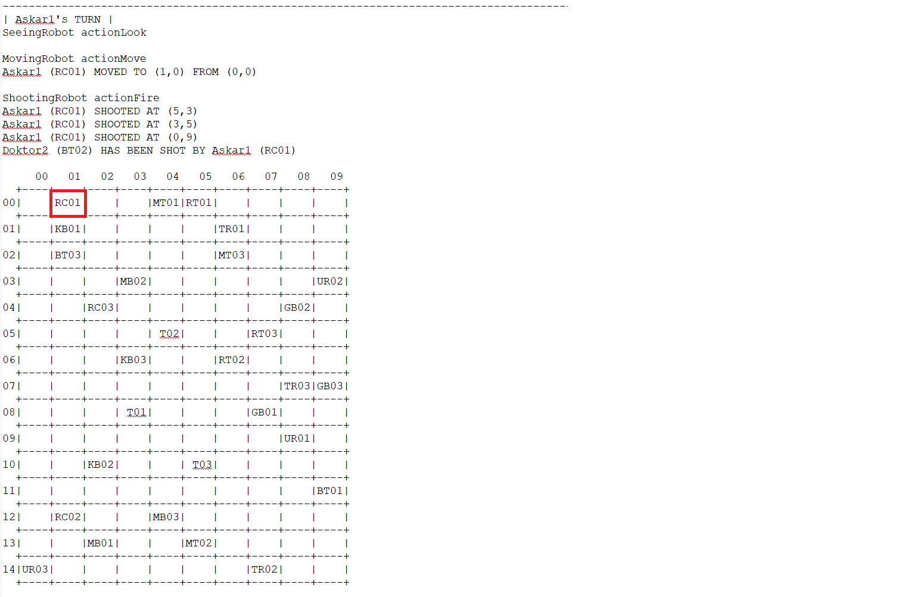

Askar1 (RC01) is at (0,0), this robot looks at its current position and decides on a move to one of its 8 neighboring locations. Thus, it MOVED TO (1,0) which is from his 8 neighborhoods.

SHOOTING

**BEFORE**

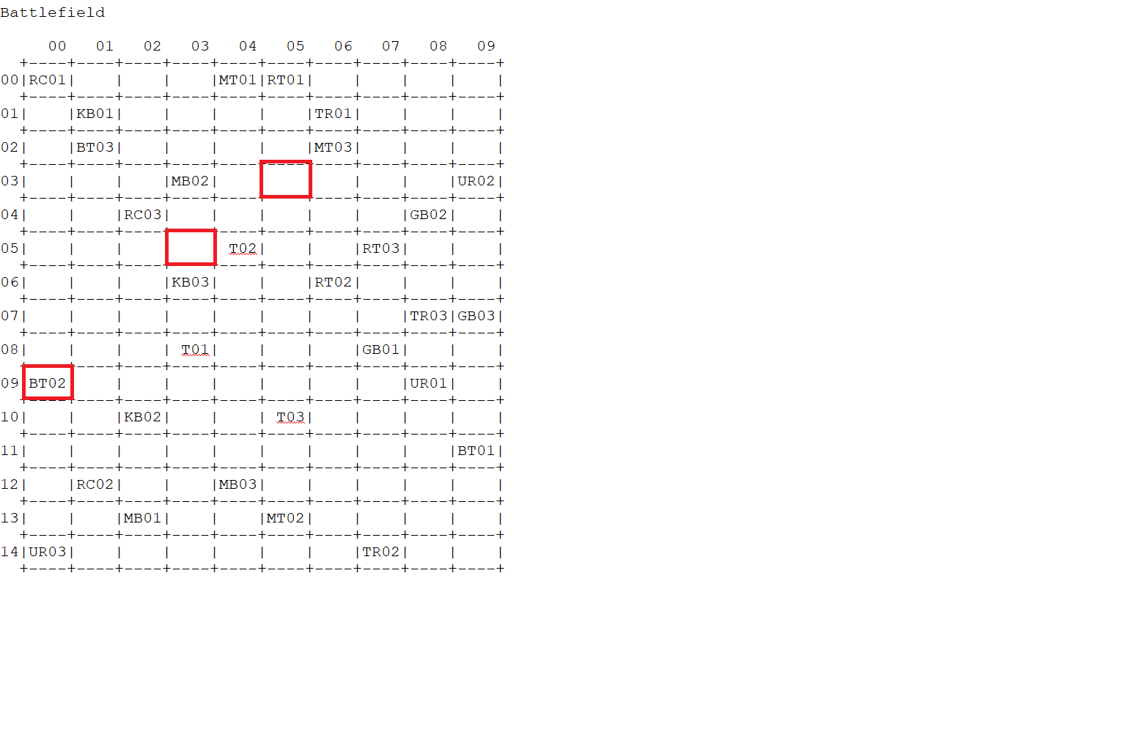

**AFTER**

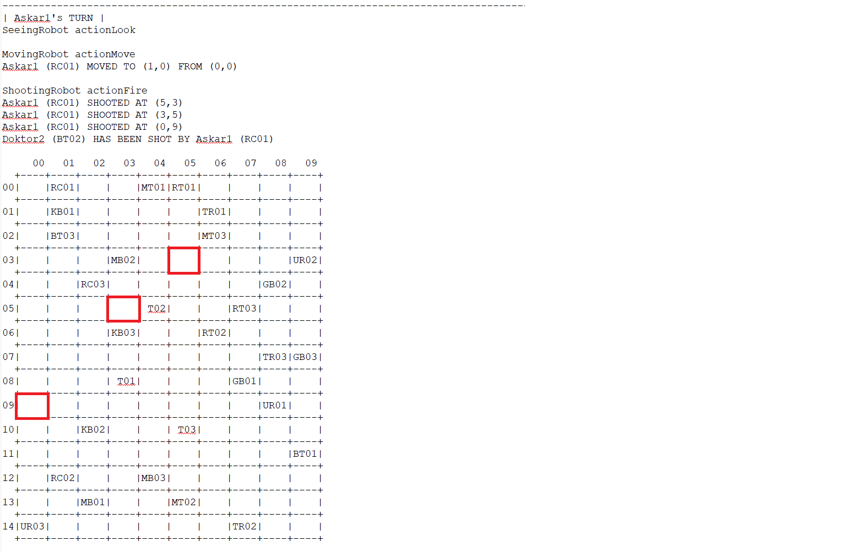

Askar1 (RC01) is at (0,0), this robot fires (three times) at random positions in the battlefield.

This robot fire the robot at position (5,3), (3,5), (0,9) and it shot a robot BT02 at position (0,9).

**b. Terminator**: In each turn, this robot looks at the immediate 8 neighborhoods (3x3 window centered at the robot position) and performs a move to one of the 8 neighbors. Thus, a Terminator will not fire at all and will terminate robots in its path. It will prefer locations which contain enemy robots. If the Terminator kills a total of 3 other robots, then the Terminator will be upgraded to be allowed to fire in a similar way to a RoboCop fire, this type of robot will now become a TerminatorRoboCop as well.

**BEFORE**

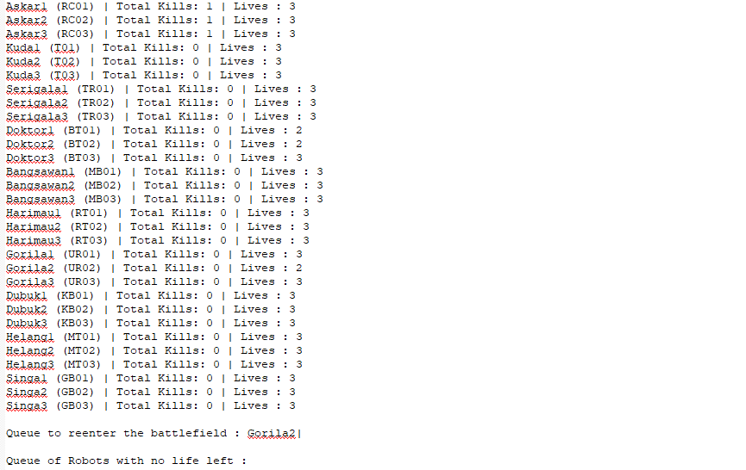

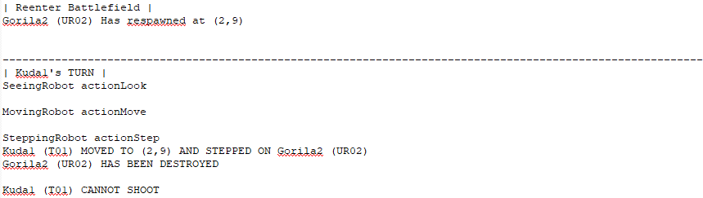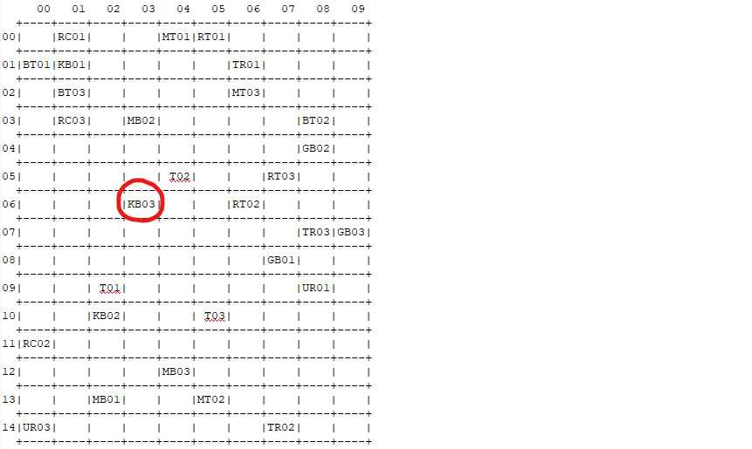

**AFTER**

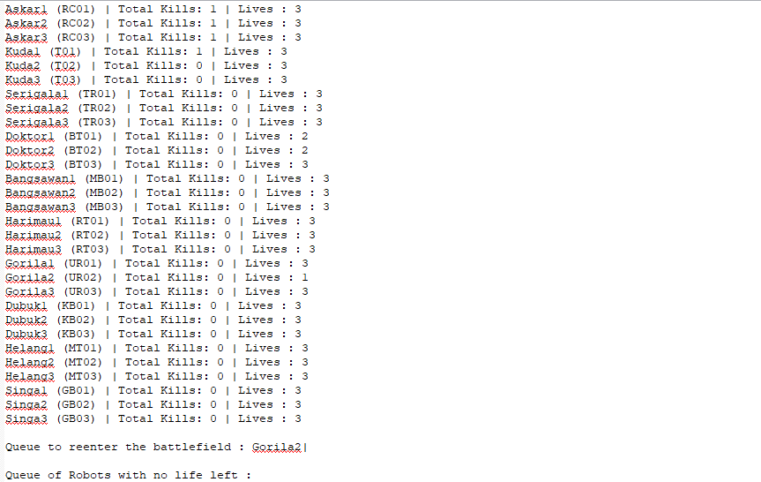

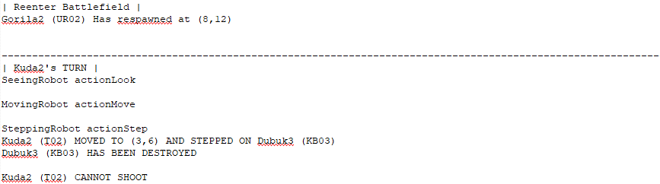

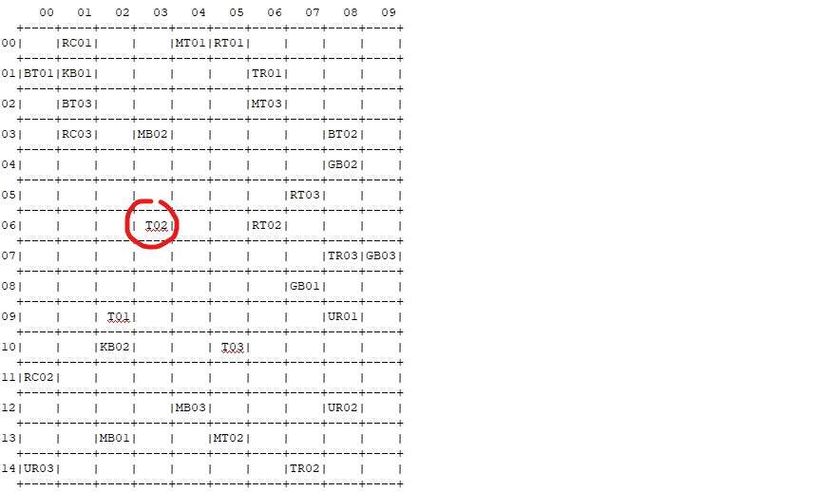

Previously, Kuda2(K02) was at (4,5). Kuda2 cannot shoot because there is no virtual function public moving in Terminator class so the program mentioned CANNOT SHOOT in the simulation, then it moves and steps on KB03 at (3,6) and destroys it.

**c. TerminatorRoboCop**: This is either an upgraded RoboCop or an upgraded Terminator, it means it is a robot that can fire like RoboCop, and step on other robots like Terminator.

If the TerminatorRoboCop kills 3 other robots, it will be upgraded to UltimateRobot (see below).

**BEFORE**

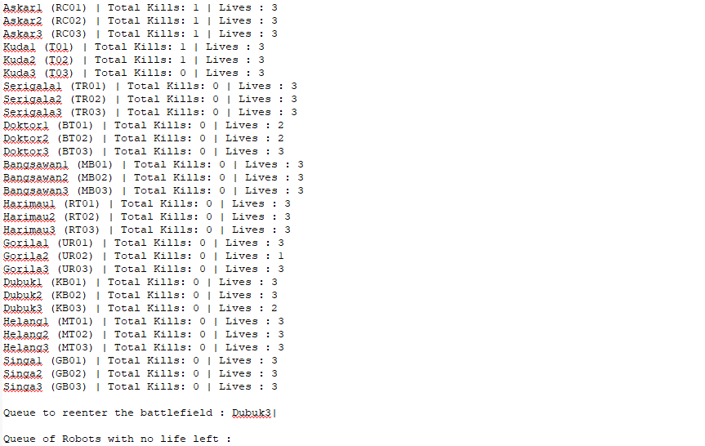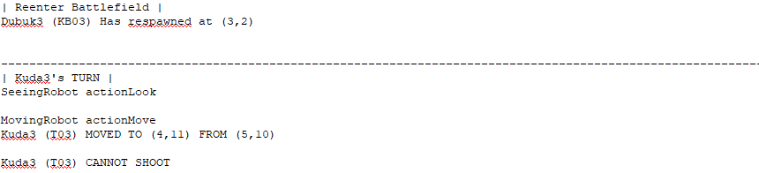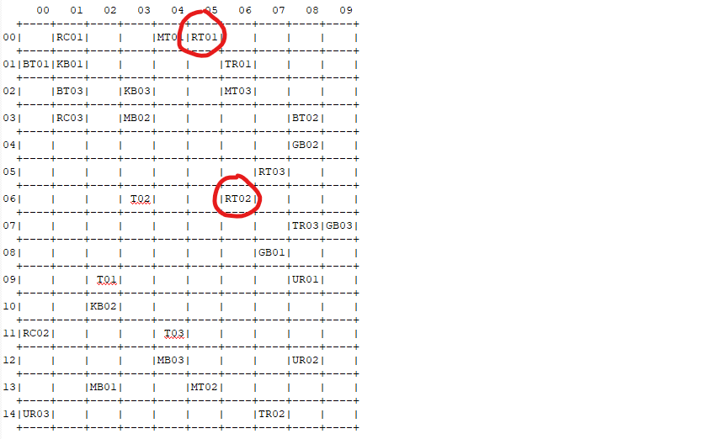

**AFTER**

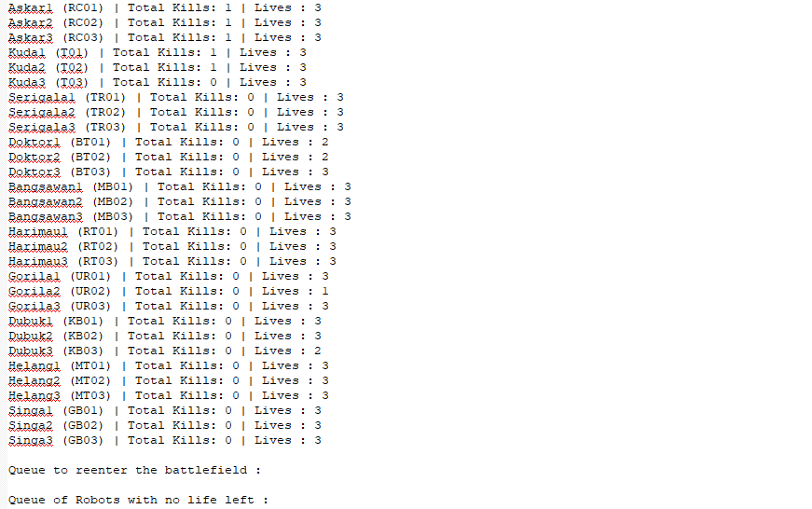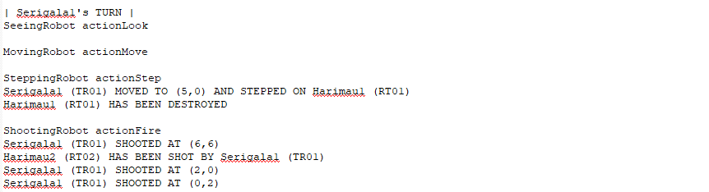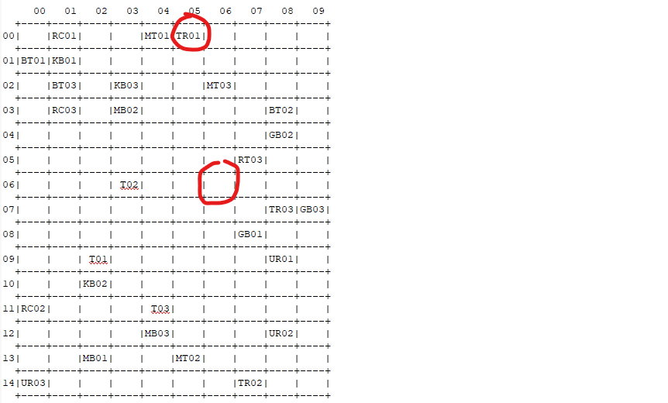

Previously, Serigala1(TR01) was at (6,1). Since Serigala1 has pure virtual public moving, stepping and shooting, Serigala1 moves and steps on RT01 at (5,0) and destroys it. Next, Serigala1 shoots at 3 random positions and hits RT02 at (6,6) and destroys it.

**d. BlueThunder**: This robot does not move and cannot look. It fires at only one of its immediate 8 neighboring cells surrounding it. In each turn, the target location to fire is not random. The sequence of firing is such that it starts from the location up and continues with a new location clockwise in each following turn. If BlueThunder fires a total of 3 other robots, it will be upgraded to Madbot.

**BEFORE**

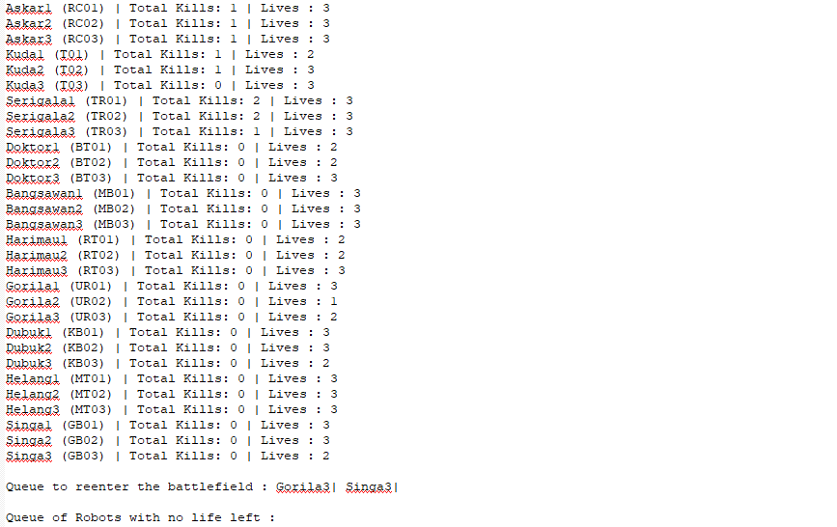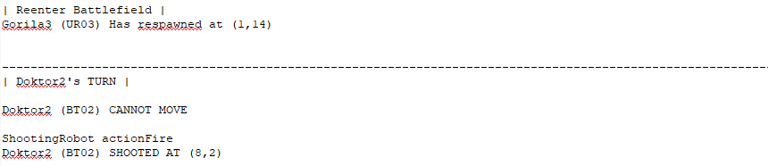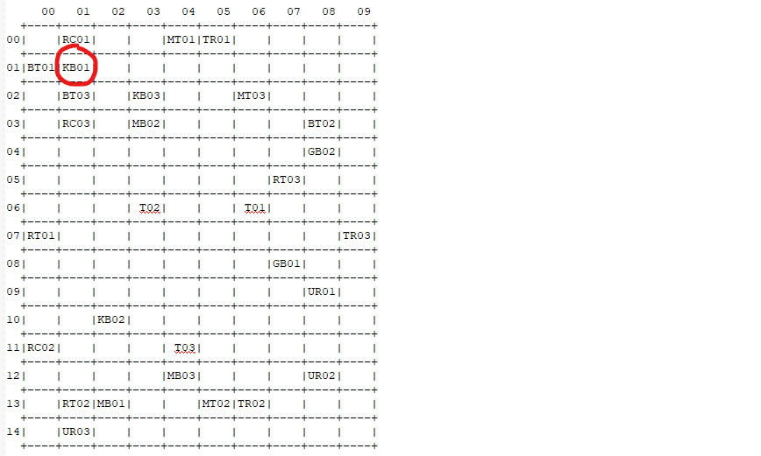

**AFTER**

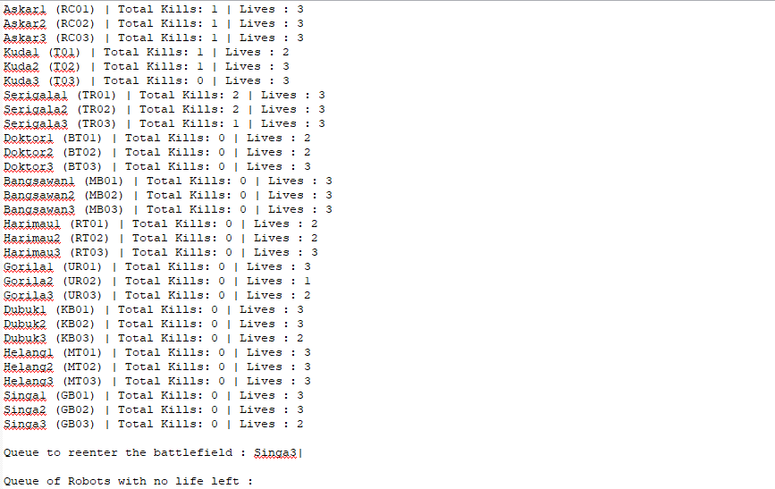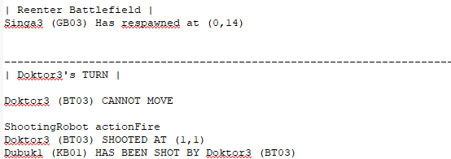

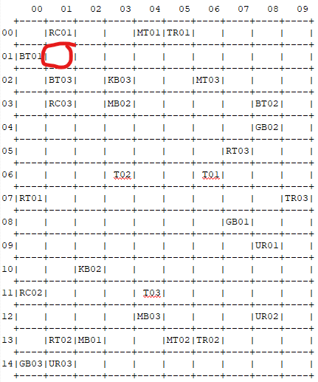

Doktor3(BT03) is at (1,2). BT03 cannot move since there is no pure virtual moving function. The simulation will output CANNOT MOVE. Due to its shooting pattern, BT03 shoots at (1,1) and destroy KB01.

**e. Madbot**: This robot does not move. It fires at only one of its immediate neighboring locations 8 neighborhoods randomly.

If Madbot eliminates a total of 3 other robots, it will be upgraded to RoboTank.

**BEFORE**

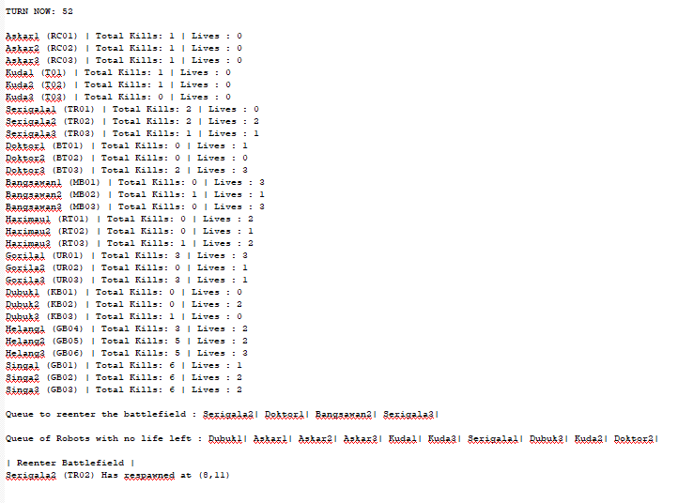

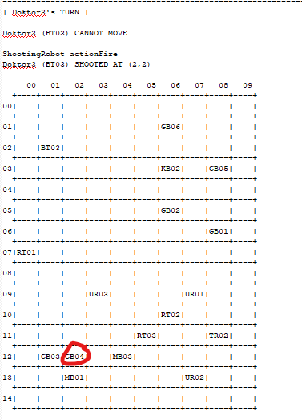

**AFTER**

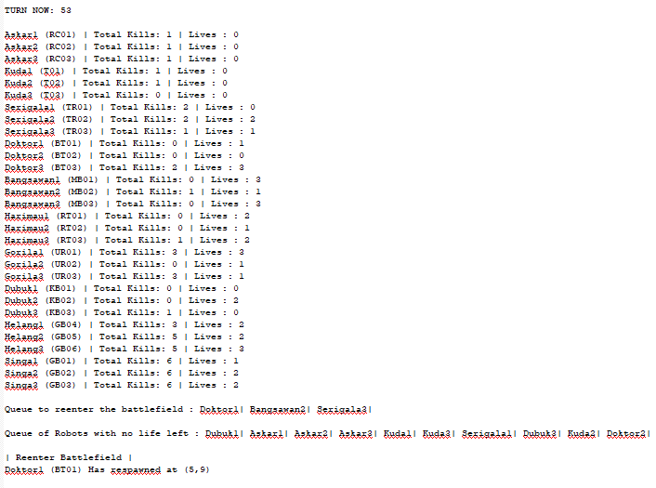

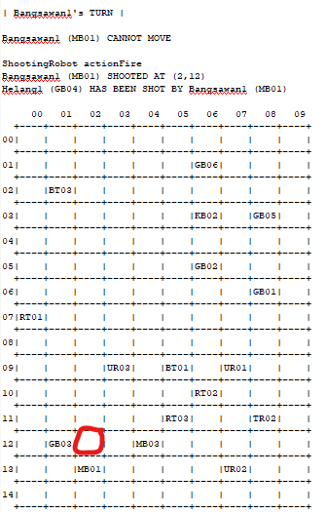

Bangsawan1 (MB01) is at (2,13) , It cannot move because there is no **virtual public moving** in the MadBot class so it's mentioned CANNOT MOVE in the output THEN it shot a robot GB04 at (2,12) which is from his 8 neighborhoods.

**f. RoboTank**: This robot does not move. It fires at one random location (x, y) in the battlefield, killing a robot if one exists in that position.

If RoboTank kills a total of 3 other robots, it will be upgraded to UltimateRobot.

**BEFORE**

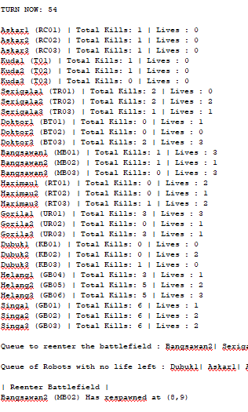

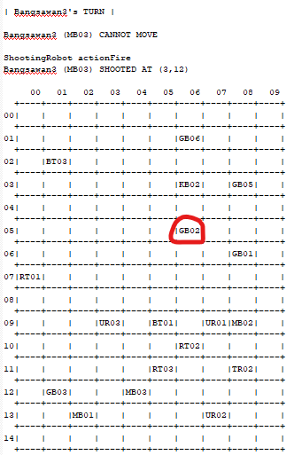

**AFTER**

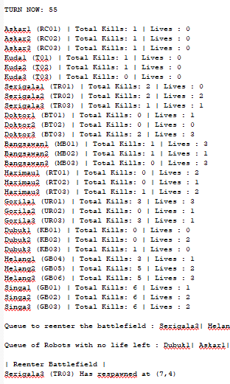

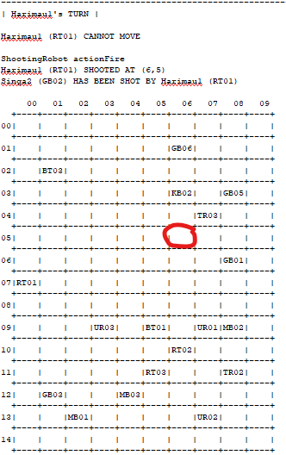

Harimau (RT01) is at (0,7), It cannot move because there is no **virtual public moving** in the RoboTank class so it's mentioned CANNOT MOVE in the output THEN it shot a robot GB02 at (6,5) which is a random location.

**g. UltimateRobot**: This robot moves like the TerminatorRoboCop, stepping and killing any robots on its path.

On top of that, in each turn, this robot fires randomly at 3 locations (x, y) in the battlefield.

MOVING

**BEFORE**

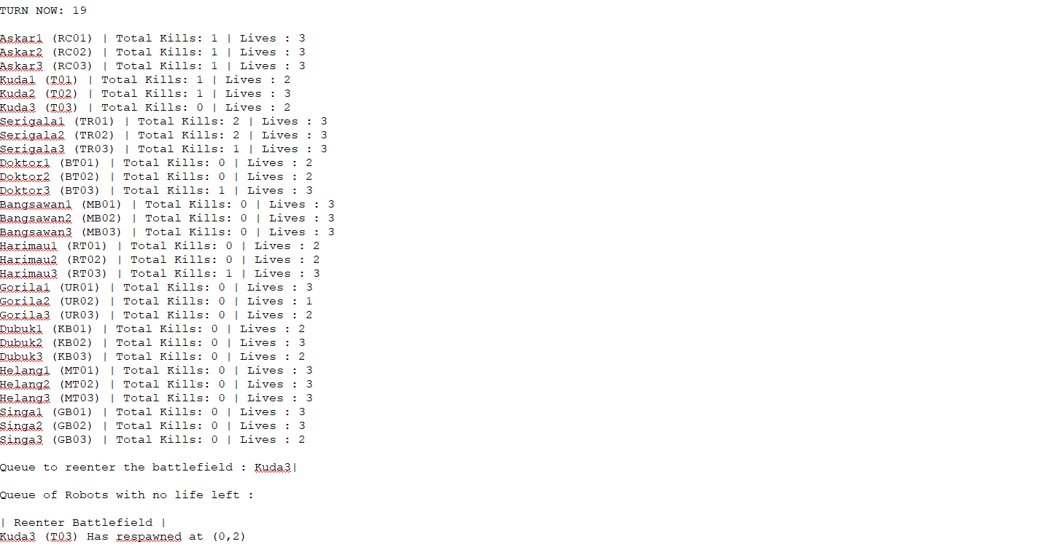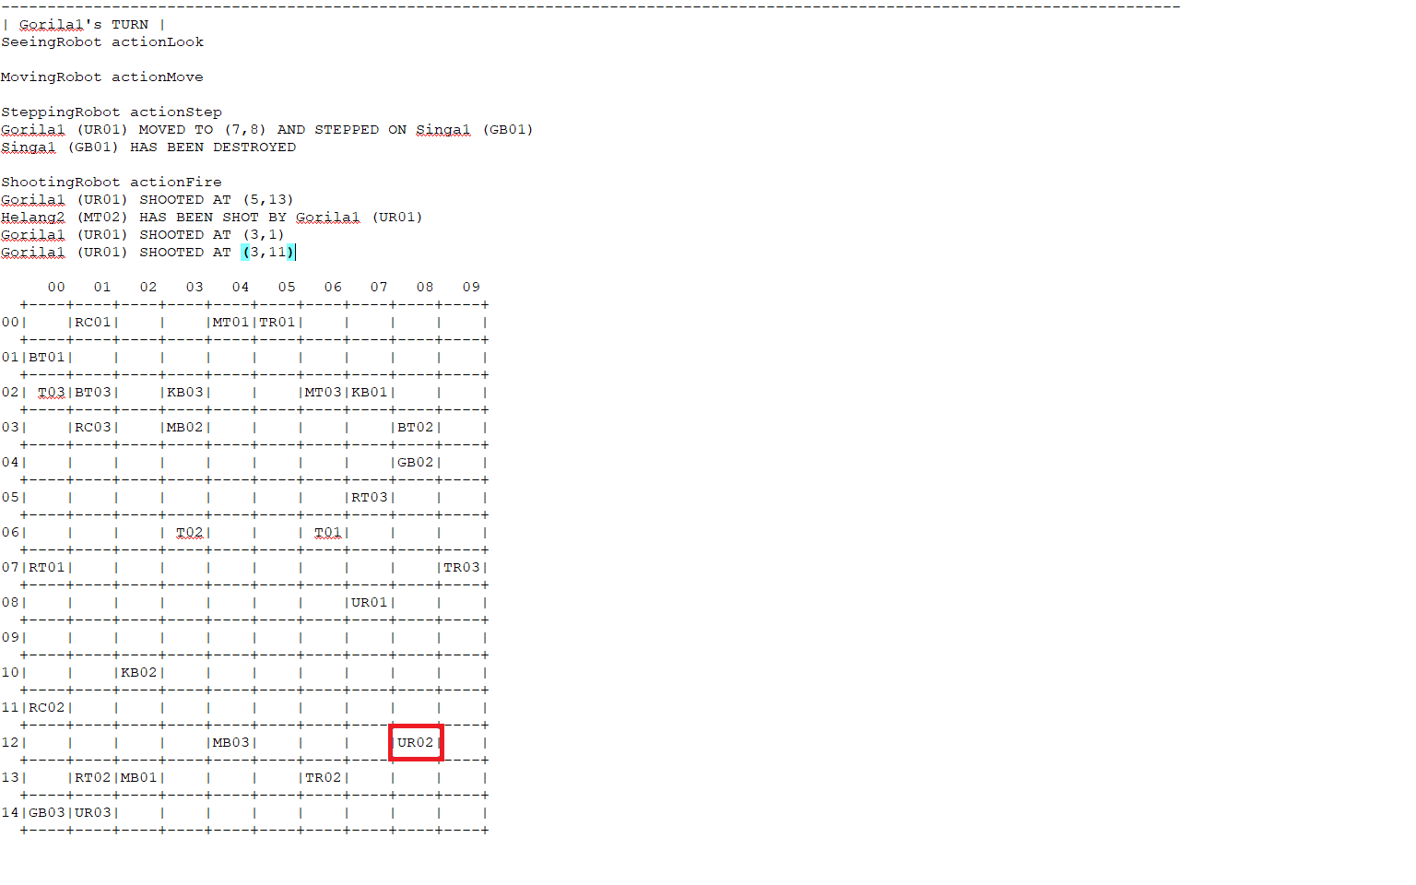

**AFTER**

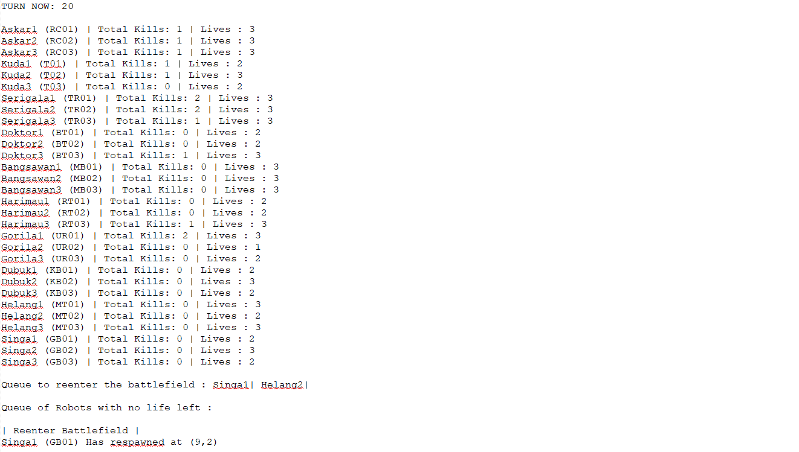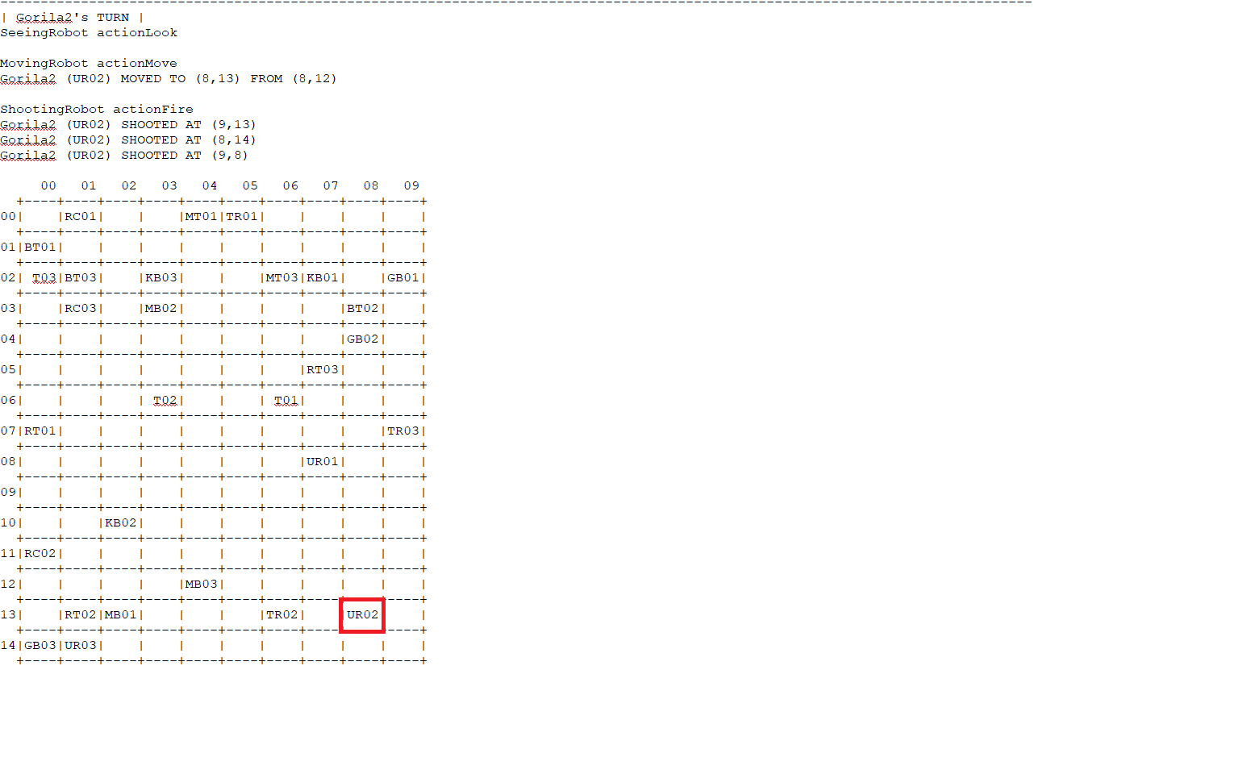

Gorila2 (UR02) is at (8,12) , this robot looks at the immediate 8 neighborhoods and performs a move to one of the 8 neighbors.s Thus, it MOVED TO (8,13) which is from his 8 neighborhoods.

STEPPING

**BEFORE**

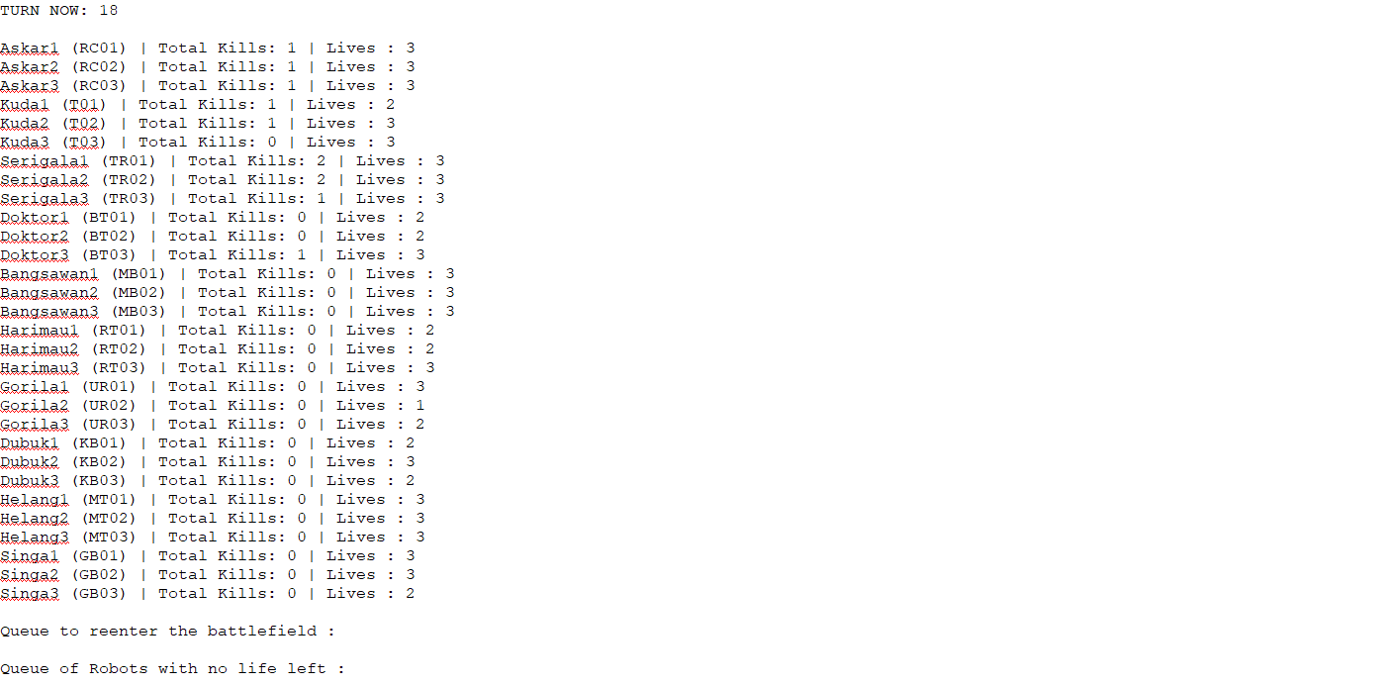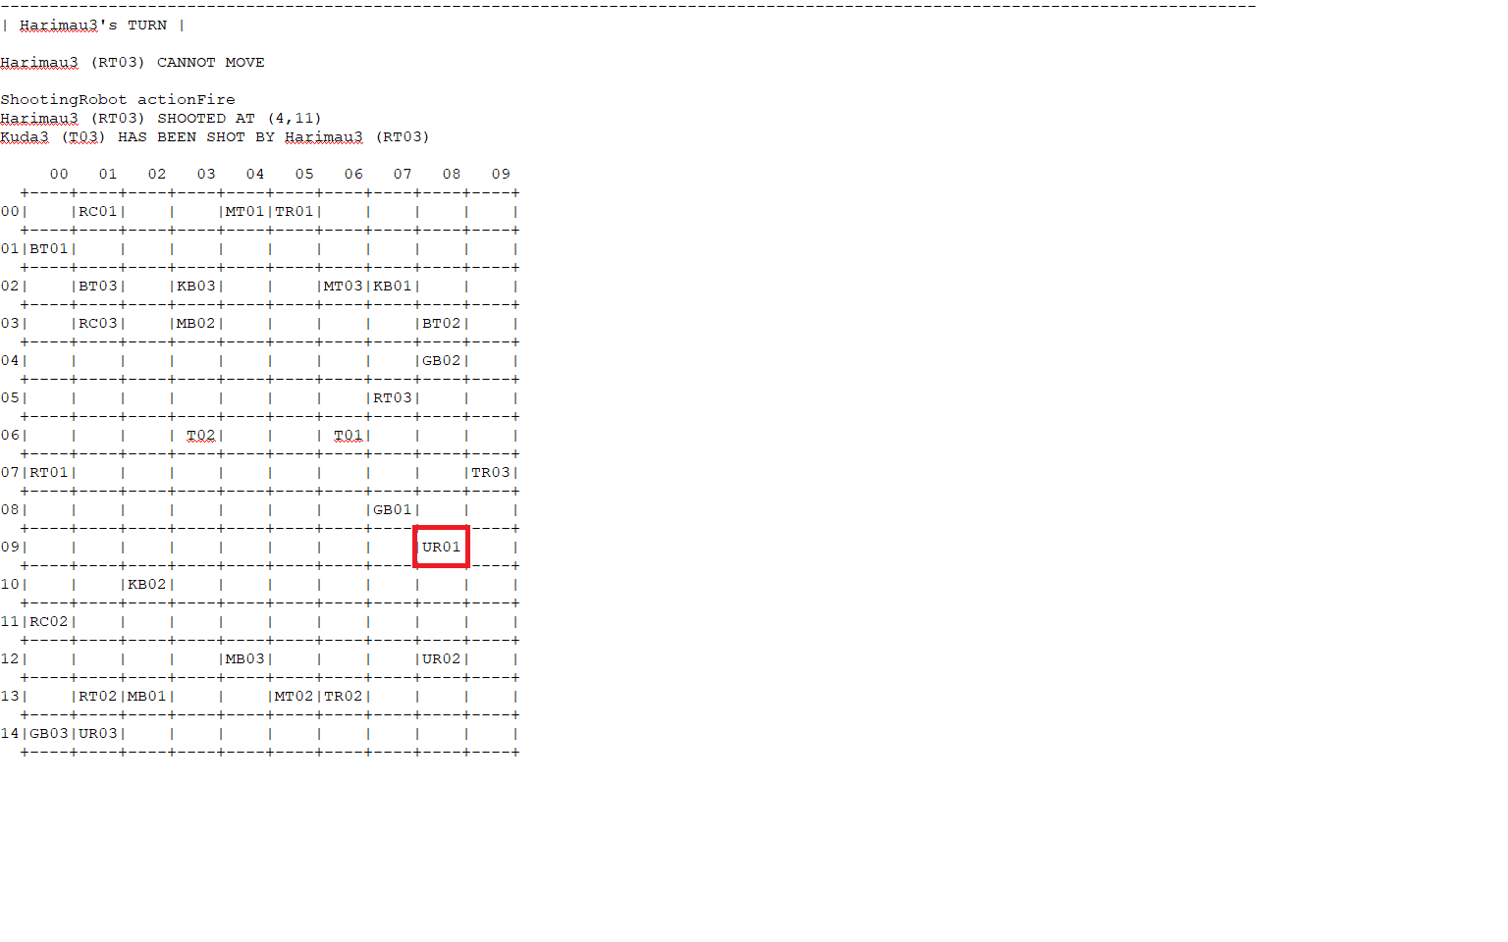

**AFTER**

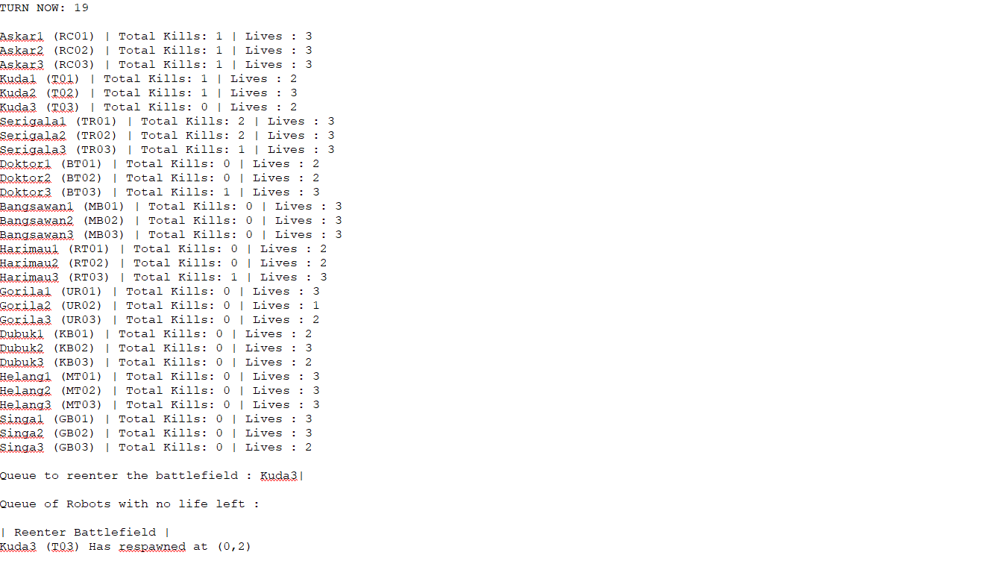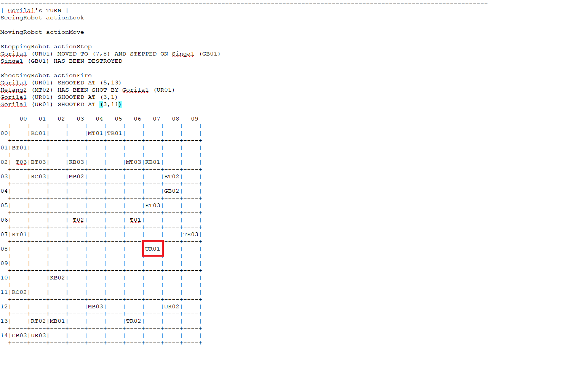

Gorila1 (UR01) is at (8,9), this robot looks at its current position and decides to step to one of its 8 neighboring locations. Thus, it MOVED TO (7,8) and STEPPED ON (GB01) at (7,8) which is from his 8 neighborhoods.

SHOOTING

**BEFORE**

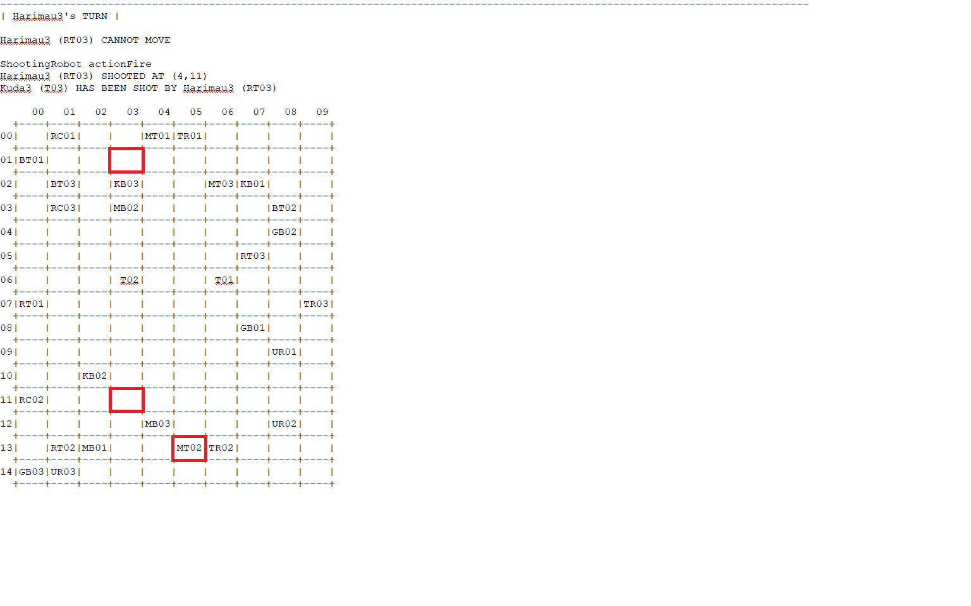

**AFTER**

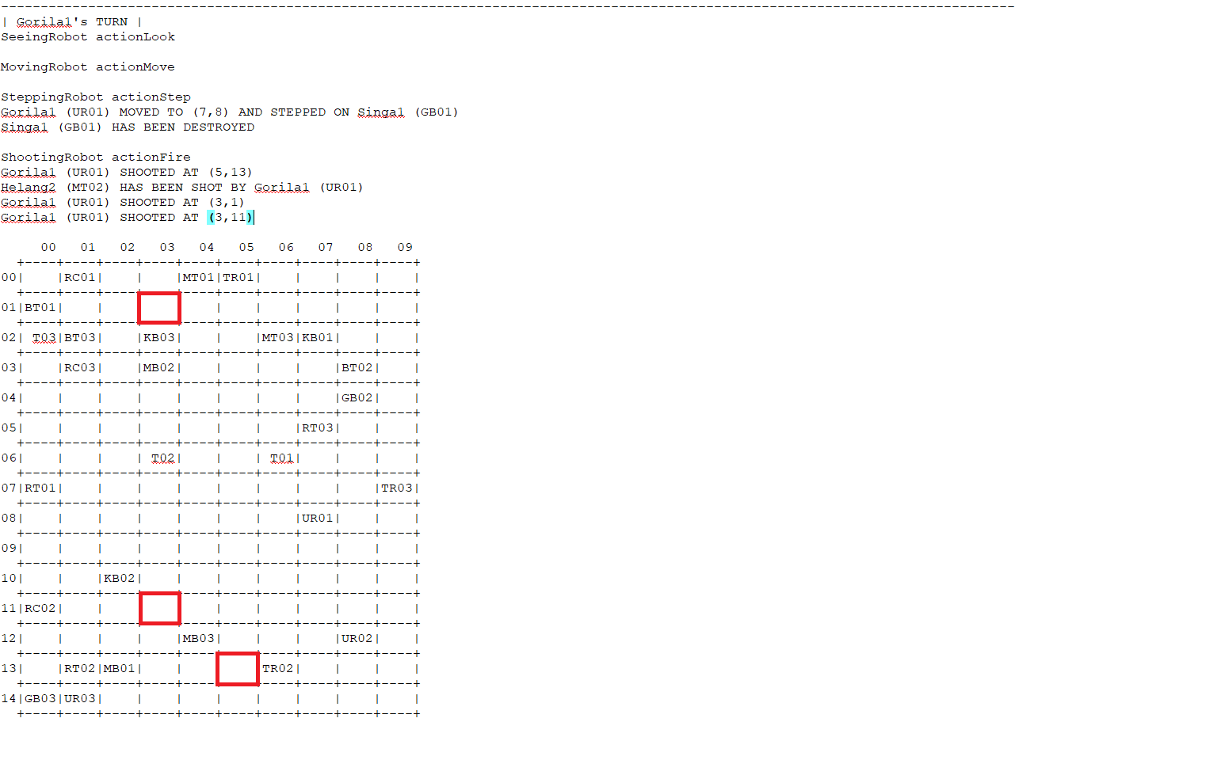

Gorila1 (UR01) is at (8,9), this robot fires (three times) at random positions in the battlefield.

This robot fire the robot at position (5,13), (3,1), (3,11) and it shot a robot MT02 at position (5,13).

# Q5. [8] Implementation of the required 7 robot classes with OOP concepts +1 or I&P&OO -3

**OPERATOR OVERLOADING**

class RobotPos;

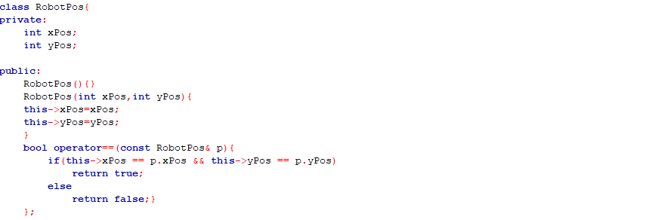

void moving in every Robot that can move ( ***RoboCop, Terminator, TerminatorRoboCop, UltimateRobot***)

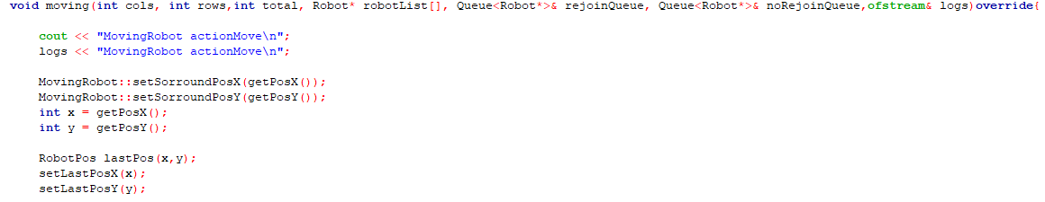

Before the logs of new coordinates of the robot , there is these commands

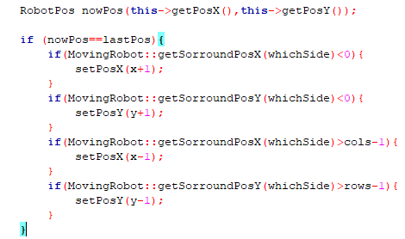

The RobotPos class overloads the equality operator (==). This allows two RobotPos objects to be compared directly using the == operator.

In the ‘moving’ method of the robot class that can move ( ***RoboCop, Terminator, TerminatorRoboCop, UltimateRobot***), the ‘RobotPos’ class and its overloaded ‘==’ operator are used to check if the robot has moved to a new position.

**How the ‘==’ Operator is Used**

*i. Track the Last Position*:

A ‘RobotPos’ object ‘lastPos’ is created to store the robot’s current position (x and y)

*ii. Move the robot:*

The robot’s position is updated based on nearby robots or random surrounding positions and the robot cannot move outside the grid, if it tries to then the robot will stay.

*iii. Create a New Position Object:*

A new ‘RobotPos’ object ‘nowPos’ is created to store the robot’s new position after moving.

*iv. Compare Positions:*

The overloaded ‘==’ operator is used to compare the new position ‘nowPos’ with the last position ‘lastPos’. If they are equal, it means the robot hasn’t moved, and the position will be adjusted. It will only be equal if the robot tries to move outside the grid as mentioned in *ii.*

**POLYMORPHISM AND INHERITANCE**

**a. RoboCop**

Polymorphism and Inheritance:

class RoboCop;

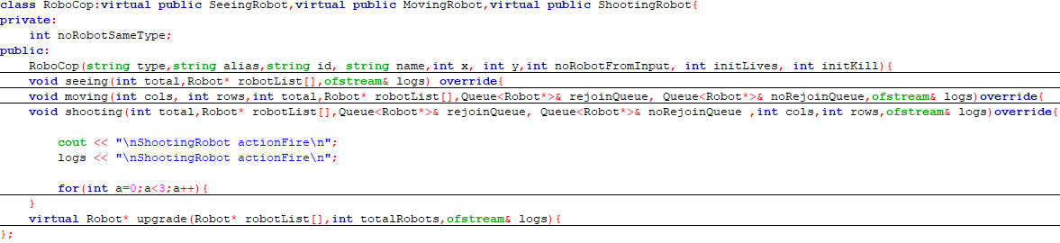

class ShootingRobot;

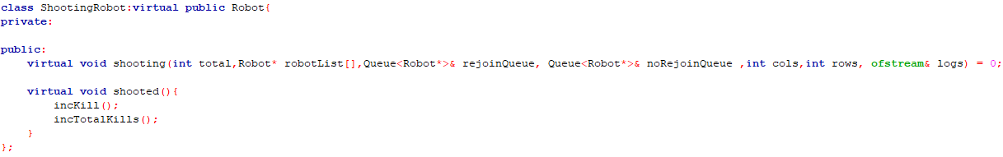

class Robot;

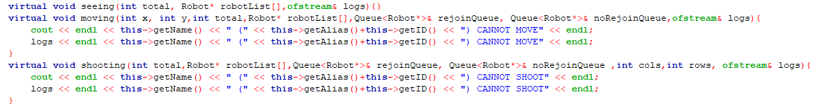

Inheritance: The RoboCop class inherits from ShootingRobot using virtual inheritance to avoid multiple instances of the Robot base class.This means that RoboCop inherits the shooting method and provides specific implementations for this class itself.

Polymorphism: It overrides the shooting function that has been made at base class ‘Robot’. By overriding the shooting method , RoboCop can be defined by its characteristics and behavior.

**b. Terminator**

Polymorphism and Inheritance:

**class SeeingRobot;**

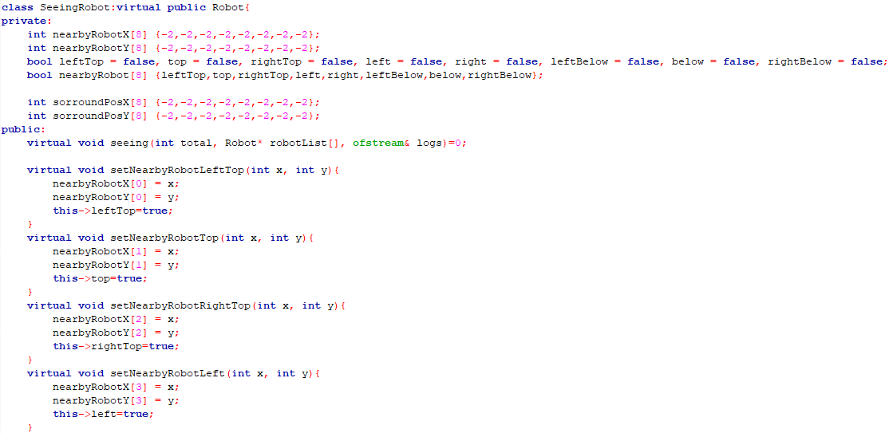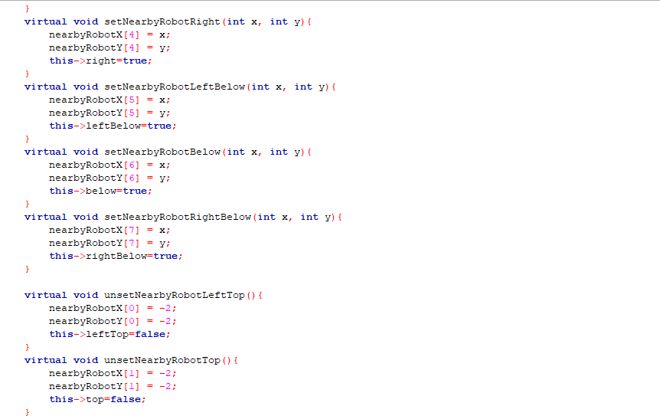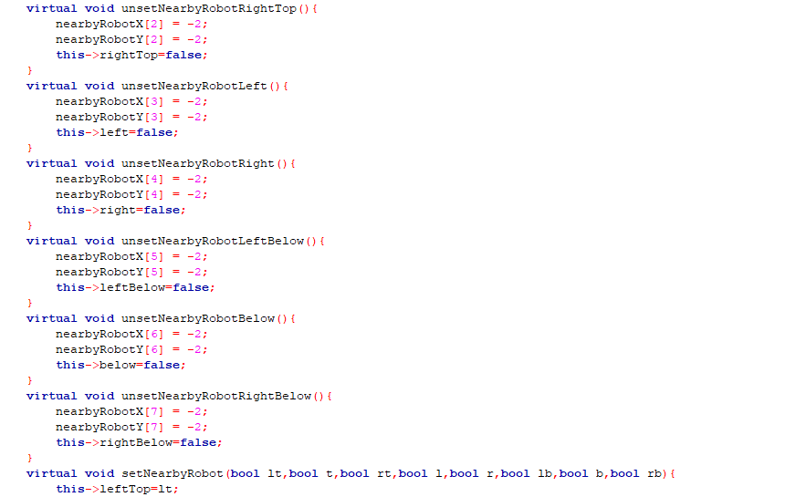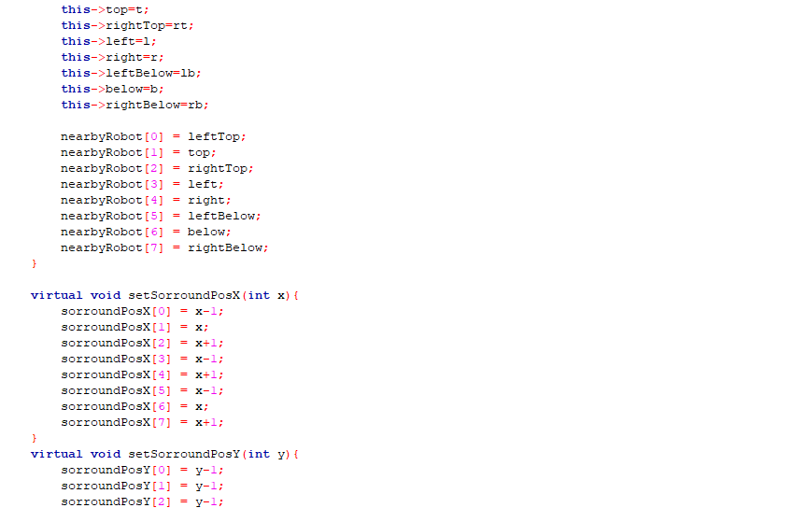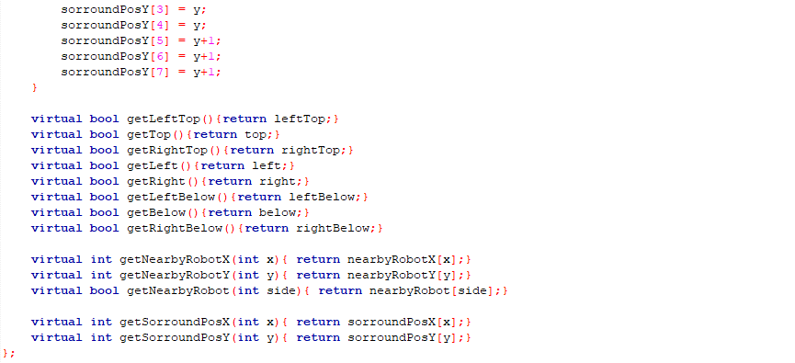

**class Terminator;**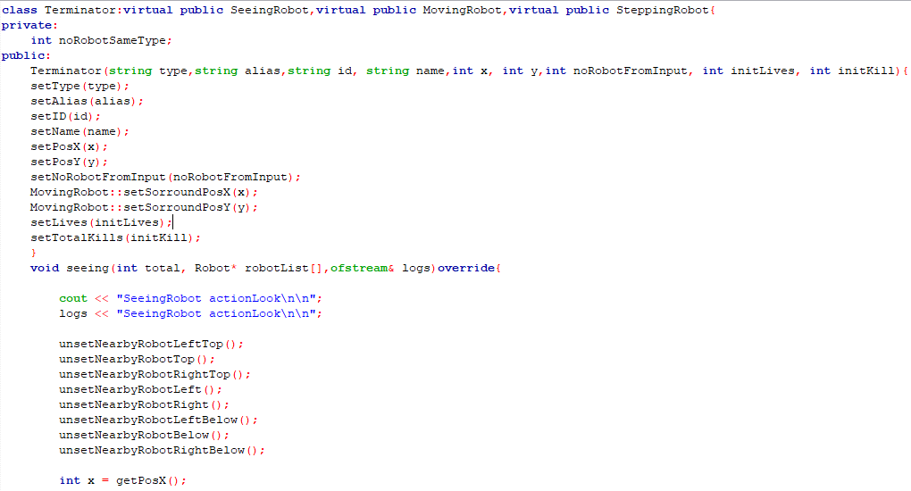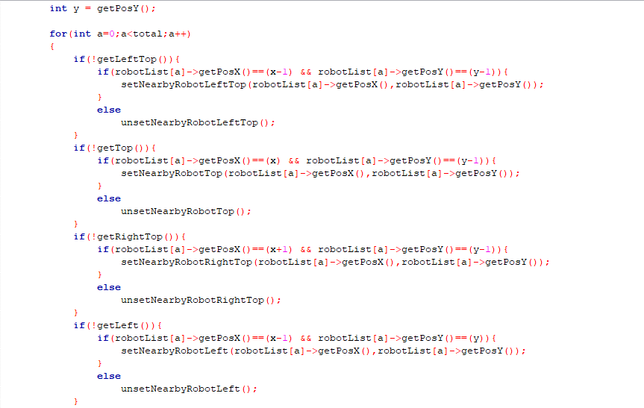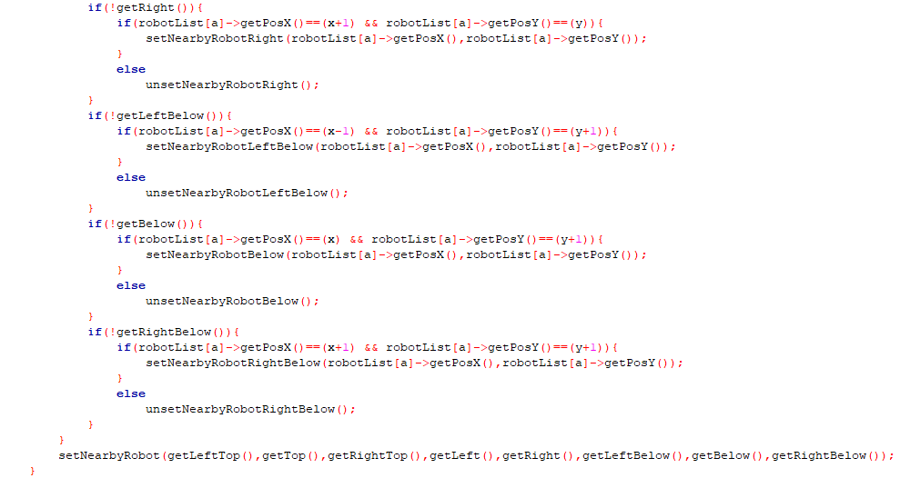

Inheritance: The Terminator class inherits from SeeingRobot using virtual inheritance to avoid multiple instances of the Robot base class.This means that Terminator inherits the seeing method and provides specific implementations for this class itself.

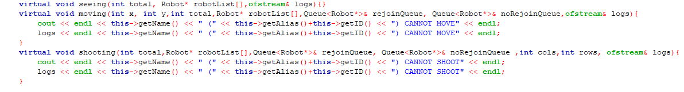

Polymorphism: It overrides the seeing function that has been made at base class ‘Robot’. By overriding the seeing method , Terminator can be defined by its characteristics and behavior.

c. **TerminatorRoboCop**

Polymorphism and Inheritance:

class SeeingRobot;

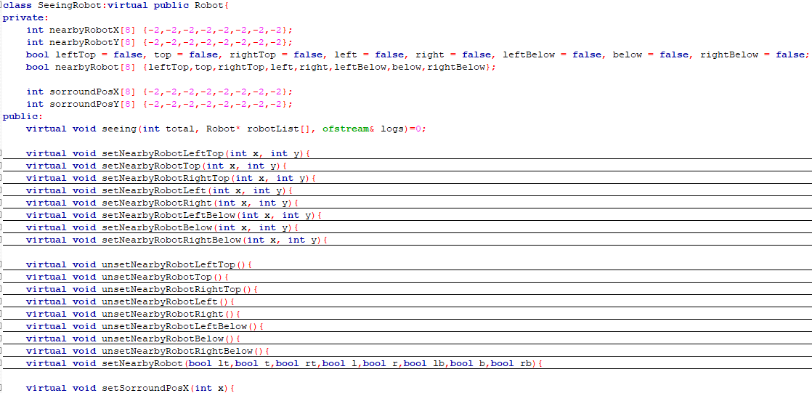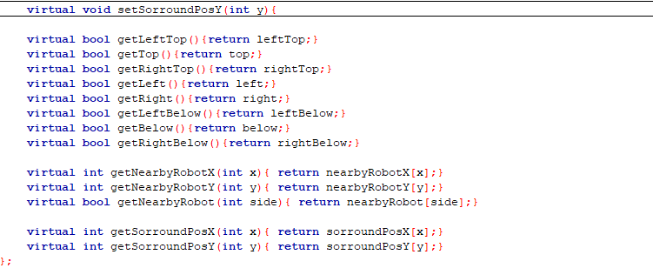

class TerminatorRoboCop;

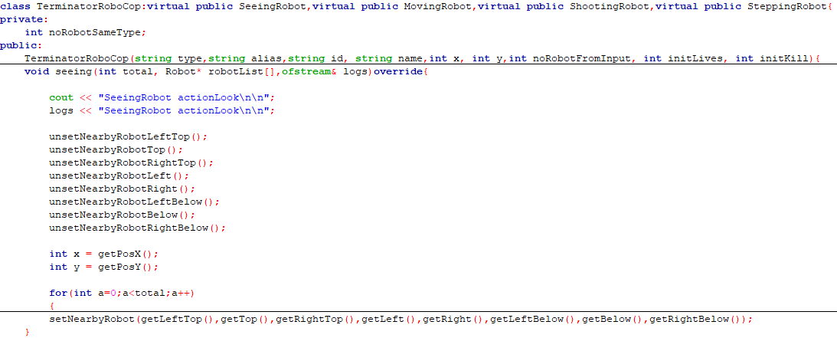

class Robot;

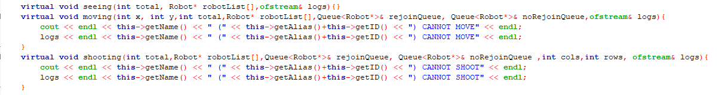

The TerminatorRoboCop class inherits from SeeingRobot using virtual inheritance to avoid multiple instances of the Robot base class.This means that TerminatorRoboCop inherits the seeing method and provides specific implementations for this class itself.

Polymorphism: It overrides the seeing function that has been made at base class ‘Robot’. By overriding the seeing method , TerminatorRoboCop can be defined by its characteristics and behavior.

**d. BlueThunder**

Polymorphism and Inheritance:

class ShootingRobot;

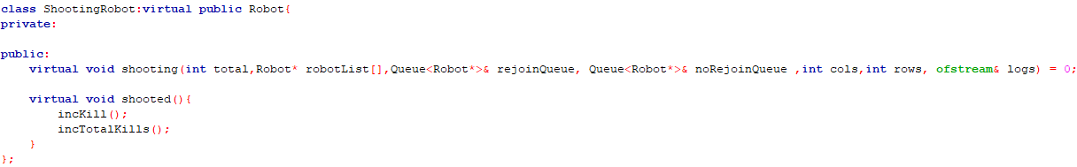

class BlueThunder;

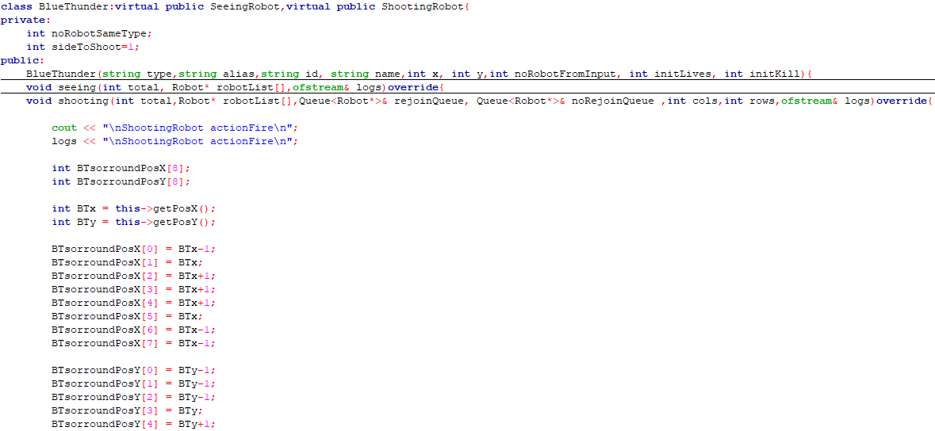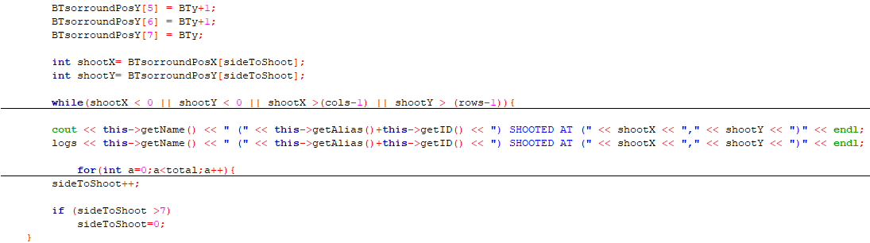

class Robot;

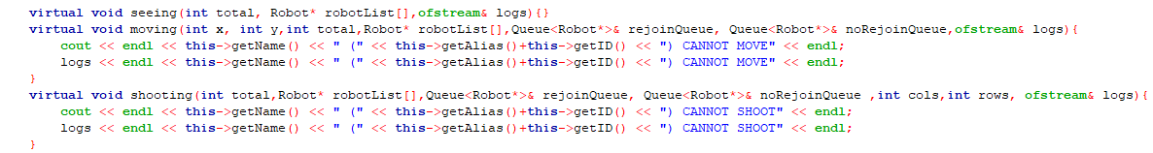

Inheritance: The BlueThunder class inherits from ShootingRobot using virtual inheritance to avoid multiple instances of the Robot base class.This means that BlueThunder inherits the shooting method and provides specific implementations for this class itself.

Polymorphism: It overrides the shooting function that has been made at base class ‘Robot’. By overriding the shooting method , BlueThunder can be defined by its characteristics and behavior.

**e. Madbot**

Polymorphism and Inheritance :

class ShootingRobot;



class MadBot;

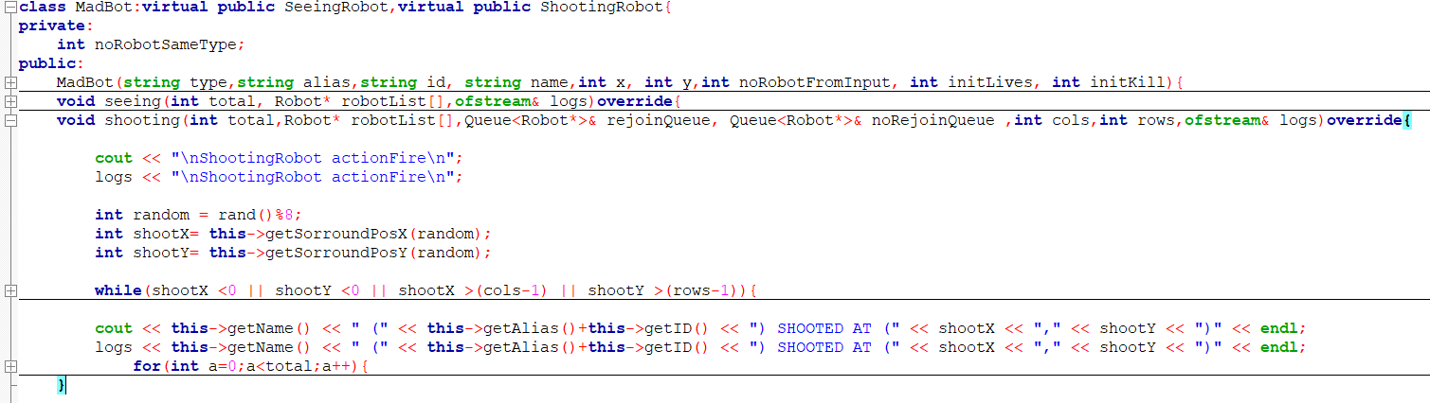

class Robot;



Inheritance: The MadBot class inherits from ShootingRobot using virtual inheritance to avoid multiple instances of the Robot base class.This means that Terminator inherits the shooting method and provides specific implementations for this class itself.

Polymorphism: It overrides the shooting function that has been made at base class ‘Robot’. By overriding the shooting method , MadBot can be defined by its characteristics and behavior.

**f. RoboTank**

Polymorphism and Inheritance :

class ShootingRobot;



class RoboTank;

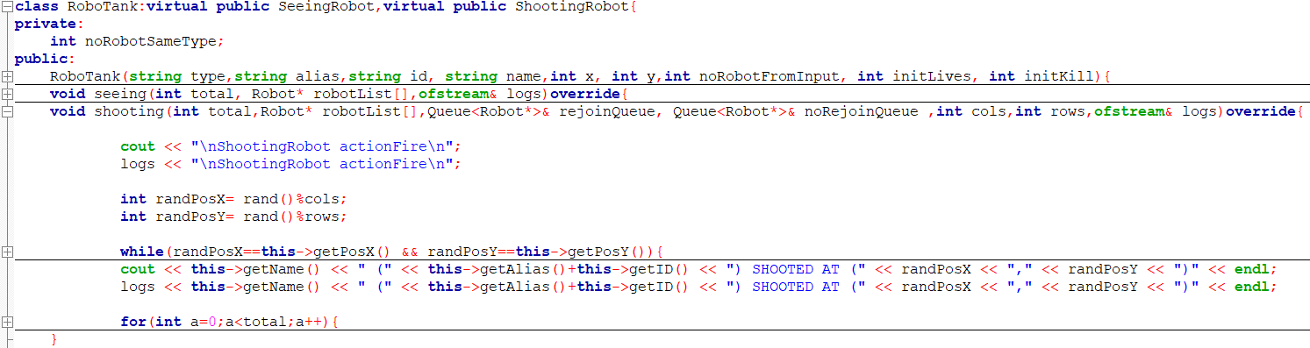

class Robot;



Inheritance: The RoboTank class inherits from ShootingRobot using virtual inheritance to avoid multiple instances of the Robot base class.This means that RoboTank inherits the shooting method and provides specific implementations for this class itself.

Polymorphism: It overrides the shooting function that has been made at base class ‘Robot’. By overriding the shooting method , RoboTank can be defined by its characteristics and behavior.

**g. UltimateRobot**

Polymorphism and Inheritence:

class UltimateRobot:

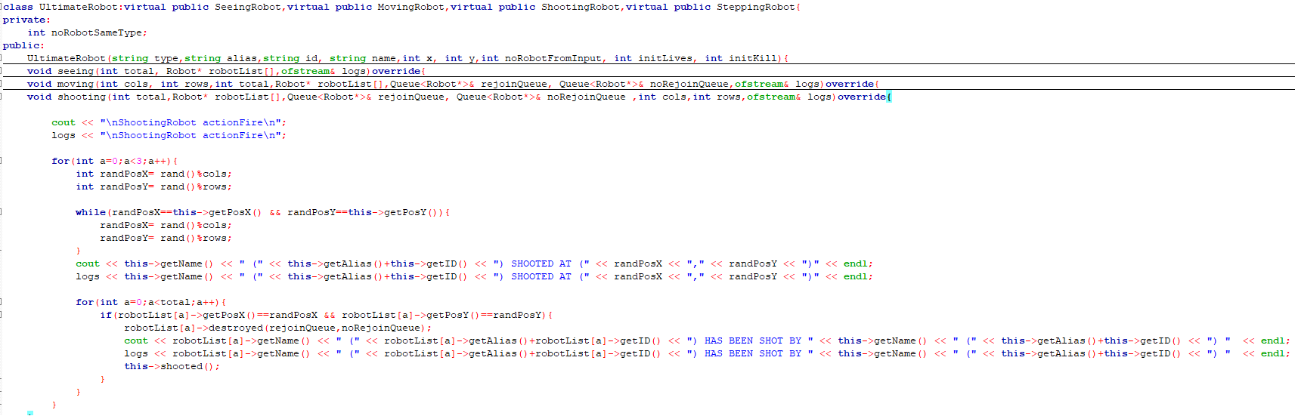

class ShootingRobot:

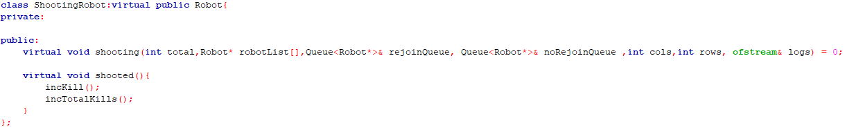

class Robot:

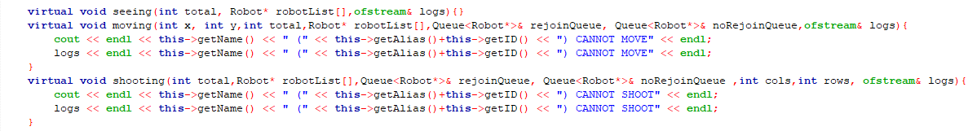

Inheritance: The UltimateRobot class inherits from ShootingRobot using virtual inheritance to avoid multiple instances of the Robot base class.This means that UltimateRobot inherits the shooting method and provides specific implementations for this class itself.

Polymorphism: It overrides the shooting function that has been made at base class ‘Robot’. By overriding the shooting method , UltimateRobot can be defined by its characteristics and behavior.

# Q6. [5] The algorithms used to optimize the actions of robots, optimize the two actions or -2

1. **Randomized Shooting Algorithm (Used in the ‘shooting’ method)**

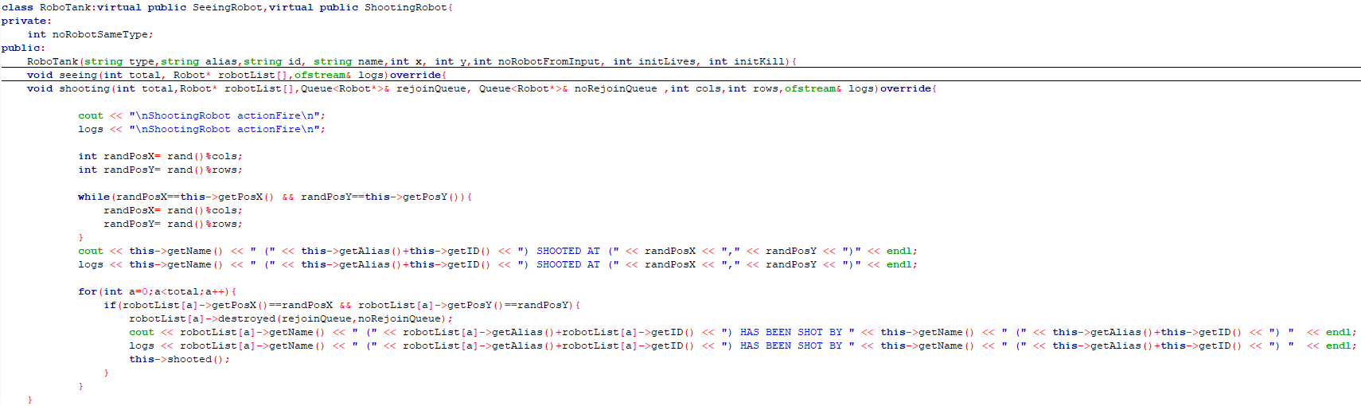

**Algorithm Description:** This algorithm allows a robot to shoot at a random location on the battlefield, ensuring that it does not target its own position. This introduces an element of unpredictability, making the robots’ actions less predictable and more dynamic.

**Implementation Details:**

* The robot generates random x and y coordinates within the boundaries of the battlefield.
* It checks to ensure that the randomly generated position is not its own current position.
* It then iterates through the list of robots to see if any robot is present at the targeted position and, if so, performs the shooting action and outputs the targeted robot ‘has been shot’. If there is no robot there, it will not output any robot ‘has been shot’.

1. **Proximity-based Decision Making (Used in the ‘seeing’ method)**

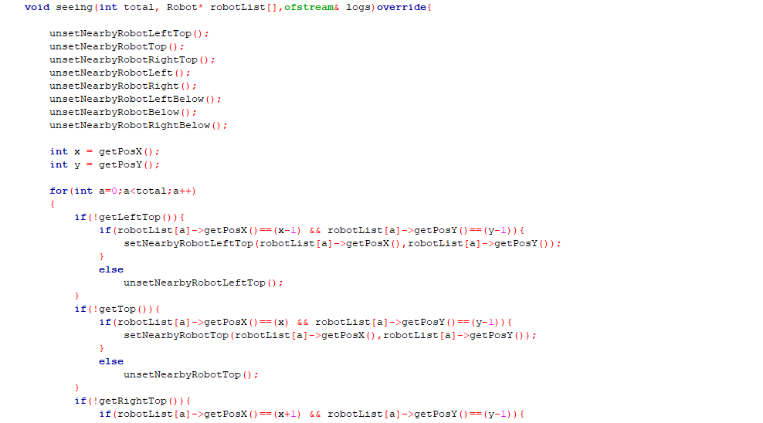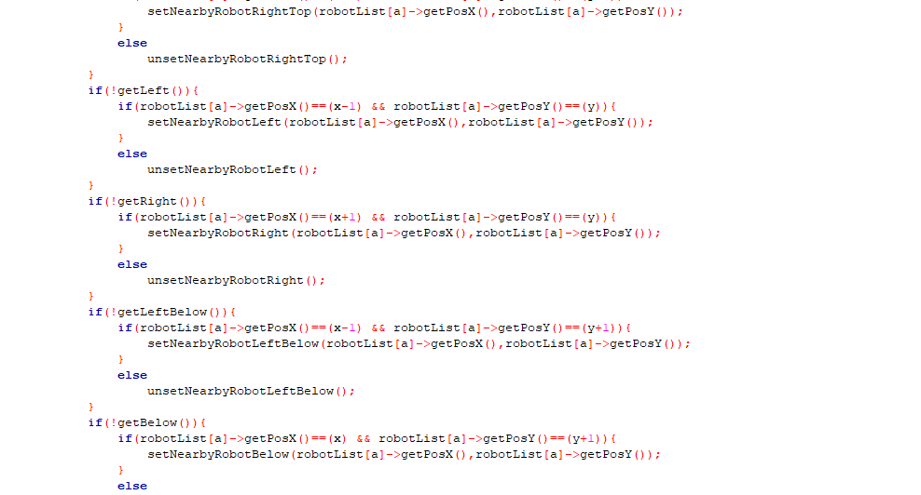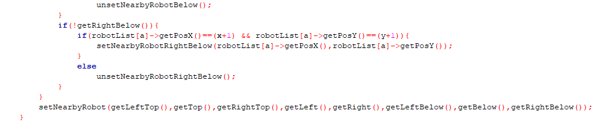

**Algorithm Description:** This algorithm allows a robot to check its immediate surroundings to determine the presence and positions of other robots. By iterating through a list of all robots and comparing their positions to the current robot’s position, the robot can determine the presence of other robots in adjacent cells.

**Implementation Details:**

* The robot iterates through the list of all robots (‘robotList’).
* It checks the positions of each robot relative to its own position.
* It updates its internal state to record the positions of nearby robots.
* This helps in making decisions for movement and actions (like stepping)

# Q7. [5] Design and implementation of data structures, linked list and queues

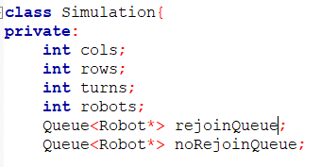

In the ‘Simulation’ class, we use two queues:

1. ‘rejoinQueue’: Tracks robots that are destroyed but can rejoin the battlefield.
2. ‘noRejoinQueue’: Tracks robots that are destroyed and cannot rejoin the battlefield.

**i. When a Robot is Destroyed**

When a robot is destroyed, it is added to either the ‘rejoinQueue’ or ‘noRejoinQueue’ based on its remaining lives.

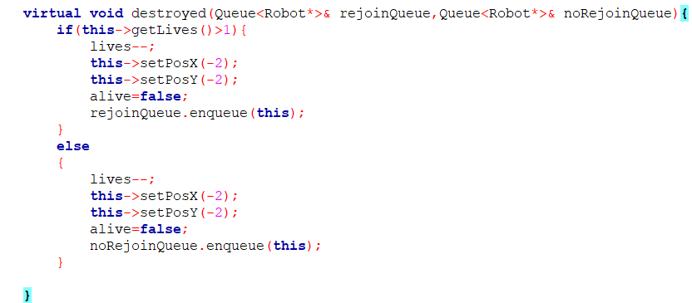

Rejoining Queue: If the robot has more than one life left, it decrements the life count, sets its position to (-2,-2) (indicating it is off the battlefield), marks it as not alive, and adds it to the ‘rejoinQueue’.

No Rejoining Queue: If the robot has no more lives left, it performs similar actions but adds the robot to the ‘noRejoinQueue’.

**ii. Processing Robots to Rejoin the Battlefield**

The ‘processRejoin’ method handles robots in the ‘rejoinQueue’, allowing them to rejoin the battlefield if they have lives remaining.

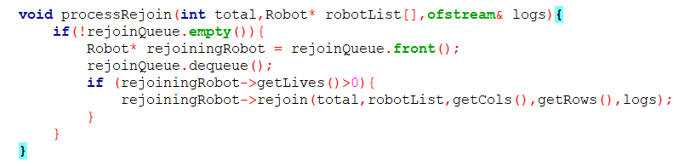

Checking the Queue: The method checks if the ‘rejoinQueue’ is not empty.

Dequeuing a Robot: It gets the front robot from the queue and removes it from the queue.

Rejoining: If the dequeued robot has lives remaining, it calls the ‘rejoin’ method on the robot to place it back on the battlefield.

**iii. Rejoining the Battlefield**

The ‘rejoin’ method is responsible for placing a robot back on the battlefield in a random, unoccupied position.

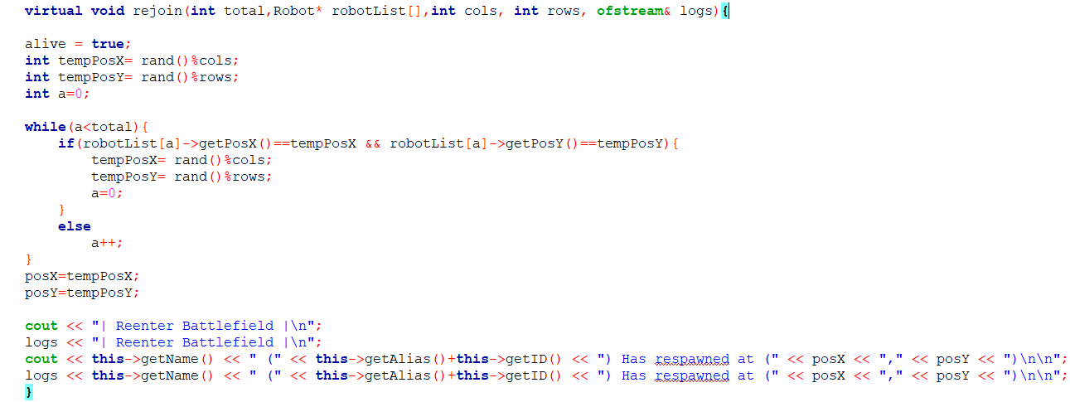

Setting Alive: The robot is marked as alive.

Random Position: It generates a random position within the grid.

Checking for Unoccupied Position: It ensures the generated position is not occupied by another robot.

Updating Position: Sets the robot’s position to the new coordinates and logs the respawn.

**Example of Queue implementation**

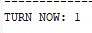

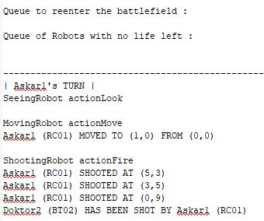

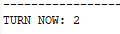

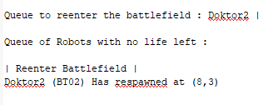

Based on the figure , Turn 1 Doktor2 has been shot , then at Turn 2 Doktor2 queue to reenter the battlefield and respawn immediately since there is no robot queuing in front of Doktor2.

# 

# 

# 

# 

# 

# 

# 

# 

# 

# 

# 

# 

# Question: How to compile, how to run the program

Step 1, Open Codeblocks app.

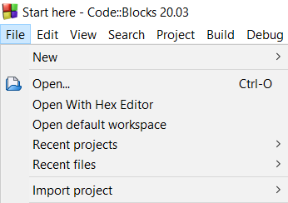

Step 2, File > Open…

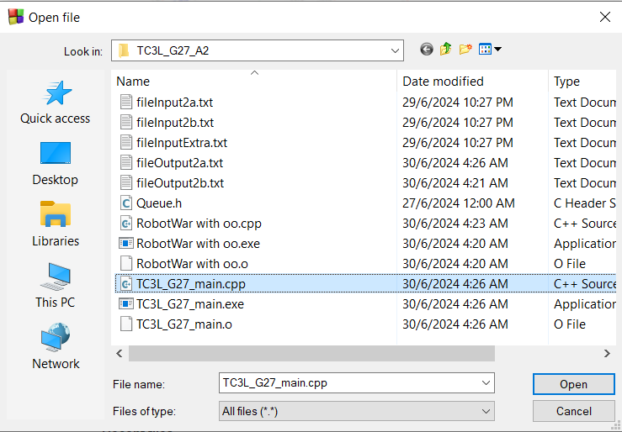

Step 3, Open folder to open the project. For example, TC3L_G27_A2_FadzlulL_Haziq_Umar_Wan.zip

Step 4, Open folder name TC3L_G27_main.cpp and click Open

Step 5, Click Build and Run at the top

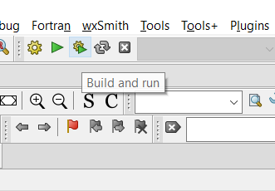

**Additional Info**

If the user wants to use another file input and output (currently fileInput2a.txt as default)

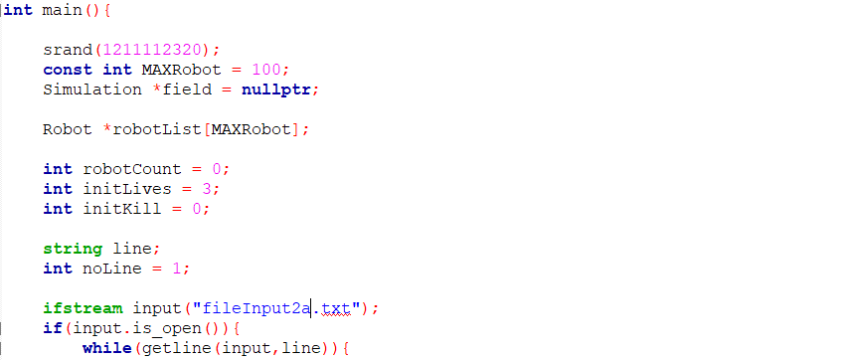

Step 1, change the fileInput2a.txt file to fileInput2b.txt

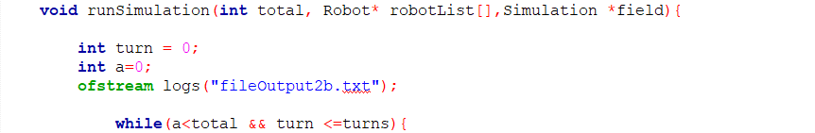

Step 2, change the fileOuput2a.txt to fileInput2b.txt